#46

***Trump Picks Gas Executive as Energy Secretary***

Chris Wright is a TV-ready evangelist for fossil fuels who lacks government experience.

**Listen to this article · 8:01 min**[Learn more](https://help.nytimes.com/hc/en-us/articles/24318293692180)

* Share full article



Chris Wright, the chief executive of Liberty Oilfield Services, on the floor of the New York Stock Exchange after ringing the opening bell in 2018.Credit...Lucas Jackson/Reuters

[](https://www.nytimes.com/by/coral-davenport)[](https://www.nytimes.com/by/lisa-friedman)

**By**[**Coral Davenport**](https://www.nytimes.com/by/coral-davenport)**and**[**Lisa Friedman**](https://www.nytimes.com/by/lisa-friedman)

Nov. 16, 2024

President-elect Donald J. Trump has tapped Chris Wright, chief executive of Liberty Energy, a fracking company based in Denver, as his choice for secretary of energy.

Mr. Wright, who calls himself “a tech nerd turned entrepreneur,” is a media-friendly evangelist for fossil fuels who promotes a feel-good message that oil and gas can lift people out of poverty, while disparaging climate science.

In a video posted on LinkedIn last year, Mr. Wright declared, “There is no climate crisis, and we’re not in the midst of an energy transition either.”

Mr. Wright, who has no government experience, caught the attention of Mr. Trump in part through his appearances on Fox News. He also appears frequently on podcasts and social media videos, often using language and imagery associated with progressive causes to link oil and gas with issues like the fight for women’s equality.

Mr. Trump announced Mr. Wright’s appointment in a statement and praised him as a “leading technologist and entrepreneur in energy.” He said in addition to leading the Energy Department, Mr. Wright would also be a member of the newly formed council of national energy.

“He has worked in nuclear, solar, geothermal, and oil and gas,” Mr. Trump wrote, referring to Mr. Wright. “Most significantly, Chris was one of the pioneers who helped launch the American shale revolution that fueled American energy independence, and transformed the global energy markets and geopolitics.”

Mr. Wright is close to Harold G. Hamm, the billionaire founder of Continental Resources who donated nearly $5 million to Mr. Trump since 2023 and is playing a role in the transition.

Mr. Wright was a director of the Domestic Energy Producers Alliance, a [lobbying group](https://depausa.org/executive-committee/) that Mr. Hamm founded. The Wall Street Journal described the alliance as a “[counterweight](https://www.wsj.com/politics/elections/donald-trump-energy-policy-oil-gas-donors-1cbc98f6)” to larger oil industry groups that recognize that climate change is caused by human activity and support some action to address it.

Mr. Hamm told Hart Energy, an online publication, that Mr. Wright was his [top choice](https://www.hartenergy.com/exclusives/liberty-energys-chris-wright-harold-hamms-top-choice-energy-secretary-211066) to lead the Energy Department.

**Editors’ Picks**

[[](https://www.nytimes.com/2025/06/16/arts/design/pigeon-fest-high-line.html)](https://www.nytimes.com/2025/06/16/arts/design/pigeon-fest-high-line.html)

[Crowning New York’s Top ‘Pigeon’](https://www.nytimes.com/2025/06/16/arts/design/pigeon-fest-high-line.html)

[[](https://www.nytimes.com/2025/06/13/t-magazine/summer-swimsuit-quiz.html)](https://www.nytimes.com/2025/06/13/t-magazine/summer-swimsuit-quiz.html)

[How to Choose the Perfect Swimsuit](https://www.nytimes.com/2025/06/13/t-magazine/summer-swimsuit-quiz.html)

[[](https://www.nytimes.com/2025/06/15/movies/how-to-train-your-dragon-mason-thames-interview.html)](https://www.nytimes.com/2025/06/15/movies/how-to-train-your-dragon-mason-thames-interview.html)

[The ‘How to Train Your Dragon’ Star Mason Thames Is Still Freaking Out](https://www.nytimes.com/2025/06/15/movies/how-to-train-your-dragon-mason-thames-interview.html)

In August, Mr. Wright’s wife, Liz Wright, [co-hosted a fund-raiser](https://x.com/teddyschleifer/status/1810790170184065061) in Montana for Mr. Trump. Campaign finance records show that Chris Wright and Liz Wright donated $175,000 apiece to Mr. Trump’s joint fund-raising campaign committee, called Trump 47.

The core mission of the Energy Department is ensuring the safety of the country’s nuclear arsenal. But under President Biden, the agency has also played a large role in leading the energy transition away from fossil fuels and toward wind, solar, nuclear and other forms of noncarbon energy.

As one of his first tasks, Mr. Wright is expected to end a Biden administration pause on new liquefied natural gas export terminals. A judge [blocked](https://www.nytimes.com/2024/07/01/climate/federal-judge-biden-gas-exports.html) the pause and the Biden administration did approve at least one export permit, but Republicans and the oil and gas industry have accused the administration of deliberately stalling new approvals.

“We look forward to working with him once confirmed to bolster American geopolitical strength by lifting D.O.E.’s pause on L.N.G. permits and ensuring the open access of American energy for our allies around the world,” said Mike Sommers, the president of the American Petroleum Institute, which represents oil companies, in a statement.

Climate activists criticized the selection of a fossil fuel executive at a time when they say the country needs to invest more heavily in clean energy.

“Like his new boss, Donald Trump, Wright denies the threat of the scientifically proven climate crisis,” said Lori Lodes, the executive director of Climate Power, an environmental nonprofit group. She noted that renewable energy was cheaper to produce than fossil fuels, in part because of the Inflation Reduction Act, a 2022 law pumping hundreds of billions of dollars into wind, solar and other clean energy. Mr. Trump wants Congress to repeal it.

“No matter who they voted for, Americans want cheaper, cleaner energy options,” Ms. Lodes said.

Earlier this week Mr. Trump [named Gov. Doug Burgum](https://www.nytimes.com/2024/11/14/climate/trump-burgum-for-interior-secretary.html?searchResultPosition=3) of North Dakota to lead the Interior Department and chair the new national energy council. Mr. Trump said the team “will drive U.S. energy dominance, which will drive down inflation, win the A.I. arms race with China (and others) and expand American diplomatic power to end wars all across the world.”

The image of Mr. Wright, who often appears in videos wearing button-down shirts, designer sneakers and no jacket or tie, runs counter to the stereotype of the conservative oil executive.

Yet Mr. Wright’s underlying message lines up almost exactly with Mr. Trump’s: fossil fuels are the critical to growing the economy and climate change is a hoax — or at least, fears of it are overblown.

The president-elect has pledged to “drill, baby drill,” called climate change a scam and promised to erase regulations designed to curb the fossil fuel pollution that is dangerously heating the planet.

Mr. Wright’s rhetoric is less provocative but essentially conveys the same ideas.

On an episode of the podcast “Flipping the Barrel,” Mr. Wright suggested that oil and gas could liberate poor, rural women in developing economies from having to spend hours gathering fuel, including dung, for cookstoves.

“I‘ve been to 55 countries,” he said. “Low income, poor rural areas and traditional societies. Those humans have the same hearts and dreams, want to take care of their kids.”

“A third of humanity doesn’t have access to modern energy, and what’s the biggest impediment to that last third of humanity getting energy right now?” he said. “An irrational and way exaggerated fear of climate change.”

At the United Nations climate summit currently taking place in Baku, Azerbaijan, the main topic is how to help developing nations invest in solar, wind and other clean energy and avoid a reliance on fossil fuels.

Scientists have said that the United States and other major economies must stop developing new oil and gas projects to avert the most catastrophic effects of global warming. The burning of oil, gas and coal is the main driver of climate change.

The current year is shaping up to be the hottest on record, and researchers say the world is on track for dangerous levels of warming this century. Extreme weather linked to climate change is no longer a distant threat; heat waves, floods, drought and hurricanes have caused death and destruction across the globe this year.

People familiar with the thinking of Mr. Trump’s transition team said that among Mr. Wright’s appealing qualities was his oft-told “conversion” story about how he grew up believing that consuming too much oil and gas could be dangerous to humanity — and then later discovered the virtues of abundant oil and gas.

In the podcast, he described being told by a physics professor in high school that oil and gas were running out. Later, however, as an engineering student in graduate school, he learned about hydraulic fracturing, or fracking, the technology of injecting water, chemicals and sand at high pressure into rock to release oil and gas inaccessible through conventional drilling. Over the past decade, fracking has created an American oil and gas boom. Environmentalists worry that fracking can contaminate groundwater.

“There’s a whole lot more oil and gas underground than I certainly thought there was,” said Mr. Wright.

Mr. Wright, who studied engineering at the Massachusetts Institute of Technology, founded Pinnacle Technologies in 1992, a company focused on providing shale gas extraction services. From 2000 to 2006 he was chairman of Stroud Energy, an early shale gas producer, according to his website. And in 2011, he founded Liberty Energy, [a $2.8 billion company](https://stockanalysis.com/stocks/lbrt/market-cap/) that provides fracking equipment and services.

<https://www.nytimes.com/2024/11/16/climate/trump-picks-chris-wright.html>

#47

***Meet the Oil Man in Charge of Leading the World Away From Oil***

Sultan al Jaber, the energy executive leading this year’s global climate summit, says fossil fuel companies are key to the world’s energy transition. Some disagree.

* Share full article
* 67

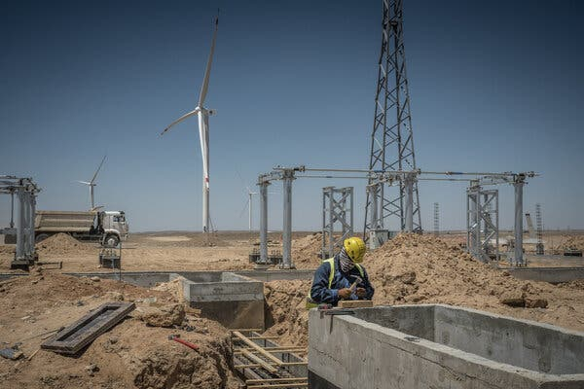

A new wind farm in Uzbekistan.

[](https://www.nytimes.com/by/max-bearak)[](https://www.nytimes.com/by/sergey-ponomarev)

**By**[**Max Bearak**](https://www.nytimes.com/by/max-bearak)

**Photographs by**[**Sergey Ponomarev**](https://www.nytimes.com/by/sergey-ponomarev)

Reporter Max Bearak and photographer Sergey Ponomarev traversed Uzbekistan, from its irrigated heartland to the windswept Kyzylkum desert.

Published Sept. 14, 2023Updated Nov. 29, 2023

**Sign up for the Audio newsletter, for Times subscribers only.**Our editors share their favorite listens from the New York Times Audio app. Get it sent to your inbox.

On a craggy desert plateau in Uzbekistan, a renewable energy company from the United Arab Emirates is putting up more than 100 wind turbines.

**Listen to This Article**

Listen · 12:52 min

And on the other side of this vast, landlocked Central Asian nation, the same company’s owners, Emirati fossil-fuel investors, are pouring billions of dollars into a gas plant expansion.

The Emirates, made wealthy by decades of oil exports, wants to be seen as a climate-friendly renewable energy superpower, even as it helps lock developing nations around the world into decades more fossil fuel use.

Advertisement

[SKIP ADVERTISEMENT](https://www.nytimes.com/2023/09/14/climate/sultan-al-jaber-uae-cop28.html#after-story-ad-1)

Straddling that split is one man: Sultan al Jaber.

He founded the renewable energy company, Masdar, which has invested billions of dollars in zero-emissions energy technologies like wind and solar power across 40 countries. Simultaneously, he directs Adnoc, the national oil company, a behemoth that makes Masdar look minuscule. Adnoc pumps millions of barrels of oil per day and aims to spend $150 billion over the next five years, mostly to ramp up its output.

And this year, the United Nations has in effect vested Mr. al Jaber with one of humanity’s most pressing tasks: steering its annual global climate negotiations, which are set to begin in November in Dubai.

Those increasingly urgent talks are the world’s main forum to address how to limit global warming. The scientific consensus, that preventing runaway climate change must be done largely by bring a rapid end to the fossil fuel era, has made the decision to have Mr. al-Jaber preside over the summit intensely controversial.

In an interview, Mr. al Jaber, 49, said he was the perfect fit for the job.

**Editors’ Picks**

[[](https://www.nytimes.com/2025/06/16/arts/design/pigeon-fest-high-line.html)](https://www.nytimes.com/2025/06/16/arts/design/pigeon-fest-high-line.html)

[Crowning New York’s Top ‘Pigeon’](https://www.nytimes.com/2025/06/16/arts/design/pigeon-fest-high-line.html)

[[](https://www.nytimes.com/2025/06/13/t-magazine/summer-swimsuit-quiz.html)](https://www.nytimes.com/2025/06/13/t-magazine/summer-swimsuit-quiz.html)

[How to Choose the Perfect Swimsuit](https://www.nytimes.com/2025/06/13/t-magazine/summer-swimsuit-quiz.html)

[[](https://www.nytimes.com/2025/06/15/movies/how-to-train-your-dragon-mason-thames-interview.html)](https://www.nytimes.com/2025/06/15/movies/how-to-train-your-dragon-mason-thames-interview.html)

[The ‘How to Train Your Dragon’ Star Mason Thames Is Still Freaking Out](https://www.nytimes.com/2025/06/15/movies/how-to-train-your-dragon-mason-thames-interview.html)

[SKIP ADVERTISEMENT](https://www.nytimes.com/2023/09/14/climate/sultan-al-jaber-uae-cop28.html#after-pp_edpick)

Image



Sultan al Jaber at a climate conference in Brussels this year. He wants oil companies to play a more prominent role in the fight against climate change. Credit...Francois Walschaerts/Agence France-Presse — Getty Images

Over six months of preparation for the summit, known as COP28, Mr. al Jaber said, he has consulted everyone from academicians to financiers to Indigenous leaders to fellow oil executives to understand why past summits have yielded such little progress.

Advertisement

[SKIP ADVERTISEMENT](https://www.nytimes.com/2023/09/14/climate/sultan-al-jaber-uae-cop28.html#after-story-ad-2)

His conclusion was that the fossil fuel industry had little to do with it.

“That was not one of the findings,” he said. Instead, he said, progress was stymied because climate advocates and fossil fuel interests vilified each other. “Why are we fighting industries? Fighting emissions should focus on reducing emissions across the board, whether it’s oil and gas, whether it’s industry, regardless of what it is.”

[Have Climate Questions? Get Answers Here.](https://www.nytimes.com/interactive/2023/climate/climate-change-faq.html)

Advocates for bold climate action have been outraged by his approach, which rests on bringing fossil fuel companies to the table, and which he claims will break that cycle of recrimination. A group of 133 U.S. Senators and European Union lawmakers signed a letter this year calling for him to be replaced.

Multinational fossil fuel companies have a [well-documented track record](https://www.nytimes.com/2021/10/28/climate/oil-executives-house-disinformation-testimony.html) of countering climate science through misinformation and lobbying campaigns, even as now-public internal documents have revealed [they were well aware of the effects of their products](https://www.nytimes.com/2023/01/12/climate/exxon-mobil-global-warming-climate-change.html) on the atmosphere.

Image

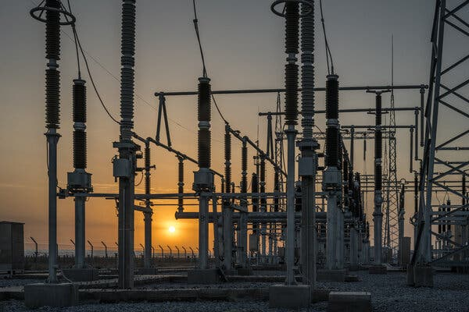

A substation at a Masdar solar installation in Uzbekistan that was built in 2021.

Advertisement

[SKIP ADVERTISEMENT](https://www.nytimes.com/2023/09/14/climate/sultan-al-jaber-uae-cop28.html#after-story-ad-3)

Image

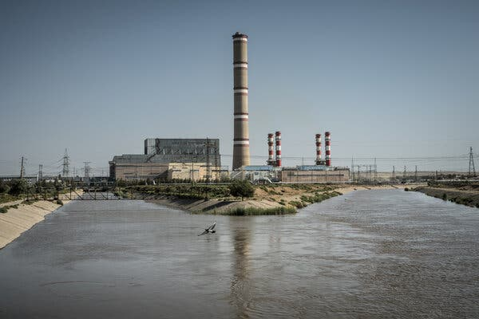

The gas-burning power plant in Talimarjon, Uzbekistan. Emirati investors are financing two more in the area.

At last year’s COP summit, Saudi Arabia, China, Russia and other fossil fuel producing nations blocked language in a final resolution that would have set a timeline for phasing out oil and gas, scuttling an outcome favored by most of the world’s countries. Mr. al-Jaber will be responsible for building a new consensus this year.

Negotiations at recent United Nations climate summits have faltered because countries struggle to agree on how quickly the world can move away from burning fossil fuels, which produce emissions that are warming the planet and making it increasingly dangerous for human habitation. Rich countries have produced the vast majority of greenhouse gas emissions since the beginning of the industrial age.

Mr. al Jaber points to the Emirates as a model for speeding up the change. The Emirates’ leaders, he says, “saw the future that the world was heading toward and wanted to get ahead of it.”

In other words, they predicted the energy transition (fossil fuels are finite, after all) and wanted to make sure they remained an energy powerhouse.

Advertisement

[SKIP ADVERTISEMENT](https://www.nytimes.com/2023/09/14/climate/sultan-al-jaber-uae-cop28.html#after-story-ad-4)

Masdar, which the Emirates’ crown prince helped Mr. al Jaber found in 2006, is now partly owned by Adnoc, as well as by TAQA, the Emirates’ national gas company, and Mubadala, its biggest state-run investment firm. Mr. al Jaber said that Masdar would receive investments of around $35 billion over the next five years, less than a quarter of Adnoc’s $150 billion spending target.

Image

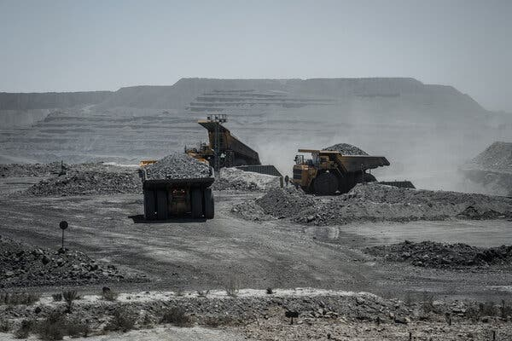

The Muruntau open-pit gold mine in the Navoi region of Uzbekistan is the world’s largest.

Image



Uzbekistan’s population and energy needs are growing rapidly.

In Uzbekistan, TAQA and Mubadala are building two new gas facilities. Other countries in the region are also getting Emirati help to expand fossil fuel energy infrastructure: In Azerbaijan, a recent Adnoc investment in an offshore oil field overshadowed Masdar’s expansion in renewable energy there.

“There is a large consensus that investing billions into new oil and gas projects flies in the face of clear warnings we’ve been getting from the scientific community for many years,” said Scott Zimmerman, who manages a database of oil and gas projects at Global Energy Monitor, a research organization.

Advertisement

[SKIP ADVERTISEMENT](https://www.nytimes.com/2023/09/14/climate/sultan-al-jaber-uae-cop28.html#after-story-ad-5)

The Emirates is not the only country where [companies are announcing new fossil fuel projects](https://www.nytimes.com/2023/04/06/climate/oil-gas-drilling-investment-worldwide-willow.html). But while investments worldwide in solar energy, for instance, have already surpassed those in oil, the Emirates is still a major exporter of fossil fuel projects.

Adnoc’s projected growth will lead to more than 2.7 gigatons of carbon dioxide emissions through their production and burning, [according to a 2022 report](https://priceofoil.org/content/uploads/2022/11/Investing_In_Disaster.pdf) from Oil Change International. That is more than a year of combined emissions from Germany and Japan, and is second only to Qatar’s national energy company, which is building the world’s largest gas facility.

Mr. al Jaber said that he foresees Adnoc’s fossil fuel production expanding “as long as the market demands it,” but that the effects on the globe can be blunted with new technologies that one day may allow them to minimize emissions stemming from the production of oil and gas. That argument for abatement echoes that of world’s largest fossil fuel producers, [including Adnoc](https://www.reuters.com/world/middle-east/uaes-adnoc-proceed-with-habshan-carbon-capture-project-2023-09-06/), which are investing huge sums of money into carbon capture.

Image

<https://www.nytimes.com/2023/09/14/climate/sultan-al-jaber-uae-cop28.html>

#48

***Why Oil Companies Are Walking Back From Green Energy***

As leaders gather for a global climate summit, investors are rewarding oil giants like Exxon Mobil that did not embrace wind and solar.

**Listen to this article · 6:37 min**[Learn more](https://help.nytimes.com/hc/en-us/articles/24318293692180)

* Share full article
* 169

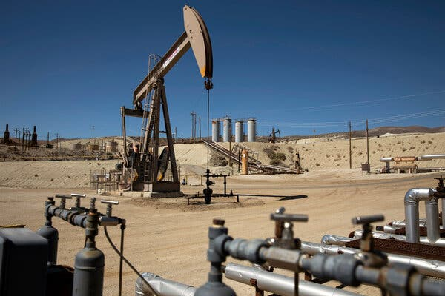

The difference in profits companies can make from extracting oil and gas and what they can earn from harnessing wind and solar has swung sharply in favor of fossil fuels.Credit...Alisha Jucevic for The New York Times

[](https://www.nytimes.com/by/rebecca-f-elliott)

**By**[**Rebecca F. Elliott**](https://www.nytimes.com/by/rebecca-f-elliott)

Reporting from the COP29 climate summit in Baku, Azerbaijan, and New York

Nov. 18, 2024

**The DealBook Newsletter**Our columnist Andrew Ross Sorkin and his Times colleagues help you make sense of major business and policy headlines — and the power-brokers who shape them. Get it sent to your inbox.

When oil and gas companies made ambitious commitments four years ago to curb emissions and transition to renewable energy, their businesses were in free fall.

Demand for the fuels was drying up as the pandemic took hold. Prices plunged. And large Western oil companies were hemorrhaging money, with losses topping $100 billion, according to the energy consulting firm Wood Mackenzie.

Renewable energy, it seemed to many companies and investors at the time, was not just cleaner — it was a better business than oil and gas.

“Investors were focused on what I would say was the prevailing narrative around it’s all moving to wind and solar,” Darren Woods, Exxon Mobil’s chief executive, said in an interview with The New York Times last week at a United Nations climate conference in Baku, Azerbaijan. “I had a lot of pressure to get into the wind and solar business,” he added.

Mr. Woods resisted, reasoning that Exxon did not have expertise in those areas. Instead, the company invested in areas like hydrogen and lithium extraction that are [more akin to its traditional business](https://www.nytimes.com/2024/11/12/business/energy-environment/exxon-mobil-baku-climate-cop29.html).

Wall Street has rewarded the company for those bets. The company’s stock price has climbed more than 70 percent since the end of 2019, lifting its market valuation to a record of nearly $560 billion in October, though it has since fallen to about $524 billion.

The American oil giant’s performance stands in contrast with BP and Shell, oil and gas companies based in London that embraced wind, solar and other technologies like electric-vehicle charging. BP’s stock has fallen around 19 percent in that time, based on trading in London, while Shell’s has climbed about 15 percent.

The market’s renewed acceptance of fossil fuels underscores one of the core challenges of curbing global emissions: Climate change poses risks that compound over decades. Scientists say every fraction of a degree of warming caused by fossil fuels brings greater risks from deadly heat waves, wildfires, drought, storms and species extinction. But investors are focused on making money over months and years.

“If we want to combat climate change, we need to make it in the firms’ and consumers’ self-interest to produce and buy the low-carbon alternatives,” said Christopher Knittel, a professor of energy economics at the Massachusetts Institute of Technology.

**Editors’ Picks**

[[](https://www.nytimes.com/2025/06/16/arts/design/pigeon-fest-high-line.html)](https://www.nytimes.com/2025/06/16/arts/design/pigeon-fest-high-line.html)

[Crowning New York’s Top ‘Pigeon’](https://www.nytimes.com/2025/06/16/arts/design/pigeon-fest-high-line.html)

[[](https://www.nytimes.com/2025/06/13/t-magazine/summer-swimsuit-quiz.html)](https://www.nytimes.com/2025/06/13/t-magazine/summer-swimsuit-quiz.html)

[How to Choose the Perfect Swimsuit](https://www.nytimes.com/2025/06/13/t-magazine/summer-swimsuit-quiz.html)

[[](https://www.nytimes.com/2025/06/15/movies/how-to-train-your-dragon-mason-thames-interview.html)](https://www.nytimes.com/2025/06/15/movies/how-to-train-your-dragon-mason-thames-interview.html)

[The ‘How to Train Your Dragon’ Star Mason Thames Is Still Freaking Out](https://www.nytimes.com/2025/06/15/movies/how-to-train-your-dragon-mason-thames-interview.html)

The election of Donald J. Trump, who has [falsely described global warming as a hoax](https://www.nytimes.com/2024/11/08/climate/elon-musk-trump-tesla.html), has led to even greater optimism about the oil and gas business.

The difference in profits that companies can make from extracting oil and gas and what they can earn from harnessing wind and solar had already swung sharply in favor of fossil fuels in recent years.

The median return on capital among some of the world’s biggest investor-owned oil companies, a key measure of profitability, topped 11 percent last year, up from negative 8 percent in 2020, according to an analysis by S&P Global Commodity Insights. The median return over that same period for the top renewable energy companies has stayed around 2 percent.

**Where the Money Is for Energy Companies**

Investors pushed oil and gas companies toward renewable energy around the pandemic. But Wall Street changed its tune when oil and gas profits rebounded.

**Median return on invested capital by year for:**

Notes: The group of renewables developers and owners only includes those valued above $1 billion. The group of oil and gas producers includes seven integrated, investor-owned companies.

Source: S&P Global Commodity Insights

By The New York Times

“If you look at the relative shareholder returns, the market’s been sending a very clear signal that it wants energy companies to focus on their core competencies,” said Mark Viviano, a managing partner at Kimmeridge, an energy investment firm based in Denver and New York. “That doesn’t mean abandoning the energy transition, but it just means being more pragmatic about it.”

BP [pledged in 2020](https://www.nytimes.com/2020/08/04/business/energy-environment/bp-renewable-investment.html) to cut its oil and gas production 40 percent by the end of the decade. Less than three years later, it [backtracked](https://www.nytimes.com/2023/02/07/business/bp-oil-gas-profits.html) and said it would increase spending on fossil fuels. The company [wrote off $1.1 billion](https://www.nytimes.com/2024/02/06/business/bp-oil-gas-profits.html) in offshore wind investments last year and recently said it wanted to sell other wind assets, though it continues to invest in renewable energy.

Behind the Journalism

**Our business coverage.** Times journalists are not allowed to have any direct financial stake in companies they cover.

[Here’s more on our standards and practices.](https://www.nytimes.com/editorial-standards/ethical-journalism.html#investmentsAndFinancialTies)

“We will be very, very returns-focused, making sure that the new businesses compete on a competitive level with the historic businesses for scarce capital,” the company’s chief executive, Murray Auchincloss, told financial analysts on a recent conference call.

Shell has softened or discarded some of its emissions-reduction targets, as it scaled back growth expectations for its renewable power business.

“We do not see ourselves as being advantaged in renewable generation to create material returns over others,” Wael Sawan, Shell’s chief executive, told analysts recently. “And so you do see us stepping back.”

In the United States, where [environmentally conscious investing](https://www.nytimes.com/2023/02/28/climate/esg-climate-backlash.html) has become increasingly politicized, investors have gone from regularly quizzing oil and gas executives about their energy transition plans to zeroing in on projects that are more likely to lift the bottom line soon, executives said.

“Some people jumped the gun and moved toward some paths that ultimately turned out to be, I’d say, devastating to their bottom line,” Toby Rice, the chief executive of a Pittsburgh natural gas producer, EQT, said in an interview. “They’ve now come back to center.”

That said, the oil and gas business is subject to wild price swings that can quickly make fortunes and dash them just as rapidly. Before the Covid-19 pandemic, investors turned away from domestic producers after sustaining bruising losses as the companies chased production growth. Renewable energy tends to be a far steadier business.

Investors still widely expect oil and gas companies to curb their emissions by, among other things, plugging leaks of methane, a potent greenhouse gas. And around the world, nearly twice as much money is being invested in clean energy as in fossil fuels, according to the International Energy Agency, a Paris-based organization whose members include the United States and other industrialized countries.

“The end goal here I think is still widely endorsed,” said Dan Pickering, chief investment officer at Pickering Energy Partners, an investment firm based in Houston. “We’re oscillating around an upward slope.”

Next year may pose a test for oil companies and their shareholders.

U.S. crude prices have slipped below $70 a barrel, from around $78 last year, squeezing corporate profits. Next year, global production is likely to be more than one million barrels a day higher than demand, the I.E.A. said last week.

“Let’s see how these companies do if the price of oil goes back down,” said Amy Myers Jaffe, director of the Energy, Climate Justice and Sustainability Lab at New York University.

<https://www.nytimes.com/2024/11/18/business/energy-environment/cop-oil-gas-green-energy.html>

#49

***Hungry for Clean Energy, Facebook Looks to a New Type of Geothermal***

As electricity demand from data centers soars, Meta and Google are looking at a novel solution: harnessing clean heat far below Earth’s surface.

**Listen to this article · 5:27 min**[Learn more](https://help.nytimes.com/hc/en-us/articles/24318293692180)

* Share full article
* 136

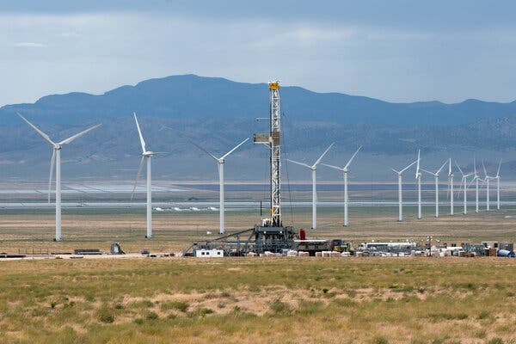

A Fervo Energy geothermal site near Milford, Utah, last year. Meta has announced a similar project with a Sage Geosystems in Texas.Credit...Brandon Thibodeaux for The New York Times

[](https://www.nytimes.com/by/brad-plumer)

**By**[**Brad Plumer**](https://www.nytimes.com/by/brad-plumer)

Aug. 26, 2024

Big tech companies across the United States are struggling to find enough clean energy to power [all the data centers](https://www.nytimes.com/interactive/2024/03/13/climate/electric-power-climate-change.html) they plan to build.

Now, some firms are betting on a novel solution: harvesting the heat deep beneath the Earth’s surface to create emissions-free electricity, using drilling techniques from the oil and gas fracking boom.

On Monday, Meta, the company that owns Facebook, announced an agreement with a start-up called [Sage Geosystems](https://www.sagegeosystems.com/) to develop up to 150 megawatts of an advanced type of geothermal energy that would help power the tech giant’s expanding array of data centers. That is roughly enough electricity to power 70,000 homes.

Sage will use fracking techniques similar to those that have helped extract vast amounts of oil and gas from shale rock. But rather than drill for fossil fuels, Sage plans to create fractures thousands of feet beneath the surface and pump water into them. The heat and pressure underground should heat the water to the point where it can be used to generate electricity in a turbine, all without the greenhouse gases that are causing global warming.

“It’s basically the same fracking technology,” said Cindy Taff, an oil industry veteran who worked at Shell for 36 years before becoming Sage’s chief executive. “The difference is that we’re going after clean heat instead of hydrocarbons” such as oil and gas.

Sage [has already drilled a test well](https://www.sagegeosystems.com/press-release-sage-geosystems-landmark-full-scale-commercial-pilot/) in South Texas to demonstrate its approach. The startup now aims to build its first large-scale power plant at a yet-to-be-determined location east of the Rocky Mountains, with the first phase coming online by 2027.

The deal is the latest sign of growing excitement for [new types of geothermal power](https://www.nytimes.com/2023/08/28/climate/geothermal-energy-projects.html) that could provide enormous amounts of emissions-free electricity around the clock and complement more variable sources like wind and solar power.

Google has partnered with Fervo Energy, a prominent geothermal start-up, to build [a 5-megawatt pilot plant](https://fervoenergy.com/fervos-year-in-review/) in Nevada that has already begun supplying power to the grid. The two companies [recently reached a deal](https://blog.google/outreach-initiatives/sustainability/google-clean-energy-partnership/) to supply much more geothermal power in the years ahead to Google’s data centers.

Fervo is also building a 400-megawatt plant in Utah [that will sell electricity to utilities in Southern California](https://fervoenergy.com/fervo-energy-announces-320-mw-power-purchase-agreements-with-southern-california-edison/) and is expected to come online starting in 2026.

**Editors’ Picks**

[[](https://www.nytimes.com/2025/06/16/arts/design/pigeon-fest-high-line.html)](https://www.nytimes.com/2025/06/16/arts/design/pigeon-fest-high-line.html)

[Crowning New York’s Top ‘Pigeon’](https://www.nytimes.com/2025/06/16/arts/design/pigeon-fest-high-line.html)

[[](https://www.nytimes.com/2025/06/13/t-magazine/summer-swimsuit-quiz.html)](https://www.nytimes.com/2025/06/13/t-magazine/summer-swimsuit-quiz.html)

[How to Choose the Perfect Swimsuit](https://www.nytimes.com/2025/06/13/t-magazine/summer-swimsuit-quiz.html)

[[](https://www.nytimes.com/2025/06/15/movies/how-to-train-your-dragon-mason-thames-interview.html)](https://www.nytimes.com/2025/06/15/movies/how-to-train-your-dragon-mason-thames-interview.html)

[The ‘How to Train Your Dragon’ Star Mason Thames Is Still Freaking Out](https://www.nytimes.com/2025/06/15/movies/how-to-train-your-dragon-mason-thames-interview.html)

Tech firms are facing an urgent need for more electricity, as growing interest in artificial intelligence has triggered a data center boom. By one estimate, data centers [could consume 9 percent of U.S. electricity by 2030](https://www.epri.com/about/media-resources/press-release/q5vU86fr8TKxATfX8IHf1U48Vw4r1DZF#:~:text=EPRI%20Study%3A%20Data%20Centers%20Could,U.S.%20Electricity%20Generation%20by%202030&text=PALO%20ALTO%2C%20Calif.,the%20data%20centers%20processing%20AI.), up from 4 percent today.

[[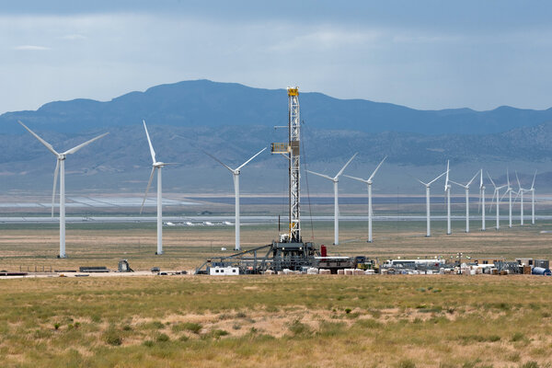](https://www.nytimes.com/2023/08/28/climate/geothermal-energy-projects.html)](https://www.nytimes.com/2023/08/28/climate/geothermal-energy-projects.html)

**[There’s a Vast Source of Clean Energy Beneath Our Feet. And a Race to Tap It.](https://www.nytimes.com/2023/08/28/climate/geothermal-energy-projects.html)**

[The United States has enough geothermal energy to power the entire country. Some are trying to unlock it by using techniques from the fracking boom.](https://www.nytimes.com/2023/08/28/climate/geothermal-energy-projects.html)

[Aug. 28, 2023](https://www.nytimes.com/2023/08/28/climate/geothermal-energy-projects.html)

Data centers typically need power 24 hours a day, which wind turbines and solar panels alone can’t provide. At the same time, many technology companies have promised to reduce their planet-warming emissions and face pressure not to rely on fossil fuels like coal or gas. So they are exploring technologies that can run around the clock, like nuclear power or enhanced geothermal.

“We’re going to need every tool in the arsenal,” said Michelle Solomon, a senior policy analyst at Energy Innovation, a nonprofit organization. “In the near term, enhanced geothermal might play a relatively small role, but I feel very optimistic about where the technology is going.”

Geothermal power has been around for decades. But traditionally, geothermal plants were limited to places where companies could easily tap underground hot water reservoirs close to the surface. Only a few locations have the right geology for this, such as parts of California or Iceland, which is why geothermal currently provides just 0.4 percent of America’s electricity.

But everywhere on Earth contains enormous amounts of underground heat if one can drill down far enough, and dozens of startups [are exploring techniques](https://www.nytimes.com/2023/08/28/climate/geothermal-energy-projects.html) to unlock that heat in new locations. Although it can be expensive to drill thousands of feet deep into hot, dry rock, those costs are falling as companies gain experience. In February, Fervo said it had already [reduced drilling times](https://fervoenergy.com/fervo-energy-drilling-results-show-rapid-advancement-of-geothermal-performance/) by up to 70 percent in just one year.

“We’re already way ahead of where people expected us to be, and we’re expecting more dramatic cost reductions in the future,” said Tim Latimer, Fervo’s chief executive.

The Energy Department estimates that geothermal could provide 90,000 megawatts of U.S. electric capacity by 2050 if technologies keep improving, a twentyfold increase from today.

“Geothermal has such enormous potential,” Energy Secretary Jennifer Granholm said in March.

Still, next-generation geothermal gets significantly less federal funding than other technologies like hydrogen fuels or nuclear power, in part because it has only recently emerged as a promising energy source. That means support from climate-conscious tech companies could be crucial as geothermal start-ups navigate the risks of getting early projects built.

Urvi Parekh, head of renewable energy at Meta, said the company wanted to signal ahead of time that it intended to buy electricity from Sage so that the start-up could raise funding and begin lining up equipment. “There’s a tremendous value to us making that commitment today,” Ms. Parekh said. “That way they can take the steps necessary to get that project that we want to see on the electricity grids.”

<https://www.nytimes.com/2024/08/26/climate/meta-facebook-geothermal-fracking-energy.html>

#50

Solar Farms Have a Superpower Beyond Clean Energy

The sites fight climate change and can help with another global crisis: the collapse of nature. But so far, efforts to nurture wildlife habitat have been spotty.

A solar farm in Ramsey, Minn., landscaped with native plants that support pollinators, and, by extension, myriad other species.Credit...Tim Gruber for The New York Times

**Listen to this article · 13:55 min**[Learn more](https://help.nytimes.com/hc/en-us/articles/24318293692180)

* Share full article
* **270**

[](https://www.nytimes.com/by/catrin-einhorn)

**By**[**Catrin Einhorn**](https://www.nytimes.com/by/catrin-einhorn)

Catrin Einhorn visited seven solar sites in California and Minnesota for this article.

* Published Sept. 5, 2024Updated Sept. 6, 2024

It’s not your average solar farm.

The glassy panels stand in a meadow. Wildflowers sway in the breeze, bursts of purple, pink, yellow, orange and white among native grasses. A monarch butterfly flits from one blossom to the next. Dragonflies zip, bees hum and goldfinches trill.

As solar projects unfurl across the United States, sites like this one in Ramsey, Minn., stand out because they offer a way to fight climate change while also tackling another ecological crisis: a global biodiversity collapse, driven in large part by habitat loss.

The sun’s clean energy is a powerful weapon in the battle against climate change. But the sites that capture that energy take up land that wildlife needs to survive and thrive. Solar farms could blanket millions of acres in the United States over the coming decades.

So developers, operators, biologists and environmentalists are teaming up with an innovative strategy.

“We have to address both challenges at the same exact time,” said Rebecca Hernandez, a professor of ecology at the University of California, Davis, whose research focuses on how to do just that.

Insects, those small animals that play a mighty role in supporting life on Earth, [are facing alarming declines](https://www.pnas.org/doi/full/10.1073/pnas.2023989118). Solar farms can offer them food and shelter by providing a diverse mix of native plants.

Such plants can also decrease erosion, nourish the soil and store planet-warming carbon. They can also attract insects that improve pollination of nearby crops.

Image

Rebecca Hernandez, a professor of ecology at the University of California, Davis, whose research focuses on preventing habitat loss in the transition to renewable energy.Credit...Loren Elliott for The New York Times

Image

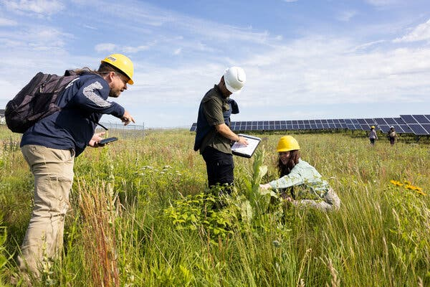

Lee Walston, a landscape ecologist, left, with students during a plant survey at the Ramsey site.Credit...Tim Gruber for The New York Times

Pollinator friendly solar can pay off for business, too, potentially saving money and giving projects an edge for approval at a time when communities are increasingly wary of vast solar farms. Developers are taking note.

But there’s a broad spectrum of pollinator friendliness and little agreement on what efforts should count. Standards are often nonexistent. Some big projects are limiting pollinator habitat to tiny corners of their sites. Ecological value varies widely.

Communities may not understand the difference, and corporate marketing may exaggerate. That’s led to accusations of greenwashing.

Pollinator habitat on solar farms is “a serious work in progress,” said Scott Black, executive director of the Xerces Society for Invertebrate Conservation, a nonprofit group that is working on an effort to bring some clarity by certifying solar sites.

“It’s not fair if some people are truly stepping up to do this right and another company is barely doing anything and saying they’re pollinator friendly,” he said.

Image



‘If you build it, will they come?’

Image



A study published last year found that insect abundance had tripled over five years on test plots at two Minnesota solar sites.Credit...Tim Gruber for The New York Times

On a recent morning at the solar meadow in Ramsey, it was time to count insects.

Among the rows of panels at the 18-acre site, Lee Walston, a landscape ecologist at Argonne National Laboratory, found the plastic flags marking one of his research tracts. He set off with two students through plants that brushed above their knees, eyes scanning below.

“There’s a sweat bee,” Mr. Walston said, pointing to a bee that glistened metallic green.

“I’ve got a moth and two hoverflies,” one of the students said. The other recorded observations.

In solar pollinator habitat, Minnesota was an early leader among states. Since 2017, funded by the Department of Energy, Mr. Walston has been studying sites there and throughout the Midwest.

“If you build it, will they come?” he asks in his research. So far the answer is a resounding yes, if you grow the right plants.

In a [study published late last year](https://iopscience.iop.org/article/10.1088/1748-9326/ad0f72#erlad0f72s3), his team found that insect abundance had tripled over five years on test plots at two other Minnesota solar sites. The abundance of native bees grew twentyfold.

Image

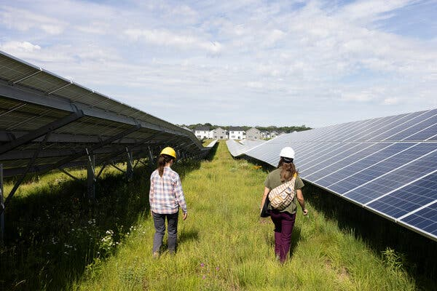

Researchers at the Ramsey site. Higher arrays let developers use plants that otherwise would shade the panels. Credit...Tim Gruber for The New York Times

Image



Native plants attract a range of pollinators.Credit...Tim Gruber for The New York Times

The results come amid a [global decline of wildlife](https://www.nytimes.com/2019/05/06/climate/humans-are-speeding-extinction-and-altering-the-natural-world-at-an-unprecedented-pace.html) that leaders are struggling to address. Some of the most well-known insect species are in trouble: Later this year, the federal government is expected to rule on whether to place monarch butterflies on the Endangered Species List. North American birds, for their part, are [down almost 30 percent since 1970](https://www.science.org/doi/10.1126/science.aaw1313).

But at this site, called Anoka County Solar, acoustic monitoring has documented 73 species of birds, presumably attracted by the buffet of seeds and insects. Some build nests in the structures supporting the panels.

**Wild Places, Clean Energy**

Read the first article in this series

[The Planet Needs Solar Power. Can We Build It Without Harming Nature?](https://www.nytimes.com/interactive/2024/02/11/climate/climate-change-wildlife-solar.html)

Mammals are showing up, too. Mr. Walston checked a trail camera before leaving, hoping to discover the occupant of a remarkably large burrow: A fox, he thought, or a badger. No luck.

(It’s trickier to make solar sites friendly to large wild animals, in part because developers are nervous to let them near expensive infrastructure, but [efforts are underway there](https://www.nytimes.com/interactive/2024/02/11/climate/climate-change-wildlife-solar.html), too.)

What makes this meadow possible is the height of the panels. A prairie restoration firm had told ENGIE, the owner and developer, that taller panels would allow for a sharp increase in native vegetation species, providing much more ecological diversity, said John Gantner, the director of engineering and delivery for ENGIE’s smaller-scale sites.

Image



A monarch butterfly at the site in Ramsey, Minn.Credit...Tim Gruber for The New York Times

Image



A nest under one of the site’s panels.Credit...Tim Gruber for The New York Times

The price of the additional steel and the native seeds were “insignificant to the overall project cost,” Mr. Gantner said. Over the life of the project, ENGIE has found, pollinator friendly landscaping actually saves money because it needs far less mowing.

“We’ve calculated and ran the numbers and there’s significant savings,” Mr. Gantner said.

But many other projects, especially big utility-scale sites, avoid the taller panels. Margins are razor tight, developers say, and the higher costs up front feel too risky or even insurmountable.

That limits the options for landscapers.

“When I sit down and do a utility-scale solar project seed mixture, and I look in my toolbox, it’s like I have a rusty screwdriver and a roll of duct tape,” said Peter Berthelsen, a wildlife biologist who runs a company that specializes in creating habitat for solar projects.

So he scours his sites for any patch of land that doesn’t have panels. In those areas, which he said often encompass 10 or 20 percent of a given site, he plants a native pollinator mix of at least 40 species.

Editors’ Picks

[[](https://www.nytimes.com/2025/06/16/arts/design/pigeon-fest-high-line.html)](https://www.nytimes.com/2025/06/16/arts/design/pigeon-fest-high-line.html)

[Crowning New York’s Top ‘Pigeon’](https://www.nytimes.com/2025/06/16/arts/design/pigeon-fest-high-line.html)

[[](https://www.nytimes.com/2025/06/13/t-magazine/summer-swimsuit-quiz.html)](https://www.nytimes.com/2025/06/13/t-magazine/summer-swimsuit-quiz.html)

[How to Choose the Perfect Swimsuit](https://www.nytimes.com/2025/06/13/t-magazine/summer-swimsuit-quiz.html)

[[](https://www.nytimes.com/2025/06/15/movies/how-to-train-your-dragon-mason-thames-interview.html)](https://www.nytimes.com/2025/06/15/movies/how-to-train-your-dragon-mason-thames-interview.html)

[The ‘How to Train Your Dragon’ Star Mason Thames Is Still Freaking Out](https://www.nytimes.com/2025/06/15/movies/how-to-train-your-dragon-mason-thames-interview.html)

Image

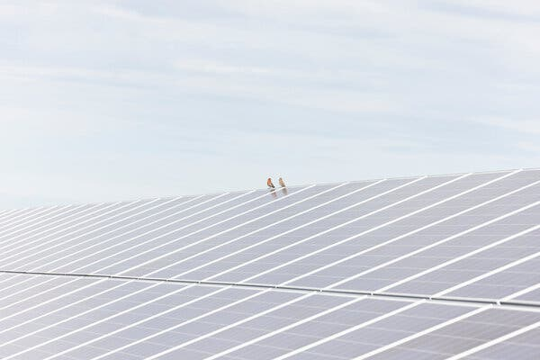

House finches on a solar panel at the site in Ramsey, Minn.Credit...Tim Gruber for The New York Times

Under the panels, he and others often turn to Dutch white clover. While that provides some nectar for native insects like bumblebees, it’s considered better forage for honeybees, an introduced agricultural species. (Honeybees pollinate plants and make a delicious food for people, but ecologists generally don’t view them as wildlife in need of conservation.)

The more plant diversity allowed under the panels, Mr. Berthelsen said, the more environmental benefits will follow. Still, he cautioned, it’s important to “not let the pursuit of perfect be the enemy of doing something good.”

In measuring ecological value, the starting point is fundamental, scientists say. Replacing a field of row crops with solar panels and clover would provide a net benefit for pollinators, even without a mix of native species. On the other hand, no amount of high-quality seeding will match the ecological value of an intact ecosystem, especially in places where solar panels would require the removal of trees or shrubs.

Nationwide, it’s unclear what portion of solar farms include any kind of pollinator habitat. The [federal project that Mr. Walston is part of](https://openei.org/wiki/InSPIRE) has a running rough count of just under 24,000 acres. That’s compared with about 600,000 acres of currently operating large-scale sites across the country, according to the Solar Energy Industries Association, with a sharp increase expected over the next couple decades.

Then there’s the question of developers delivering on their commitments.

Image



‘Not enough plants here’

Four years ago, a project was in development outside Sacramento. Described as “a pollinator friendly solar farm,” even its name signaled ecological beauty: Wildflower Solar. “Fostering biodiversity and boosting crop yields for the community,” a brochure read.

One aspect of the project, developed by Lightsource BP, which is co-owned by the oil and gas giant, raised questions from the beginning: Diverse pollinator vegetation was restricted to a garden on roughly 1.5 acres of the 67 acre site in an area underneath transmission lines.

Throughout the panels, the company said it would use a seed mix of five native grasses and a smaller amount of native clover. That’s better than turfgrass, scientists say, but it doesn’t come close to the benefits from a more diverse assemblage. At the time, Lightsource BP [defended its decision](https://insideclimatenews.org/news/28112020/pollinator-friendly-solar-greenwashing-risk/) to a reporter for Inside Climate News, claiming that the entire site would be pollinator friendly.

Dr. Hernandez of U.C. Davis wished the project was going further. But she was pleased about one thing: a pledge to plant more than 200 native trees and shrubs along the perimeter, on the edge of a rural neighborhood. The plantings would not only create a more attractive view for the community, but also a corridor of habitat for wildlife.

But when she drove by last year, Dr. Hernandez said, she didn’t see any plantings.

In May, Dr. Hernandez accompanied me to Wildflower. The 200 trees and shrubs, promised both in planning documents submitted to the county and in marketing materials, were nowhere to be seen. Instead, the area was overgrown with invasive grasses and noxious weeds like yellow star thistle, which the state has spent millions trying to eradicate. After tromping through shoulder-high, dried-out vegetation, we found the remnants of a few plantings underneath.

Image

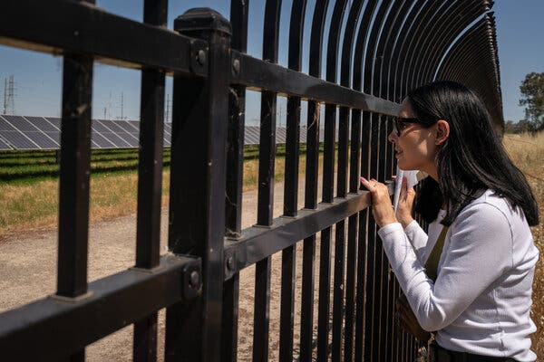

Dr. Hernandez visited the Wildflower Solar site in Rio Linda, Calif. Credit...Loren Elliott for The New York Times

Image



Toyon, a perennial shrub, amid nonnative wild oats at the edge of the Wildflower Solar site.Credit...Loren Elliott for The New York Times

“There’s not enough plants here,” Dr. Hernandez said. “And there’s no vegetation management.”

In an interview and follow-up emails, representatives of Lightsource BP said the trees and shrubs had been planted around fall 2020 and blamed droughts for their demise. They said they had instructed their landscaping contractor “to solicit replacement plantings and a robust, multiyear care plan for the landscaping trees and shrubs.” They did not say why the problems had not been addressed earlier.

Alyssa Edwards, who leads environmental affairs and governmental relations for Lightsource BP, said the company was a leader in the industry when it came to biodiversity.

“It really is in our ethos, and it’s embedded into the way we develop, construct and operate projects,” Ms. Edwards said. The company’s Facebook page regularly posts about its commitment to biodiversity. But she was clear: “We do not raise our panels to accommodate pollinators.”

At least 15 states have some kind of pollinator scorecard, meant to guard against greenwashing by awarding points for various ecologically valuable features. States do not require certification, but in many cases a project must achieve a certain score to declare itself pollinator friendly.

Image

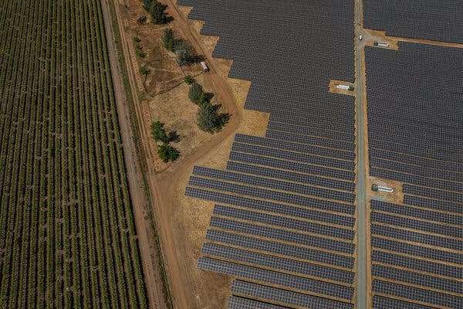

The Rancho Seco Solar II site near Herald, Calif. Operators had to take endangered salamanders into account. Credit...Loren Elliott for The New York Times

But the scorecards have been criticized as both too weak and too stringent. On one hand, they typically lack a mechanism for monitoring, simply relying on a company’s promises. On the other, developers say some of the standards are not feasible given realities on the ground. When some local governments started mandating use of the scorecards, some in the industry pushed back, saying it could have a chilling effect on solar development.

A new nongovernmental certification is in the works, a partnership between the Electric Power Research Institute, an industry-funded research group, and the Xerces Society. But the effort has proceeded slowly as partners try to find compromise between the needs of the solar industry and the needs of nature. The current draft would require 15 percent of vegetated areas on the site to include a diverse mix of native, pollinator friendly vegetation.

“On one side, we want to protect biodiversity and pollinators. On the other side, we need the most efficient way to get kilowatt hours to customers, to power at the plug,” said Jessica Fox, a conservation biologist with the electric power institute. “So we’re doing this work now to find where is a middle space.”

Among the challenges developers face: Higher upfront costs are no guarantee of greater savings. Landscapers with the right experience can be hard to find, as can native seeds.

Image

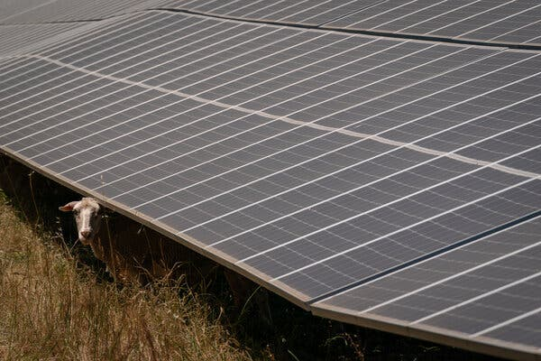

At the Rancho Seco Solar II site. Sheep are sometimes used instead of mowing at solar farms.Credit...Loren Elliott for The New York Times

Image



A local resident at the Rancho Seco Solar II site.Credit...Loren Elliott for The New York Times

Not every site is even appropriate for pollinator habitat, Ms. Fox noted. And even when they are, each has its own distinct characteristics. Climate, topography, soil type and other factors all change the palette of possibilities. For example, not far from Wildflower, at a site called Rancho Seco Solar II, the presence of endangered salamanders made it difficult for scientists to prepare the soil before planting a research plot with three native seed mixes.

The site’s owner, the Sacramento Municipal Utility District, sees more promise in creating a hedgerow of more than 300 native shrubs and perennials along the perimeter of the site, which can increase habitat connectivity without complicating matters with the solar panels.

Given the urgency to tackle both global warming and biodiversity loss, solar sites should be experimenting with promising solutions, scientists say.

“We’re in this infancy, the infancy of trying to make this work and to do better,” Dr. Hernandez said. “And we need to get there faster.”

<https://www.nytimes.com/2024/09/05/climate/solar-power-pollinators-wildlife.html>

#51

***Can Fusion Solve the Climate Crisis?***

Scientists made a huge breakthrough on the road to emissions-free power. Here’s what that means, and doesn’t mean.

* Share full article



An illustration of lasers focused on a target pellet. Credit...The National Ignition Facility at the Lawrence Livermore National Laboratory, via Associated Press

**By**[**Henry Fountain**](https://www.nytimes.com/by/henry-fountain)

Dec. 13, 2022

**You’re reading the Climate Forward newsletter, for Times subscribers only.**News and insights for a warming world. Get it with a Times subscription.

The news this week that scientists had achieved a breakthrough in fusion technology was hailed as a milestone on the path toward a future of nearly limitless, emissions-free power.

But if you think that means the days of burning fossil fuels for electricity will soon be over, enabling the world to more easily meet the goal of limiting warming this century, you may end up being disappointed.

The breakthrough is a huge step toward a long-held dream, one that has captured the world’s collective imagination: The ability to mimic the way the sun generates the energy that sustains life on Earth, and to control that process for the good of humankind.

The achievement, at Lawrence Livermore National Laboratory in California, “will go down in the history books,” said Energy Secretary Jennifer M. Granholm at a news conference Tuesday.

Advertisement

[SKIP ADVERTISEMENT](https://www.nytimes.com/2022/12/13/climate/fusion-climate-change.html#after-story-ad-1)

**A remarkable achievement**

As my colleague Ken Chang wrote, scientists working on [a mammoth experiment](https://www.nytimes.com/2022/12/12/science/nuclear-fusion-energy-breakthrough.html) at Livermore, in which lasers are used to fuse two forms of hydrogen into helium, reported that, for the first time, it had released more energy than the lasers put in.

That’s a big deal. Scientists around the world have been trying to develop controllable fusion (as opposed to the out-of-control fusion of a hydrogen bomb) for the better part of a century. While there have been many advances, a fundamental stumbling block remained. Fusion requires so much power, with temperatures of millions of degrees needed for it to occur, that none of the experiments produced a net gain of energy.

That hurdle is now out of the way, at least for this kind of laser-instigated fusion. That makes it easier to envision a future of fusion power plants that would produce essentially no planet-warming carbon dioxide or other greenhouse gases. They would also have advantages over current nuclear plants that split, rather than fuse, atoms, because the fuel needed for fusion is more readily available and the radioactive waste produced is far less dangerous and problematic.

**… but huge hurdles remain**

An experiment like the one at Livermore, in which one tiny pellet was vaporized by 192 laser beams, is one thing, but a power plant that rapidly vaporizes thousands upon thousands of pellets and safely draws off the released energy for conversion into electricity is quite another. That’s not to say it can’t be done, it will just take time. Lots of time.

The same goes for the other major approach to developing fusion, which uses huge, powerful electromagnets to confine a cloud of hydrogen gas stripped of its electrons, raising temperatures to the point where fusion can occur. This is the so-called tokamak approach (taken from a Russian acronym for the doughnut-like chamber that contains the gas cloud).

**Editors’ Picks**

[[](https://www.nytimes.com/2025/06/16/arts/design/pigeon-fest-high-line.html)](https://www.nytimes.com/2025/06/16/arts/design/pigeon-fest-high-line.html)

[Crowning New York’s Top ‘Pigeon’](https://www.nytimes.com/2025/06/16/arts/design/pigeon-fest-high-line.html)

[[](https://www.nytimes.com/2025/06/13/t-magazine/summer-swimsuit-quiz.html)](https://www.nytimes.com/2025/06/13/t-magazine/summer-swimsuit-quiz.html)

[How to Choose the Perfect Swimsuit](https://www.nytimes.com/2025/06/13/t-magazine/summer-swimsuit-quiz.html)

[[](https://www.nytimes.com/2025/06/15/movies/how-to-train-your-dragon-mason-thames-interview.html)](https://www.nytimes.com/2025/06/15/movies/how-to-train-your-dragon-mason-thames-interview.html)

[The ‘How to Train Your Dragon’ Star Mason Thames Is Still Freaking Out](https://www.nytimes.com/2025/06/15/movies/how-to-train-your-dragon-mason-thames-interview.html)

[SKIP ADVERTISEMENT](https://www.nytimes.com/2022/12/13/climate/fusion-climate-change.html#after-pp_edpick)

Advertisement

[SKIP ADVERTISEMENT](https://www.nytimes.com/2022/12/13/climate/fusion-climate-change.html#after-story-ad-2)

In 2017, [I visited the largest tokamak project](https://www.nytimes.com/2017/03/27/science/fusion-power-plant-iter-france.html), ITER, in southern France. It’s a mind-bogglingly complex machine, a multinational effort being assembled from parts produced in many countries. The project was first envisioned in the 1980s; the hope is that it will produce fusion by the mid-2030s.

But ITER, like the Livermore project, is only an experiment. Even if ITER works, designing and building a plant that captures the energy from a tokamak and converts it to electricity is most likely very far-off.

And the world needs to sharply cut emissions soon. To limit warming to 1.5 degrees Celsius above 19th-century levels, the stricter of two limits that came out of the 2015 Paris climate talks, emissions need to reach nearly zero by 2050.

So even if fusion power plants become a reality, it likely would not happen in time to help stave off the near-term worsening effects of climate change. It’s far better, many climate scientists and policymakers say, to focus on currently available renewable energy technologies like solar and wind power to help reach these emissions targets.

**When could the power start to flow?**

So if fusion isn’t a quick climate fix, could it be a more long-term solution to the world’s energy needs? Perhaps, but cost may be an issue. The National Ignition Facility at Livermore, where the experiment was conducted, was built for $3.5 billion. ITER’s price tag, so far, is more than $20 billion. It’s unclear whether the world could afford any fusion power plants that resulted from these two projects.

Advertisement

[SKIP ADVERTISEMENT](https://www.nytimes.com/2022/12/13/climate/fusion-climate-change.html#after-story-ad-3)

In recent years there has been a proliferation of private, smaller efforts at developing fusion power, some using alternative approaches. More than 30 companies are working on the technology, about two-thirds of them in the United States, according to the Fusion Industry Association, a trade group. Together they have received nearly $5 billion in private investment.

Of these efforts, Commonwealth Fusion, a company spun off from the Massachusetts Institute of Technology, is among the most advanced. [As I wrote in 2020](https://www.nytimes.com/2020/09/29/climate/nuclear-fusion-reactor.html), a series of peer-reviewed studies showed that the approach, a much more compact tokamak than ITER that makes use of advances in electromagnet technology, could work.

The company has raised nearly $2 billion, has begun construction of a test reactor outside of Boston, and is developing plans for a fusion power plant as well.

The Fusion Industry Association says that most of the companies involved in these smaller efforts predict that fusion will provide electricity to the grid sometime in the 2030s. That may be an aspirational, rather than realistic, goal. But if fusion power is to become commercially viable and a clean-energy alternative, perhaps it will be through one or more of these efforts.

<https://www.nytimes.com/2022/12/13/climate/fusion-climate-change.html>

#52

***Dilemma on Wall Street: Short-Term Gain or Climate Benefit?***

Portfolio managers have conflicting incentives as the economic and financial risks from climate change become more apparent but remain imprecise.

Credit...Edmon de Haro

**Listen to this article · 9:30 min**[Learn more](https://help.nytimes.com/hc/en-us/articles/24318293692180)

* Share full article
* 87

[](https://www.nytimes.com/by/lydia-depillis)

**By**[**Lydia DePillis**](https://www.nytimes.com/by/lydia-depillis)

* June 20, 2024

[Leer en español](https://www.nytimes.com/es/2024/06/24/espanol/wall-street-cambio-climatico.html)

A team of economists recently [analyzed](https://www.nber.org/papers/w32544) 20 years of peer-reviewed research on the social cost of carbon, an estimate of the damage from climate change. They concluded that the average cost, adjusted for improved methods, is substantially higher than even the U.S. government’s most up-to-date figure.

That means greenhouse gas emissions, over time, will take a larger toll than regulators are accounting for. As tools for measuring the links between weather patterns and economic output evolve — and the interactions between weather and the economy magnify the costs in unpredictable ways — the damage estimates have only risen.

It’s the kind of data that one might expect to set off alarm bells across the financial industry, which closely tracks economic developments that might affect portfolios of stocks and loans. But it was hard to detect even a ripple.

In fact, the news from Wall Street lately has mostly been about retreat from climate goals, rather than recommitment. Banks and asset managers are [withdrawing](https://www.bloomberg.com/news/articles/2024-02-16/what-s-greenhushing-jpmorgan-s-climate-group-exit-brings-new-term-to-light?srnd=undefined) from international climate alliances and [chafing](https://www.bloomberg.com/news/features/2024-03-27/ubs-banker-s-comments-highlight-challenges-facing-green-banking?srnd=undefined) at their rules. Regional banks are [stepping up lending](https://www.bloomberg.com/news/articles/2024-02-15/jpmorgan-state-street-decide-to-leave-industry-s-biggest-climate-group) to fossil fuel producers. Sustainable investment funds have sustained [crippling outflows](https://www.bloomberg.com/news/articles/2024-04-25/us-fund-managers-with-esg-mandates-hit-by-worst-ever-outflows), and many have [collapsed](https://www.bloomberg.com/news/articles/2024-05-15/esg-fund-liquididations-rip-through-america-s-etf-market?sref=Ufko9ynM).

So what explains this apparent disconnect? In some cases, it’s a classic prisoner’s dilemma: If firms collectively shift to cleaner energy, a cooler climate benefits everyone more in the future. But in the short term, each firm has an individual incentive to cash in on fossil fuels, making the transition much harder to achieve.

And when it comes to avoiding climate damage to their own operations, the financial industry is genuinely struggling to comprehend what a warming future will mean.

To understand what’s going on, put yourself in the shoes of a banker or an asset manager.

In 2021, President Biden brought the United States back into the Paris Agreement, and his financial regulators started issuing [reports](https://home.treasury.gov/system/files/261/FSOC-Climate-Report.pdf) about the risk that climate change posed to the financial system. A global compact of financial institutions made commitments [worth $130 trillion](https://www.reuters.com/business/cop/wrapup-politicians-exit-cop26-130tn-worth-financiers-take-stage-2021-11-03/) to try to bring down emissions, confident that governments would create a regulatory and financial infrastructure to make those investments profitable. And in 2022, the Inflation Reduction Act passed.

Since then, hundreds of billions of dollars have flowed into renewable-energy projects in the United States. But that doesn’t mean they’re a sure bet for people paid to build investment strategies. Clean-energy stocks have been pummeled by high interest rates and supply-chain hiccups, resulting in the [cancellation of offshore wind projects](https://www.nytimes.com/2023/12/11/business/energy-environment/offshore-wind-energy-east-coast.html). If you bought some of the largest solar-energy exchange-traded funds in early 2023, you would have lost about 20 percent of your money, while the rest of the stock market soared.

“If we think about what is going to be the best way to tilt your portfolios in the direction to benefit, it’s really difficult to do,” said Derek Schug, the head of portfolio management for Kestra Investment Management. “These will probably be great investments over 20 years, but when we’re judged over one to three years, it’s a little more challenging for us.”

**Editors’ Picks**

[[](https://www.nytimes.com/2025/06/16/arts/design/pigeon-fest-high-line.html)](https://www.nytimes.com/2025/06/16/arts/design/pigeon-fest-high-line.html)

[Crowning New York’s Top ‘Pigeon’](https://www.nytimes.com/2025/06/16/arts/design/pigeon-fest-high-line.html)

[[](https://www.nytimes.com/2025/06/13/t-magazine/summer-swimsuit-quiz.html)](https://www.nytimes.com/2025/06/13/t-magazine/summer-swimsuit-quiz.html)

[How to Choose the Perfect Swimsuit](https://www.nytimes.com/2025/06/13/t-magazine/summer-swimsuit-quiz.html)

[[](https://www.nytimes.com/2025/06/15/movies/how-to-train-your-dragon-mason-thames-interview.html)](https://www.nytimes.com/2025/06/15/movies/how-to-train-your-dragon-mason-thames-interview.html)

[The ‘How to Train Your Dragon’ Star Mason Thames Is Still Freaking Out](https://www.nytimes.com/2025/06/15/movies/how-to-train-your-dragon-mason-thames-interview.html)

Some firms cater to institutional clients, like public employee pension funds, that want combating climate change to be part of their investment strategy and are willing to take a short-term hit. But they aren’t a majority. And over the past couple of years, many banks and asset managers have shrunk from anything with a climate label for fear of losing business from states that frown on such concerns.

**Sign up for Your Places: Extreme Weather.**Get notified about extreme weather before it happens with custom alerts for places in the U.S. you choose. Get it sent to your inbox.

On top of that, the war in Ukraine scrambled the financial case for backing a rapid energy transition. Artificial intelligence and the movement toward greater electrification are [adding demand for power](https://www.nytimes.com/interactive/2024/03/13/climate/electric-power-climate-change.html), and renewables haven’t kept up. So banks [kept lending to oil and gas producers](https://www.bankingonclimatechaos.org/?bank=JPMorgan%20Chase#fulldata-panel), which have been churning out record profits. Jamie Dimon, the chief executive of JPMorgan Chase, said in his [annual letter to shareholders](https://reports.jpmorganchase.com/investor-relations/2023/ar-ceo-letters.htm) that simply halting oil and gas projects would be “naïve.”

All of that is about the relative appeal of investments that would slow climate change. What about the risk that climate change poses to the financial industry’s own investments, through more powerful hurricanes, heat waves that knock out power grids, wildfires that wipe out towns?

There is evidence that banks and investors price in some physical risk, but also that much of it still lurks, unheeded.

Over the past year, the Federal Reserve asked the nation’s six largest banks to examine what would happen to their balance sheets if a large hurricane hit the Northeast. A [summary](https://www.federalreserve.gov/publications/2024-may-pilot-climate-scenario-analysis-insights.htm) last month reported that the institutions found it difficult to assess the impact on loan default rates because of a lack of information on property characteristics, their counterparties and especially insurance coverage.

Parinitha Sastry, an assistant professor of finance at Columbia Business School, [studied](https://sites.google.com/view/parisastry/research?authuser=0) shaky insurers in states like Florida and found that coverage was often much weaker than it appeared, making mortgage defaults after hurricanes likelier.

“I’m very, very worried about this, because insurance markets are this opaque weak link,” Dr. Sastry said. “There are parallels to some of the complex linkages that happened in 2008, where there is a weak and unregulated market that spills over to the banking system.”

Regulators worry that failing to understand those ripple effects could not just put a single bank in trouble but even become a contagion that would undermine the financial system. They have [set up systems](https://home.treasury.gov/system/files/261/FSOC-2023-Staff-Report-on-Climate.pdf) to monitor potential problems, which some financial reformers have [criticized](https://bettermarkets.org/wp-content/uploads/2023/08/BetterMarkets_Report_Unseen_Banking_Crisis_Behind_Climate_Crisis_08-23-2023.pdf) as inadequate.

But while the European Central Bank has [made climate risk](https://www.ecb.europa.eu/ecb/climate/managing_mitigating_climatel_risk/html/index.en.html) a consideration in its policy and oversight, the Federal Reserve has [resisted taking a more active role](https://www.nytimes.com/2023/01/10/business/economy/powell-fed-climate.html), despite indications that extreme weather is [feeding inflation](https://www.nytimes.com/2023/02/18/climate/climate-change-cotton-tampons.html) and that high interest rates are [slowing the transition](https://www.nytimes.com/2023/12/05/climate/renewable-energy-inflation-climate-cop28.html) to clean energy.

“The argument has been, ‘Unless we can convincingly show it’s part of our mandate, Congress should deal with it, it’s none of our business,’” said Johannes Stroebel, a finance professor at New York University’s Stern School of Business.

Ultimately, that view might prove correct. Banks are in the business of risk management, and as tools for climate forecasting and modeling improve, they can stop lending to obviously at-risk businesses and places. But that only creates more problems for the people in those places when credit and business investment dry up.

“You can conclude it’s not a threat to financial stability, and there can still be large economic losses,” Dr. Stroebel noted.

While assessing where the risks lie in one’s portfolio remains difficult, a much nearer-term uncertainty looms: the outcome of the U.S. election, which could determine whether further action is taken to address climate concerns or existing efforts are rolled back. An aggressive climate strategy might not fare as well during a second Trump administration, so it may seem wise to wait and see how it shakes out.

“Given the way our system has moved so far, it’s so slow moving that there’s still time to get on the other side of the proverbial fence,” said Nicholas Codola, a senior portfolio manager at Brinker Capital Investments.

John Morton served as a climate counselor to Treasury Secretary Janet L. Yellen before rejoining the Pollination Group, a climate-focused advisory and investment management firm. He has observed that big companies are hesitating on climate-sensitive investments as November approaches, but says that “two things are misguided and quite dangerous about that hypothesis.”

One: States like California are establishing [stricter rules](https://www.thomsonreuters.com/en-us/posts/esg/california-climate-reporting-law/) for carbon-related financial disclosures and may step it up further if Republicans win. And two: Europe is phasing in a “carbon border adjustment mechanism,” which will punish polluting companies that want to do business there.

“Our view is, be careful,” Mr. Morton said. “You’re going to be disadvantaged in the market if you’re left holding a big bag of carbon 10 years from now.”

But at the moment, even European financial institutions feel pressure from the United States, which — while providing some of the most generous subsidies so far for renewable-energy investment — has not imposed a price on carbon.

The global insurance company Allianz has set out a plan to [align its investments](https://www.allianz.com/content/dam/onemarketing/azcom/Allianz_com/sustainability/documents/Allianz_Inaugural-Net-Zero-Transition-Plan.pdf) in a way that would prevent warming above 1.5 degrees Celsius by the end of the century, if everyone else did the same. But it’s difficult to steer a portfolio to climate-friendly assets while other funds take on polluting companies and reap short-term profits for impatient clients.

“This is the main challenge for an asset manager, to really bring the customer along,” said Markus Zimmer, an Allianz economist. Asset managers don’t have sufficient tools on their own to move money out of polluting investments and into clean ones, if they want to stay in business, he said.

“Of course it helps if the financial industry is somehow ambitious, but you cannot really substitute the lack of actions by policymakers,” Dr. Zimmer added. “In the end, it’s very hard to get around.”

According to [new research](https://gwagner.com/wp-content/uploads/BPW-240313-CO2-as-a-Risky-Asset.pdf), the benefit is greater when decarbonization occurs faster, because the risks of extreme damage mount as time goes on. But without a uniform set of rules, someone is bound to scoop up the immediate profits, disadvantaging those that don’t — and the longer-term outcome is adverse for all.

“The worst thing is if you commit your business model to 1.5-degree compliance, and three degrees are realized,” Dr. Zimmer said.

<https://www.nytimes.com/2024/06/20/business/economy/financial-industry-climate.html>

#53

***Storing Renewable Energy, One Balloon at a Time***

To decarbonize the electrical grid, companies are finding creative ways to store energy during periods of low demand.

A carbon dioxide storage prototype built by Energy Dome in Ottana, Sardinia.Credit...Gaia Squarci for The New York Times

* Share full article

**By Amos Zeeberg**

* March 18, 2024

[Leer en español](https://www.nytimes.com/es/2024/03/20/espanol/energias-renovables-como-se-almacenan.html)

Central Sardinia is not generally considered a hotbed of innovation: Arid and rural, some of its road signs riddled with bullet holes made by target-practicing locals, the setting recalls a Clint Eastwood western. Yet in Ottana, on the brownfield site of a former petrochemical plant, a new technology is taking shape that might help the world slow climate change. The key component of this technology is as unlikely as the remote location: carbon dioxide, the chief cause of global warming.

Energy Dome, a start-up based in Milan, runs an energy-storage demonstration plant that helps to address a mismatch in the local electricity market. “In Sardinia during the day, everyone goes to the sea,” Claudio Spadacini, chief executive of Energy Dome, said. “They don’t use electricity, but there’s a lot of supply,” he added, referring to the Italian island’s abundant sunlight.

Energy Dome uses carbon dioxide held in a huge balloon, the “dome” in the company’s name, as a kind of battery. During the day, electricity from the local grid, some produced by nearby fields of solar cells, is used to compress the carbon dioxide into liquid. At night, the liquid carbon dioxide is expanded back into gas, which drives a turbine and produces electricity that is sent back to the grid.

Solar and wind power are fast-growing renewable sources, but they rely on nature’s intermittent schedule to produce electricity. Many researchers and policymakers say that storing such energy until needed, for hours or even days, is key to transitioning economies away from fossil fuels. “Advancing energy-storage technologies is critical to achieving a decarbonized power grid,” Jennifer M. Granholm, the U.S. energy secretary, said [in a 2022 statement](https://www.energy.gov/articles/biden-harris-administration-announces-nearly-350-million-long-duration-energy-storage), when her department announced that it would commit more than $300 million for long-duration energy storage.

Companies are developing and marketing varied and creative ways to store renewable energy: liquefying carbon dioxide, de-rusting iron, heating towers filled with sand to temperatures almost hot enough to melt aluminum. But predicting our energy-storage needs in the future, after a huge energy transformation, is a daunting prospect, and which of these approaches, if any, will prove effective and profitable is unclear.

“There is a real urgency around decarbonizing electricity on a timeline that is much faster than we’ve contemplated in the past,” said Elaine Hart, founding principal with Moment Energy Insights LLC, a clean-energy consultancy. “We don’t need technologies like long-duration energy storage or hydrogen today, but we might need them on a large scale in the next 15 to 20 years, so we’re in a critical time for their development.”

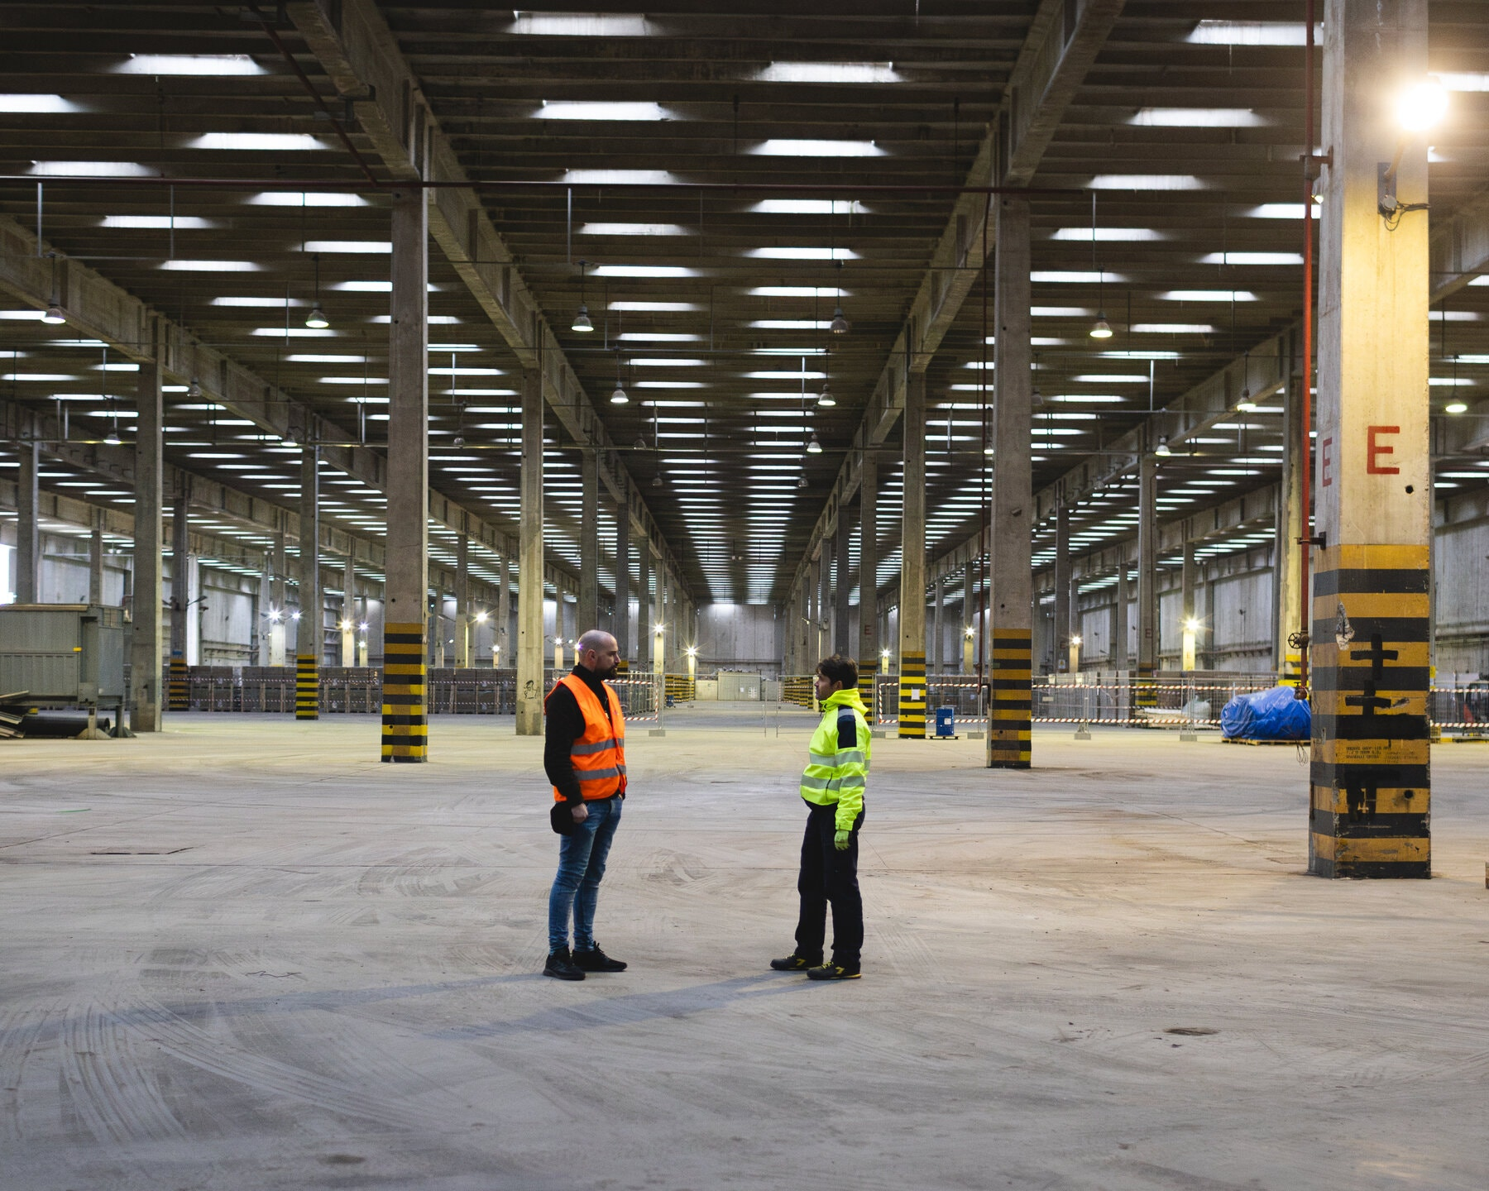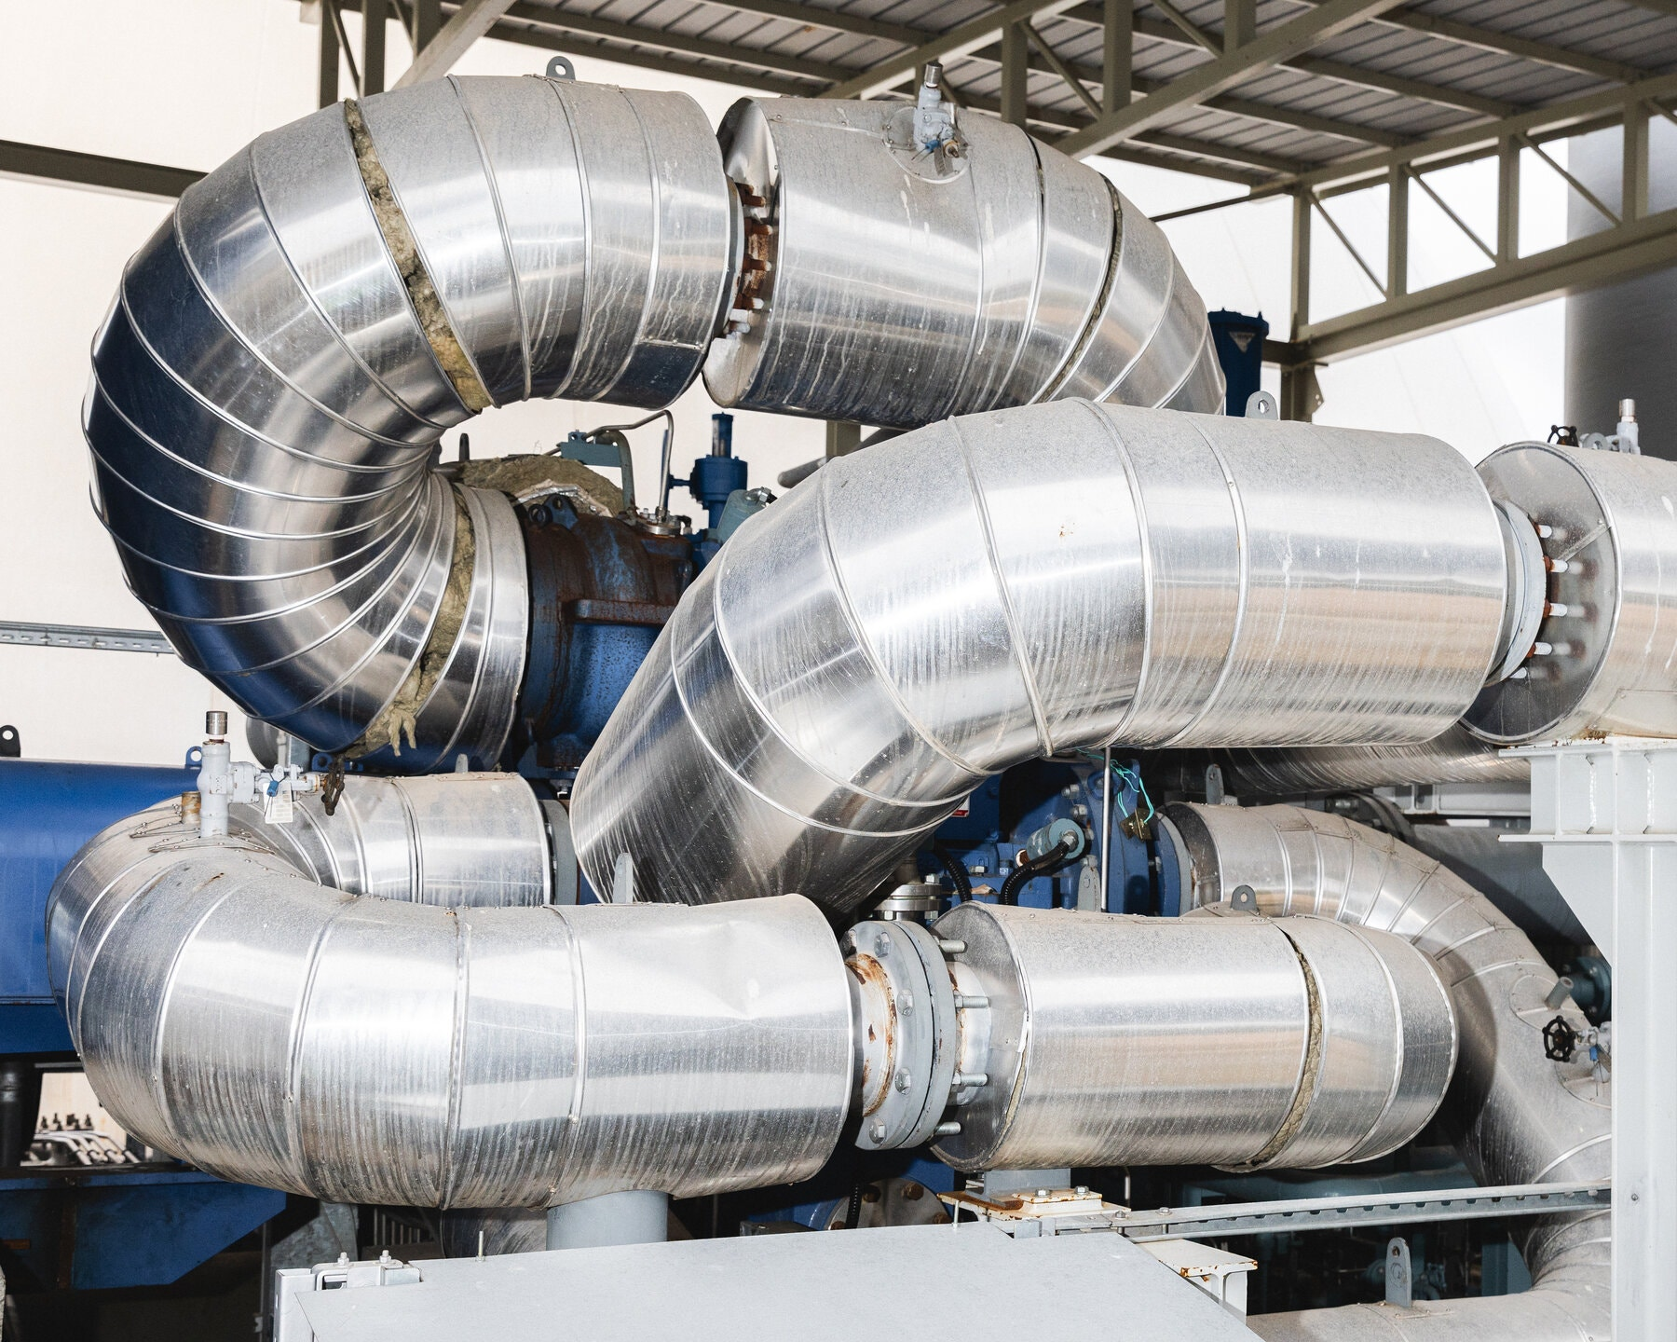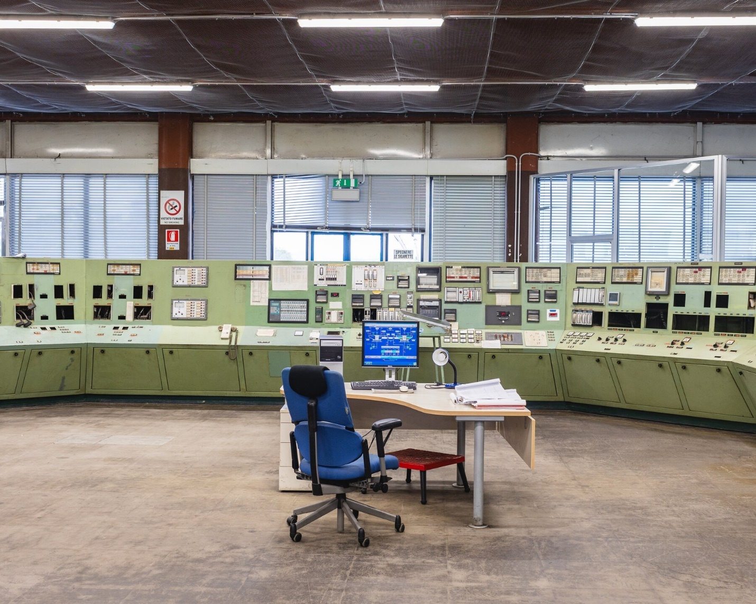

The construction of a warehouse for Energy Dome, which uses a carbon dioxide compressor; the control room of Ottana Energia, a former petrochemical plant next door.

**Supplanting the Standards**

For decades, many electric utilities responded to fluctuating demand by using pumped hydroelectric storage, which generates electricity when demand for electricity is high, then pumps water from a lower reservoir to a higher one to store energy when there is excess supply. Some utilities are now installing new pumped hydroelectric storage to balance solar and wind production. Many other utilities are installing arrays of lithium-ion batteries to store excess energy produced by renewables, and that market is booming.

But these storage methods have limitations. Pumped hydroelectric requires — and alters — hilly landscapes, and the facilities cost a lot to build. Lithium is a limited resource that is often dirty to mine, and it becomes excessively expensive when designed to store energy for much more than four hours, which may be an important capability if intermittent sources provide the majority of a grid’s power.

“Long-duration storage generally doesn’t become necessary until you get to high levels of wind and solar,” said Scott Murtishaw, executive director of the California Energy Storage Alliance, an industry group that advocates more storage on electric grids. “But it is critical if you’re committed to really decarbonizing the grid.”

Westinghouse Electric, a supplier of products and services to nuclear plant operators, says that [its new energy-storage technology](https://www.westinghousenuclear.com/flysheet-directory/long-duration-energy-storage-ldes/), which depends on carbon dioxide, like Energy Dome’s approach, is an improvement on pumped hydro and lithium-ion. The company’s technology works like a heat pump, using carbon dioxide in a supercritical state — at such high temperature and pressure that it acts like a hybrid of a liquid and a gas — to transfer heat, produced by excess electricity, into concrete blocks. Later on, the heat stored in the blocks is used to generate electricity. “It’s kind of ironic that carbon dioxide is the material that led to a lot of the innovation here,” John Battaglini, Westinghouse’s vice-president of new market development for the Americas, said.

In September, [Westinghouse announced that it would build](https://info.westinghousenuclear.com/news/westinghouse-long-duration-energy-storage-solution-selected-for-department-of-energy-program-in-alaska) a 100-megawatt storage facility in Alaska, enough to supply about 80,000 average American homes with electricity for up to 12 hours. He added that the facility would cost about half that of one using lithium-ion batteries: “We feel very, very good about the economics.”

**Going Long**

Image

Workers on power trowels level a section of what will become the floor of Form Energy’s factory in Weirton, W.Va.Credit...Kristian Thacker for The New York Times

Some companies are anticipating a time when most of our electricity comes from renewables and grids that require much longer-duration storage. Form Energy, based in Somerville, Mass., aims to provide electricity for 100 hours, after some studies found that grids based on renewables would need to be able to provide backup energy for about that long.

To provide that much capacity affordably, Form had to find a very low-cost storage process, so the company turned to a cheap, ubiquitous material that undergoes a well-understood reaction: the oxidation, or rusting, of iron. As iron rusts, it produces energy; by feeding energy back into the system, Form can reverse the reaction and store energy, which can be released later by rusting the iron again.

[Form’s storage system](https://formenergy.com/technology/battery-technology/) uses a specially tuned form of iron to maximize reversibility and durability. “That’s where there’s been a lot of invention on our side,” Mateo Jaramillo, Form’s co-founder and chief executive, said. “That’s one of the key tricks — our trade secret.”

Form says it can install storage capacity at a price that’s roughly one-tenth that of lithium-ion batteries. “The trade-off is lower cost, lower efficiency,” Mr. Jaramillo said. “Our modeling shows we’ve reached the right level of cost and efficiency.”

Last year, Form announced agreements to build plants in six states, each with 100-hour capacity, providing 55 total megawatts. The company is also building a battery-manufacturing facility in Weirton, W.Va., on the site of a former steel plant that declined in recent decades, depressing the local economy. West Virginia’s governor, Jim Justice, a Republican, [visited the site last December](https://governor.wv.gov/News/press-releases/2023/Pages/Gov.-Justice-signs-HB-2882-at-former-Weirton-Steel-Mill,-new-home-of-Form-Energy%E2%80%99s-West-Virginia-Manufacturing-Plant.aspx) for the signing of a bill that appropriated $105 million from the state to help build the facility.



Mateo Jaramillo, chief executive of Form Energy, which says it can install storage capacity at roughly one-tenth the cost of lithium-ion batteries. “The trade-off is lower cost, lower efficiency,” he said.

**The Dunkelflaute and Schwarzenegger Effects**

Corre Energy, based in the Netherlands, is working on [storing energy for several days](https://corre.energy/the-solution/) by compressing air to high pressure inside salt caverns, where natural underground salt deposits are dissolved away to leave large empty pockets.

In June, [Corre announced a deal](https://corre.energy/2023/06/15/corre-energy-signs-four-caverns-in-germany-with-solvay-to-double-european-capacity/) in Germany to provide up to 640 megawatts of electricity, enough to supply about 1.6 million German homes, for up to 125 hours, at about one-tenth the cost of lithium-ion. Corre’s partner is developing four caverns there now, with two set to go into operation in 2027.

Corre says that the demand for long-duration storage is high in Northern Europe, which is keen on renewables but prone to multiday periods of little wind and sunlight, known in green-energy circles (and German) as dunkelflaute.

“We’re addressing that accelerating demand” for long-duration storage, Keith McGrane, chief executive of Corre, said. “It’s the dunkelflaute effect.”

Some companies are pursuing approaches that can sound surprisingly simple. A Finnish start-up called Polar Night Energy [uses excess electricity](https://polarnightenergy.fi/about) to heat sand to temperatures as high as 1,100 degrees Fahrenheit. The sand can later be used to provide up to 100 hours of heat to local homes and businesses. Earlier this month, the company [announced a deal](https://polarnightenergy.fi/news/2024/3/6/loviisan-lmp-invests-in-polar-night-energys-sand-battery-in-pornainen-towards-non-combustion-heat-production) to build a storage facility for the town of Pornainen, with a projected reduction of emissions by nearly 70 percent. The company is also developing a method to start providing electricity in addition to heat.

Tommi Eronen, the chief executive of Polar Night Energy, spoke in May [at a climate conference in Vienna](https://www.austrianworldsummit.com/program/). He promoted the company to other green-leaning attendees, including the conference founder, Arnold Schwarzenegger. “It was fun to hang out with Arnold for three days. He was a nice guy,” Mr. Eronen said. “Of course, we disagree on some points. I’m more into cycling than driving cars.”

**Making a New Market**

Image

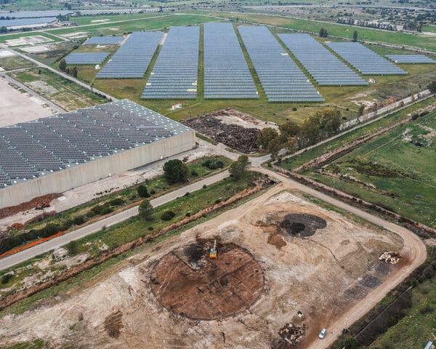

The site in Ottana of the future full-scale version of Energy Dome’s battery.Credit...Gaia Squarci for The New York Times

Image

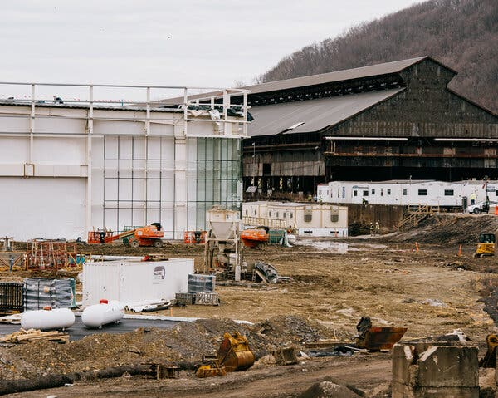

Form Energy’s factory is being built on the site of a former steel plant.Credit...Kristian Thacker for The New York Times

The road from concept to company and infrastructure is always precarious, and long-term energy storage faces particular challenges.

Utilities have used short-term storage for decades, but there has never been much of a market for storage over many hours or days. It’s not clear how storage companies could make enough money to pay for the huge increase in storage that proponents say is necessary. “The biggest challenge with long-duration energy storage is that the economics are lousy,” said James Bushnell, an economist at the University of California, Davis, who studies energy. “If your storage is sitting charged for weeks or months, that’s much less revenue.”

Mr. Battaglini of Westinghouse said the company was exploring this challenge with regional utilities and independent system operators, the nonprofit groups that oversee electric grids. Form Energy has created models to show electric utilities how to use long-duration batteries so that they’re profitable.

“You can’t know what you need if you can’t model it,” Mr. Murtishaw said. “It’s like the iPhone — a product you didn’t know you needed until someone made it.”

Another issue for the new storage approaches is the dominance and continued improvement of lithium-ion batteries. As manufacturers improve the design of batteries and scale up their production, the cost continues to decrease, gradually making lithium-ion more economical for longer durations.

These challenges have hurt some makers of long-term storage. Azelio, a company that stored energy as heat in an aluminum alloy inside modular units, [declared bankruptcy in July](https://www.azelio.com/press-release/azelio-decides-to-file-for-bankruptcy/).

Still, some providers of long-duration storage say that the market is growing fast and that they are ramping up construction to meet the demand.

In Ottana, diggers are clearing away blackened rubble from the remains of old industrial buildings to make room for a commercial-scale Energy Dome storage facility that will hold 40 times as much energy as the adjacent pilot plant. Despite the superficial differences, Mr. Spadacini described the shiny Energy Dome facility as a sort of descendant of the dirtier oil-fueled generator that used to run on the same site. “The energy of oil [was energy from the sun](https://ocean.si.edu/conservation/gulf-oil-spill/what-are-fossil-fuels), and it was stored at some efficiency in oil,” he said, noting that oil derives mostly from photosynthetic plants. “We need to store and use that energy as directly and efficiently as possible.”

<https://www.nytimes.com/2024/03/18/science/renewable-energy-storage-climate.html>

#54

***Stopping Climate Change Is Doable, but Time Is Short, U.N. Panel Warns***

A major new scientific report offers a road map for how countries can limit global warming, but warns that the margin for error is vanishingly small.

* Share full article
* 701

Video

**U.N. Chief Assails World Leaders Over ‘Broken Climate Promises’**

**0:59**

A new United Nations report warned that if countries do not move away much faster from fossil fuels, the goal of limiting global warming to 1.5 degrees Celsius would likely be out of reach by the end of the decade.CreditCredit...Hussein Faleh/Agence France-Presse — Getty Images

[](https://www.nytimes.com/by/brad-plumer)[](https://www.nytimes.com/by/raymond-zhong)

**By**[**Brad Plumer**](https://www.nytimes.com/by/brad-plumer)**and**[**Raymond Zhong**](https://www.nytimes.com/by/raymond-zhong)

April 4, 2022

Nations need to move away much faster from fossil fuels to retain any hope of preventing a perilous future on an overheated planet, according to [a major new report on climate change](https://www.ipcc.ch/report/ar6/wg3/) released on Monday, although they have made some progress because of the falling costs of clean energy.

The report by the Intergovernmental Panel on Climate Change, a body of experts convened by the United Nations, warns that unless countries drastically accelerate efforts over the next few years to slash their emissions from coal, oil and natural gas, the goal of limiting global warming to 1.5 degrees Celsius, or 2.7 degrees Fahrenheit, will likely be out of reach by the end of this decade.

That’s the threshold beyond which scientists say the [dangers of global warming](https://www.nytimes.com/2022/02/28/climate/climate-change-ipcc-report.html) — including worsening floods, droughts, wildfires and ecosystem collapse — grow considerably. Humans have already heated the planet by an average of 1.1 degrees Celsius since the 19th century, largely by burning fossil fuels for energy.

But the task is daunting: Holding warming [to just 1.5 degrees Celsius](https://www.nytimes.com/interactive/2018/10/07/climate/ipcc-report-half-degree.html) would require nations to collectively reduce their planet-warming emissions roughly 43 percent by 2030 and to stop adding carbon dioxide to the atmosphere altogether by the early 2050s, the report found. By contrast, current policies by governments are only expected to reduce global emissions by a few percentage points this decade. Last year, fossil fuel emissions worldwide [rebounded to near-record highs](https://www.nytimes.com/2021/11/03/climate/carbon-dioxide-emissions-global-warming.html) after a brief dip as a result of the coronavirus pandemic.

**Sign up for the Climate Forward newsletter**Your must-read guide to the climate crisis. Get it with a Times subscription.

“This is a climate emergency,” said United Nations Secretary General António Guterres, adding that wealthy economies and corporations “are not just turning a blind eye; they are adding fuel to the flames. They are choking our planet, based on their vested interests and historic investments in fossil fuels, when cheaper, renewable solutions provide green jobs, energy security and greater price stability.”

The report, which was approved by 195 governments and lays out strategies that countries could pursue to halt global warming, comes as Russia’s invasion of Ukraine has caused oil and gas prices to skyrocket, [diverting political attention from climate change](https://www.nytimes.com/2022/03/10/climate/climate-oil-crisis-global.html). In the United States and Europe, leaders are focused on shoring up domestic fossil fuel supplies to avoid price spikes and energy shortages, even if that means higher short term emissions.

Yet climate scientists say there is little margin for delay if the world wants to hold global warming to relatively tolerable levels.

“Every year that you let pass without going for these urgent emissions reductions makes it more and more difficult,” said Jim Skea, an energy researcher at Imperial College London who helped lead the report, which was compiled by 278 experts from 65 countries. “Unless we really do it immediately, it will not be possible to limit warming to 1.5 degrees.”

**Editors’ Picks**

[[](https://www.nytimes.com/2025/06/16/arts/design/pigeon-fest-high-line.html)](https://www.nytimes.com/2025/06/16/arts/design/pigeon-fest-high-line.html)

[Crowning New York’s Top ‘Pigeon’](https://www.nytimes.com/2025/06/16/arts/design/pigeon-fest-high-line.html)

[[](https://www.nytimes.com/2025/06/13/t-magazine/summer-swimsuit-quiz.html)](https://www.nytimes.com/2025/06/13/t-magazine/summer-swimsuit-quiz.html)

[How to Choose the Perfect Swimsuit](https://www.nytimes.com/2025/06/13/t-magazine/summer-swimsuit-quiz.html)

[[](https://www.nytimes.com/2025/06/15/movies/how-to-train-your-dragon-mason-thames-interview.html)](https://www.nytimes.com/2025/06/15/movies/how-to-train-your-dragon-mason-thames-interview.html)

[The ‘How to Train Your Dragon’ Star Mason Thames Is Still Freaking Out](https://www.nytimes.com/2025/06/15/movies/how-to-train-your-dragon-mason-thames-interview.html)

But even if that goal becomes unattainable, scientists said, it will still be worthwhile for countries to slash emissions as quickly as possible to prevent as much warming as they can. [Every additional rise in global temperatures](https://www.nytimes.com/interactive/2018/10/07/climate/ipcc-report-half-degree.html) increases the perils that people face around the world, such as water scarcity, malnutrition and life-threatening heat waves, the U.N. panel has found.

[Why Half a Degree of Global Warming Is a Big Deal](https://www.nytimes.com/interactive/2018/10/07/climate/ipcc-report-half-degree.html)

“Every fraction of a degree matters,” Dr. Skea said. “Even if we go beyond 1.5, that doesn’t mean we throw up our hands and despair.”

Scientists say that global warming will largely halt once humans stop adding heat-trapping gases to the atmosphere, a concept known as “net zero” emissions.

The new report contains glimmers of optimism. Over the past decade, many nations have adopted ambitious climate policies, scaled back plans for new coal plants and used subsidies and regulations to expand renewable energy. Although emissions from fossil fuels are still growing worldwide, the rate of growth slowed in the 2010s, compared with the 2000s, the report said, and humanity now has a much better shot [at avoiding some of the worst-case global warming scenarios](https://www.nytimes.com/interactive/2021/10/25/climate/world-climate-pledges-cop26.html) once widely feared by scientists.

Image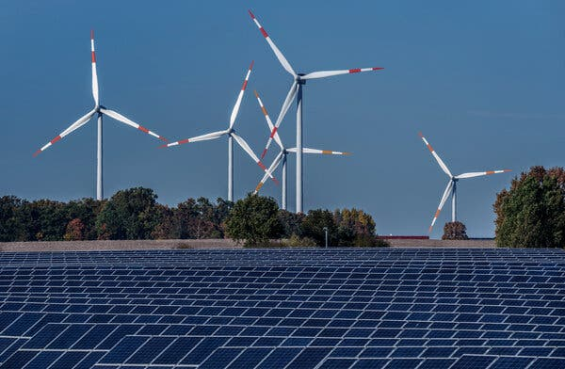

Wind turbines and a solar farm in Rapshagen, Germany, last year.Credit...Michael Sohn/Associated Press

Clean energy technology has advanced far more quickly than expected, the report said. Since 2010, the costs of solar panels and lithium-ion batteries for electric vehicles have plunged by 85 percent, while the cost of wind turbines has fallen by more than half.

Rapidly shifting away from the fossil fuels that have underpinned economies for more than a century will require nations to do much more, however. Over the next decade, governments and companies would need to invest three to six times [the roughly $600 billion](https://www.climatepolicyinitiative.org/publication/global-landscape-of-climate-finance-2021/) they currently spend annually on encouraging clean energy and cutting emissions, the report said.

But the cost of inaction is also substantial, in terms of deaths, displacement and damage. In the United States last year, damages from floods, wildfires, drought and other disasters related to weather and climate totaled approximately $145 billion, [according to the National Oceanic and Atmospheric Administration](https://www.climate.gov/news-features/blogs/beyond-data/2021-us-billion-dollar-weather-and-climate-disasters-historical). The agency said that “extremely high” levels of disasters were becoming “the new normal.”

“Reducing emissions substantially is much less painful than you would think, and probably beneficial in the short term,” said Glen Peters of the Center for International Climate Research in Oslo, Norway, who contributed to the report.

The new report examines dozens of strategies proposed by scientists and energy experts to help nations make the transition.

First, countries would need to clean up virtually all power plants worldwide that generate electricity for homes and factories. That means relying more on wind, solar, nuclear, geothermal or hydropower. Most of the world’s coal and natural gas plants would either need to shut down or install [carbon capture technology](https://www.nytimes.com/2020/06/24/climate/carbon-capture-tax-break.html) that can trap emissions and bury them underground. Such technology has been slow to take off because of its high costs.

The next step would be to reconfigure transportation, industry and other segments of the global economy to run on clean electricity rather than fossil fuels. Cars powered by gasoline could be replaced with electric vehicles charged by low-carbon grids. Gas-burning furnaces in homes could be swapped out for electric heat pumps. Instead of burning coal, steel mills could shift to electric furnaces that melt scrap.

At the same time, nations could take steps to reduce their total energy demand. That could entail expanding public transit, upgrading insulation so homes consume less energy, recycling more raw materials and making factories more energy efficient. At the high end, such demand-side policies could help cut emissions in key sectors as much as 40 to 70 percent by 2050, the report notes.

But many economic activities can’t be easily electrified. Batteries are still too heavy for most airplanes. Many industries, like cement and glass, require extreme heat and currently burn coal or gas. For those emissions, governments and businesses will have to develop new fuels and industrial processes, the report said.

Image

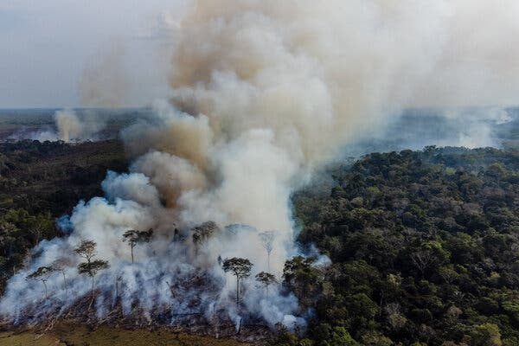

A fire set by farmers for the deforestation process in the Amazon jungle last year.Credit...Federico Rios for The New York Times

Countries will also need to address emissions from deforestation and agriculture, which account for around a fifth of global greenhouse gases. That means dealing with issues like global meat production, which emits methane and carbon dioxide, and is causing [rampant deforestation](https://www.nytimes.com/2022/03/07/climate/amazon-rainforest-climate-change-deforestation.html) in vital places like the Amazon rainforest.

Forests and wetlands naturally store carbon dioxide, which makes sparing them from destruction a highly effective and economical way to mitigate warming, said Stephanie Roe, a World Wildlife Fund scientist who helped write the report. “I can’t reiterate enough the importance of conserving those ecosystems,” she said.

Even in the best case, humanity is unlikely to eliminate all of its planet warming emissions, the report warned. So countries will likely also have to devise ways to remove billions of tons of carbon dioxide from the atmosphere each year by around midcentury. One strategy could be to plant more trees, although that may not be enough, the report cautioned. Other options include [devices that suck carbon out of the air](https://www.nytimes.com/2021/01/18/climate/carbon-removal-technology.html), though these technologies are still immature.

**The report, explained**

[Five takeaways](https://nytimes.com/2022/04/04/climate/ipcc-report-explained.html) from the latest I.P.C.C. report.

The report acknowledges the enormous challenges ahead. Winding down coal, oil and gas projects would mean job losses and financial dislocation. Some climate solutions come with major trade-offs: Protecting forests, for instance, leaves less land for growing crops or raising livestock to feed a world population that keeps growing.

And some of the biggest obstacles to climate action are political, not technological. The report notes that “incumbent fossil fuel interests” often work to thwart policies to cut emissions. Organized disinformation campaigns by climate change deniers have, in some places, increased political polarization over the issue. And politicians tend to avoid difficult decisions if the benefits are not felt beyond the current election cycle.

In the developing world, governments still need to expand access to electricity and modern cooking fuels for hundreds of millions of the poorest people, which might only be possible in the short term by burning more fossil fuels. These nations have benefited from advances in renewable energy technology, but efforts to cut emissions deeply have run up against two longstanding issues: high costs and overstretched governments.

“If technology could solve the problem completely, the problem could have been solved two or three decades ago,” said Wei Shen, a researcher at the Institute of Development Studies, a think tank in Britain, who helped write the report.

There is strong political will in many developing nations to tackle climate change, said Fatima Denton, director of the United Nations University Institute for Natural Resources in Africa and another author of the report. But greater financial support from wealthy nations is critical, she said, partly as a [matter of fairness and historical responsibility](https://www.nytimes.com/interactive/2021/11/12/climate/cop26-emissions-compensation.html): Western countries that got rich by burning fossil fuels are now effectively telling poor nations that they cannot do the same.

“You’re telling them to leave their resources in the ground, when they have always more or less seen these as the route to more capitalism, more wealth, more prosperity,” Dr. Denton said.

China’s leader, Xi Jinping, said last year that his country would [stop building new coal plants overseas](https://www.nytimes.com/2021/09/21/climate/china-power-plants-coal.html), a major step toward promoting green energy in the developing world. At home, though, China is [digging up and burning more coal](https://www.nytimes.com/2021/10/28/business/energy-environment/china-coal-climate.html) to keep electricity flowing amid the economic disruptions of the war in Ukraine and the coronavirus pandemic. China is the planet’s top emitter of greenhouse gases.

Image

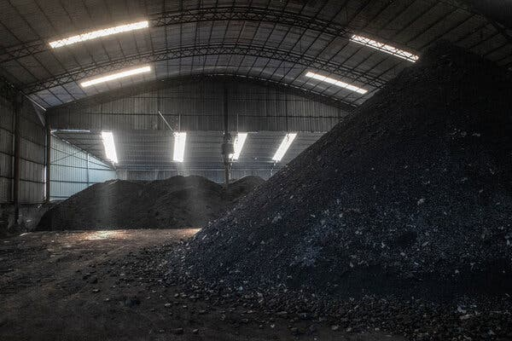

Piles of coal in a warehouse in Shanxi Province, a major Chinese coal source.Credit...Gilles Sabrié for The New York Times

“It’s unfortunate: These recent crises just demonstrate that if decarbonization happened earlier, then China, as well as other regions, would have been more resilient to some of these shocks,” said Cecilia Han Springer, a China expert at Boston University. “But that means there’s also an opportunity to double down.”

India’s government has increased energy efficiency in homes and factories, given farmers solar-powered water pumps and helped promote the rapid construction of solar farms. But the country’s state-run electric utilities remain in fragile fiscal health, meaning there is no guarantee that efforts to expand clean energy will be financially sustainable.

In remarks Monday, Mr. Guterres urged people around the world to press for action. “If you live in a big city, a rural area, or a small island state, if you invest in the stock market, if you care about justice, and our children’s future, I am appealing directly to you,” he said. “Demand that renewable energy is introduced now — at speed and at scale. Demand an end to coal-fired power. Demand an end to all fossil fuel subsidies.”

Worldwide, slashing emissions requires overhauling the way governments, businesses and even societies work, said Dr. Denton of the United Nations University. “That’s not an overnight thing, and it comes with some cost, whether we like it or not.”

<https://www.nytimes.com/2022/04/04/climate/climate-change-ipcc-un.html>

#55

***As Utility Bills Rise, Low-Income Americans Struggle for Access to Clean Energy***

The Biden administration has deployed various programs to try to increase access to clean energy. But systems that could help lower bills are still out of reach for many low-income households.

* Share full article



Cindy Camp is trying to cut down on her expenses because her gas and electric bills keep “going up and up.”Credit...Lexey Swall for The New York Times

**By**[**Madeleine Ngo**](https://www.nytimes.com/by/madeleine-ngo)**and**[**Ivan Penn**](https://www.nytimes.com/by/ivan-penn)

Madeleine Ngo reported from Washington, and Ivan Penn from Los Angeles.

Jan. 11, 2024

Cindy Camp is one of many Americans facing rising utility costs. Ms. Camp, who lives in Baltimore with three family members, said her gas and electric bills kept “going up and up” — reaching as high as $900 a month. Her family has tried to use less hot water by doing fewer loads of laundry, and she now eats more fast food to save on grocery bills.

Ms. Camp would like to save money on energy bills by transitioning to more energy-efficient appliances like a heat pump and solar panels. But she simply cannot afford it.

“It’s a struggle for me to even maintain food,” Ms. Camp said.

Power bills [have been rising nationwide](https://data.bls.gov/timeseries/APU000072610?amp%253bdata_tool=XGtable&output_view=data&include_graphs=true), and in Baltimore, electricity rates [have increased almost 30 percent](https://data.bls.gov/timeseries/APUS35E72610?amp%253bdata_tool=XGtable&output_view=data&include_graphs=true) over the last decade, according to data from the Bureau of Labor Statistics. While clean energy systems and more efficient appliances could help low-income households mitigate some of those increases, many face barriers trying to gain access to those products.

Low-income households have been [slower to adopt clean energy](https://emp.lbl.gov/news/new-berkeley-lab-report-solar-adopter-2) because they often [lack sufficient savings](https://www.cesa.org/wp-content/uploads/Bringing-the-Benefits-of-Solar-to-Low-Income-Consumers.pdf) or have low credit scores, which can impede their [ability to finance projects](https://www.energy.gov/scep/slsc/low-income-community-energy-solutions). Some have also found it difficult to navigate federal and state programs that would make installations more affordable, and many are renters who cannot make upgrades themselves.

Advertisement

[SKIP ADVERTISEMENT](https://www.nytimes.com/2024/01/11/us/politics/utility-bills-clean-energy.html#after-story-ad-1)

Energy costs have traditionally been a bigger burden for low-income households, which typically spend a far larger percentage of their gross income on utility bills than higher-earning households, [according to the Energy Department](https://www.energy.gov/eere/energy-accessibility-and-affordability). Many also live in older, less efficient homes, which can lead to [more expensive utility bills](https://www.eia.gov/todayinenergy/detail.php?id=56640). In 2020, 34 million U.S. households, or 27 percent of all households, reported difficulty paying their energy bills or kept their homes at an unsafe temperature because of energy cost concerns, [according to the Energy Information Administration](https://www.eia.gov/todayinenergy/detail.php?id=51979).

The Biden administration has deployed a suite of programs to try to increase access to clean energy and [lower household utility bills](https://www.whitehouse.gov/briefing-room/statements-releases/2022/11/02/fact-sheet-biden-harris-administration-announces-new-actions-to-lower-energy-costs-for-families/). The efforts are part of a broader push to reduce carbon emissions in response to climate change, which often [disproportionately affects](https://www.whitehouse.gov/environmentaljustice/justice40/) disadvantaged communities.

That includes [rebates for energy-efficient appliances](https://www.nytimes.com/interactive/2023/climate/tax-breaks-inflation-reduction-act.html) and tax credits for purchases of solar panels and electric cars. In recent months, administration officials have awarded [funding for energy efficiency upgrades](https://www.hud.gov/press/press_releases_media_advisories/hud_no_23_239) at federally subsidized housing properties. The federal government will also offer [bonus tax credits](https://www.irs.gov/credits-deductions/low-income-communities-bonus-credit) for clean energy investments in low-income areas and provide [billions to increase access](https://www.epa.gov/newsreleases/biden-harris-administration-launches-7-billion-solar-all-grant-competition-fund) to residential solar.

In remarks on Wednesday about the administration’s efforts to make energy more affordable, Treasury Secretary Janet L. Yellen said the policies could help reduce energy bills for lower- and middle-income families “right away.” She said they were also bolstering domestic clean energy manufacturing, which would lower costs over time.

“This will make clean energy even more affordable for American consumers,” Ms. Yellen said at a community college in Boston.

**Editors’ Picks**

[[](https://www.nytimes.com/2025/06/16/arts/design/pigeon-fest-high-line.html)](https://www.nytimes.com/2025/06/16/arts/design/pigeon-fest-high-line.html)

[Crowning New York’s Top ‘Pigeon’](https://www.nytimes.com/2025/06/16/arts/design/pigeon-fest-high-line.html)

[[](https://www.nytimes.com/2025/06/13/t-magazine/summer-swimsuit-quiz.html)](https://www.nytimes.com/2025/06/13/t-magazine/summer-swimsuit-quiz.html)

[How to Choose the Perfect Swimsuit](https://www.nytimes.com/2025/06/13/t-magazine/summer-swimsuit-quiz.html)

[[](https://www.nytimes.com/2025/06/15/movies/how-to-train-your-dragon-mason-thames-interview.html)](https://www.nytimes.com/2025/06/15/movies/how-to-train-your-dragon-mason-thames-interview.html)

[The ‘How to Train Your Dragon’ Star Mason Thames Is Still Freaking Out](https://www.nytimes.com/2025/06/15/movies/how-to-train-your-dragon-mason-thames-interview.html)

[SKIP ADVERTISEMENT](https://www.nytimes.com/2024/01/11/us/politics/utility-bills-clean-energy.html#after-pp_edpick)

Advertisement

[SKIP ADVERTISEMENT](https://www.nytimes.com/2024/01/11/us/politics/utility-bills-clean-energy.html#after-story-ad-2)

Still, some advocates said it would be a challenge for the administration’s investments to reach low-income communities.

“To me the problems for folks in Baltimore and inner cities everywhere, they’re identical: ‘We struggle to pay our bills now,’” said Kristal Hartsfield, the chief executive of the National Alliance for Equity in Energy and Infrastructure, which connects communities and companies on issues related to changes in the energy sector. “We can’t flip the switch to clean energy tomorrow.”

Although White House officials said they were providing technical assistance to help people gain access to new programs, many who want to take advantage of federal and state programs said they often faced a major hurdle: paperwork.

Ms. Camp, 56, lives in a single-family home in a Northeast Baltimore neighborhood, where she has never seen a solar panel on a home or residents with electric vehicles. Still, she wants solar power and a heat pump — if she could navigate through the depths of the application process.

Advertisement

[SKIP ADVERTISEMENT](https://www.nytimes.com/2024/01/11/us/politics/utility-bills-clean-energy.html#after-story-ad-3)

“It’s really discouraging,” said Ms. Camp, an AmeriCorps member. “The red tape is so thick.”

Image



Patricia Johnson with her husband, Glenwood Johnson. Ms. Johnson said that she could not afford to pay the $10,000 to $15,000 needed to replace her home’s heater.Credit...Lexey Swall for The New York Times

Patricia Johnson, 68, a retired machine operator who lives with her husband in East Baltimore, said her home’s heater was more than two decades old and in need of repair, but she could not afford to pay $10,000 to $15,000 to replace the system.

[**Trump Administration: Live Updates**](https://www.nytimes.com/live/2025/06/16/us/trump-news)

Updated

June 16, 2025, 9:30 p.m. ETJune 16, 2025

* [Trump renews his embrace of Putin amid his ongoing rift with his G7 allies.](https://www.nytimes.com/live/2025/06/16/us/trump-news#trump-g7-russia-ukraine)
* [The Senate proposal ends tax cuts for clean energy, disappointing climate advocates.](https://www.nytimes.com/live/2025/06/16/us/trump-news#senate-republicans-tax-package-clean-energy)
* [The Senate bill would make deep cuts to Medicaid, setting up a fight with the House.](https://www.nytimes.com/live/2025/06/16/us/trump-news#senate-bill-medicaid-cuts)

Ms. Johnson said she found it difficult to figure out which assistance programs she qualified for, so she went to a nearby community center run by GEDCO, a local nonprofit. Ms. Johnson later learned she qualified for a state program that funds energy efficiency upgrades, but it was still difficult to navigate the paperwork and she would not have applied without guidance.

Laurel Peltier, the chair of the Maryland Energy Advocates Coalition and a volunteer at GEDCO who worked with Ms. Johnson, said most of the people she assisted did not have computers or printers, which made it harder for them to apply for and learn about available programs.

“Government agencies have a lot of work to do in distributing programs to low-income people effectively,” Ms. Peltier said.

The nation’s largest municipal utility, the Los Angeles Department of Water and Power; the National Renewable Energy Laboratory; and the University of California, Los Angeles, recently [released the first comprehensive study](https://www.nytimes.com/2023/11/16/business/energy-environment/los-angeles-energy-inequality.html) of some of the impacts of the energy transition on low-wealth consumers. The study highlighted growing disparities in Los Angeles between those who can afford clean energy upgrades and those who cannot.

Advertisement

[SKIP ADVERTISEMENT](https://www.nytimes.com/2024/01/11/us/politics/utility-bills-clean-energy.html#after-story-ad-4)

Part of the reality, as Los Angeles recognized in its study and as some energy experts have argued, is that there is a need to educate the public about energy issues as well as how to move to clean energy technologies and find the available incentives.

Experts at the National Renewable Energy Laboratory say the energy transition will require broad participation from utilities and power providers as well as low-income and wealthier Americans. That means more will need to be done to include those who can least afford it.

While many of the new rebates are generous, they still might not cover the full price tag of clean energy products, said Diana Hernandez, an associate professor of sociomedical sciences and a co-director of the Energy Opportunity Lab at the Columbia Center on Global Energy Policy. The cost of heat pumps, which can heat and cool homes more efficiently than typical furnaces and air-conditioners, varies but an [average installation costs $16,000](https://www.nytimes.com/2023/11/09/business/energy-environment/heat-pumps-biden-tax-credits-rebates.html). The new rebates, which are not yet available, would only shave up to $8,000 off those systems.

Tax credits can [cover 30 percent](https://www.irs.gov/credits-deductions/residential-clean-energy-credit) of the cost of installing solar panels. But many people with low incomes do not owe enough in taxes to take full advantage of them, and the average cost of a residential solar system is [roughly $25,000](https://www.seia.org/solar-industry-research-data), according to the Solar Energy Industries Association.

Low-income households are less likely to make those upgrades if they are already struggling to afford necessary expenses, and many are also renters who will find it harder to benefit from the new programs because landlords might not be incentivized to make efficiency upgrades, Ms. Hernandez said.

Advertisement

[SKIP ADVERTISEMENT](https://www.nytimes.com/2024/01/11/us/politics/utility-bills-clean-energy.html#after-story-ad-5)

She noted, however, that people could subscribe to a portion of energy generated by [“community solar” projects](https://www.nytimes.com/2018/07/12/realestate/apartment-dwellers-solar-power.html), which are off-site solar systems, or [lease panels](https://www.nytimes.com/2022/05/24/business/energy-environment/solar-panel-advice.html).

After conducting its study, Los Angeles increased its rebates for used electric vehicles to as much as $4,000 from a maximum of $2,500 for qualified consumers. And the city said it would build and operate its own fast-charging network in low-income communities.

Without such efforts, experts say the energy transition will only work against those who can least afford to participate in it.

“This energy transition, we’re still in the process of trying to figure it out,” said Stephanie Pincetl, a professor at the U.C.L.A. Institute of the Environment and Sustainability and the director of the university’s California Center for Sustainable Communities who participated in the Los Angeles study. “We have to do this right or it’s just going to aggravate inequality.”

<https://www.nytimes.com/2024/01/11/us/politics/utility-bills-clean-energy.html>

#56

***How an Obscure Agency Became a Linchpin for Climate Policy***

The Federal Energy Regulatory Commission voted 2-to-1 in a partisan split on Monday on a new rule that could help speed up wind and solar energy.

**Listen to this article · 5:56 min**[Learn more](https://help.nytimes.com/hc/en-us/articles/24318293692180)

* Share full article

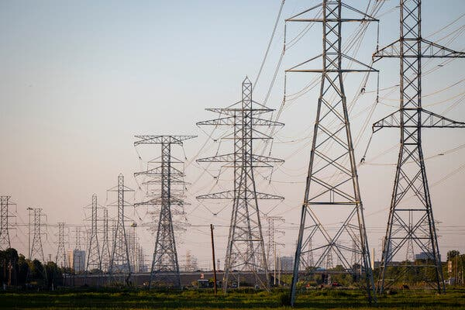

Transmission lines in Houston. The Federal Energy Regulatory Commission is charged with overseeing interstate transmission of gas, oil and electricity.Credit...Annie Mulligan for The New York Times

[](https://www.nytimes.com/by/lisa-friedman)

**By**[**Lisa Friedman**](https://www.nytimes.com/by/lisa-friedman)

May 13, 2024

The Federal Energy Regulatory Commission may be the most important climate agency you’ve never heard of.

Responsible for overseeing interstate transmission of gas, oil and electricity, the independent agency could help determine how much wind, solar and other renewable energy moves from engineering plans onto the nation’s electric grids and into homes and businesses.

On Monday the commission approved long-awaited changes that require grid operators around the country to plan 20 years into the future, taking into account changes in the energy mix, the growing number of states that have policies requiring wind and solar power, as well as the risks that extreme weather poses to reliability.

The vote was 2-to-1, with the commission’s Democrats approving and the sole Republican objecting, a partisan split that echoed the divide between the two parties over renewable energy.

**What did FERC vote on?**

The new rule [is the most significant attempt in years to upgrade and expand the country’s creaking electricity network](https://www.nytimes.com/2024/05/13/climate/electric-grid-overhaul-ferc.html).

Senator Chuck Schumer of New York, the Democratic leader, said the decisions made by the commission on Monday were critical to realizing the full extent of the Inflation Reduction Act, the sweeping climate law that Democrats muscled through without Republican support in 2022. The law provides tax incentives of more than $370 billion to jump start electric vehicles and wind, solar and other renewable energy.

But many of those energy projects have been in limbo, unable to connect to electric grids because of a lack of new transmission lines. One study warned that roughly half of the climate benefits under the law could not be realized if transmission capacity, including new high voltage power lines, was not expanded significantly.

“It was a great victory after the I.R.A. was passed, and we got plaudits all around, but I knew even as I was standing up smiling that our work wasn’t done,” Mr. Schumer said last week in an interview. “If you have lovely windmills in the mountains but you can’t bring it to where the people were, it might be for nought. It became clear early on that transmission was so important, that it would be a linchpin in developing clean energy.”

**Editors’ Picks**

[[](https://www.nytimes.com/2025/06/16/arts/design/pigeon-fest-high-line.html)](https://www.nytimes.com/2025/06/16/arts/design/pigeon-fest-high-line.html)

[Crowning New York’s Top ‘Pigeon’](https://www.nytimes.com/2025/06/16/arts/design/pigeon-fest-high-line.html)

[[](https://www.nytimes.com/2025/06/13/t-magazine/summer-swimsuit-quiz.html)](https://www.nytimes.com/2025/06/13/t-magazine/summer-swimsuit-quiz.html)

[How to Choose the Perfect Swimsuit](https://www.nytimes.com/2025/06/13/t-magazine/summer-swimsuit-quiz.html)

[[](https://www.nytimes.com/2025/06/15/movies/how-to-train-your-dragon-mason-thames-interview.html)](https://www.nytimes.com/2025/06/15/movies/how-to-train-your-dragon-mason-thames-interview.html)

[The ‘How to Train Your Dragon’ Star Mason Thames Is Still Freaking Out](https://www.nytimes.com/2025/06/15/movies/how-to-train-your-dragon-mason-thames-interview.html)

Image



Chuck Schumer, the Senate majority leader, said the decisions made by FERC on Monday are critical to realizing the full extent of the Inflation Reduction Act.Credit...Kenny Holston/The New York Times

The agency was created in 1920 as the Federal Power Commission to control hydropower dams. President Franklin D. Roosevelt later championed legislation to dismantle utility monopolies, and in 1935 Congress passed the Federal Power Act, requiring the commission to set “just and reasonable” wholesale electricity prices.

In the 1970s, it became the Federal Energy Regulatory Commission, or FERC, and got an expanded mandate to regulate interstate electricity, hydroelectric projects and oil and gas pipelines.

“The transmission and pipeline infrastructure of the entire country runs through this one agency,” said Rob Gramlich, the president of Grid Strategies, a power sector consulting firm. “Most people who are involved with FERC are happy when it stays out of the news,” he added.

In recent years, the commission has become a focal point for the connection between the power grid and climate change. Utilities that burn gas and coal to produce electricity are the second largest source of the pollution that is driving global warming.

In 2021 Richard Glick, who had been appointed to chair the commission by President Biden, said the agency should more fully consider the impacts of climate change when approving natural gas pipelines.

With that focus on climate change, came controversy.

Senator Joe Manchin, the West Virginia Democrat and champion of coal and gas, was irate that Mr. Glick was saying climate change should be a consideration during pipeline discussions. As chairman of the Senate Energy and Natural Resources Commission, Mr. Manchin refused to hold a confirmation hearing for Mr. Glick, who ultimately stepped down.

His departure left the commission with a 2-2 partisan split. Under FERC’s rules, no more than three of its five commissioners may be from a single party.

To hear Mr. Schumer tell it, that’s when Democratic strategizing went into high gear.

Image



Richard Glick, then FERC chairman, speaking during a meeting at FERC Headquarters in 2022.Credit...FERC, via Associated Press

Efforts to hammer out bipartisan legislation to speed up electricity transmission remain in limbo. Democrats want to speed up the pace of adding solar and wind to the grid while Republicans in return want faster and easier permitting for fossil fuel projects and pipelines.

Neil Chatterjee, who served as chairman of FERC under President Donald J. Trump said some Republicans have been reluctant to act on transmission because they don’t want the Inflation Reduction Act to succeed.

“The Republican Party used to be a party that led on transmission policy,” he said. But now “it’s seen as facilitating Biden achieving his climate agenda, and they’re against it just to be against Biden.”

Mr. Schumer said turning to FERC was a way to get around Republican opposition in Congress. “We always had FERC in the back of our minds because it could be done without congressional Republican approval,” he said.

When Mr. Glick stepped down, Mr. Schumer said he saw an opportunity. He learned that one of the two Republican commissioners, James Danly, was also poised to relinquish his seat. Mr. Danly left the agency in January, leaving a 2-1 commission in favor of Democrats with Willie L. Phillips, who was appointed by Mr. Biden, serving as chairman. (Nominees are still awaiting confirmation on the commission’s two empty seats.)

Mr. Schumer increased pressure on the commission to free up the congested transmission system, writing an open letter in July laying out proposed solutions.

On Monday Mr. Schumer said, “FERC is doing just about everything we asked” and called the rule the “missing piece of the puzzle” to the Inflation Reduction Act. He acknowledged that more must be done on transmission reform, but chances remain dim that Congress will act.

<https://www.nytimes.com/2024/05/13/climate/ferc-climate-renewable-energy.html>

#57

***How the Climate Crisis Became an Insurance Crisis***

Even in formerly low-risk areas, home insurers are raising premiums and ending coverage. The upheaval could push down home values and reverberate through the economy.

* Share full article



Homes on the outskirts of Silver City, N.M., an area of unusually high insurance denial rates because of wildfire risk.Credit...Paul Ratje for The New York Times

[](https://www.nytimes.com/by/christopher-flavelle)

**By**[**Christopher Flavelle**](https://www.nytimes.com/by/christopher-flavelle)

Dec. 19, 2024

**You’re reading the Climate Forward newsletter, for Times subscribers only.**News and insights for a warming world. Get it with a Times subscription.

Spend enough time talking about climate change, and you’ll eventually get pulled toward this question: What would have to happen for global warming to strike most people as an urgent crisis?

There are many candidates: More [extreme heat domes](https://www.nytimes.com/live/2024/06/20/us/heat-wave-news) hitting major American cities, coupled with [widespread blackouts](https://www.nytimes.com/2021/05/03/climate/heat-climate-health-risks.html). Extended droughts across America’s farmland, on top of the decades-long depletion of groundwater, leading to [food shortages](https://www.nytimes.com/interactive/2023/08/28/climate/groundwater-drying-climate-change.html). A two-foot rise in sea levels caused by the [collapse of the Thwaites glacier](https://www.cnn.com/2024/09/20/climate/doomsday-glacier-thwaites-melt-sea-level-rise/index.html) in Antarctica, putting entire coastal regions in the United States underwater.

Those scenarios seem a long way off to many Americans (even if they might not be). But what if the thing that will make climate change feel like a crisis to most everyone is already underway across the country? What if it’s the erosion of something entirely mundane, even a little boring, but also essential to modern life?

My colleague Mira Rojanasakul and I have spent most of this year digging into how climate shocks are [hitting America’s home insurance industry](https://www.nytimes.com/interactive/2024/12/18/climate/insurance-non-renewal-climate-crisis.html). What we’ve found looks an awful lot like the early stages of a crisis.

Advertisement

[SKIP ADVERTISEMENT](https://www.nytimes.com/2024/12/19/climate/how-the-climate-crisis-became-an-insurance-crisis.html#after-story-ad-1)

As climate-fueled disasters get worse, home insurance is becoming a money-losing business in more of the country. Without insurance, you can’t get a mortgage; without a mortgage, most Americans can’t buy a home.

Last year, insurers lost money on homeowners coverage in 18 states, up from 12 states five years ago and eight states in 2013. Nationally, over the past decade, insurers paid out more in claims than they received in premiums, and, since 2018, more than 1.9 million home insurance contracts nationwide have been dropped.

A chart that shows an increasing number of states have lost money on homeowners insurance over the past decade.



**States where homeowners insurance was unprofitable.**

2013

2014

2015

2016

2017

2018

2019

2020

2021

2022

2023

**Colo.**

**Colo.**

**Mass.**

**Colo.**

**Calif.**

**Calif.**

**Colo.**

**Ala.**

**Colo.**

**Ark.**

**Ark.**

**Ga.**

**Iowa**

**R.I.**

**Mont.**

**Colo.**

**Colo.**

**Fla.**

**Ark.**

**Iowa**

**Ariz.**

**Colo.**

**Ill.**

**Ill.**

**S.D.**

**N.D.**

**Fla.**

**Conn.**

**Ill.**

**Del.**

**Idaho**

**Fla.**

**Ga.**

**Miss.**

**Mich.**

**Neb.**

**Ga.**

**D.C.**

**Minn.**

**Fla.**

**Ky.**

**Ga.**

**Hawaii**

**Mont.**

**Mont.**

**N.M.**

**Iowa**

**Fla.**

**Mont.**

**Ga.**

**La.**

**Iowa**

**Iowa**

**Neb.**

**Neb.**

**Texas**

**Idaho**

**Ga.**

**ND**

**Iowa**

**Mich.**

**Md.**

**Ill.**

**Okla.**

**S.D.**

**Wyo.**

**Ill.**

**Idaho**

**Neb.**

**Ill.**

**Minn.**

**Minn.**

**Ind.**

**S.D.**

**Vt.**

**Minn.**

**Md.**

**Wyo.**

**La.**

**Texas**

**Mont.**

**Ky.**

**Neb.**

**NC**

**Minn.**

**Neb.**

**Mich.**

**N.M.**

**S.D.**

**Miss.**

**N.M.**

**Minn.**

**S.D.**

**Va.**

**Ore.**

**Ohio**

**Mo.**

**Texas**

**Wyo.**

**S.D.**

**S.D.**

**Miss.**

**Tenn.**

**Wash.**

**Ohio**

**Utah**

**Wis.**

**Okla.**

**Wyo.**

**Tenn.**

**Utah**

**Wash.**

**Wis.**

Source: AM Best

by Mira Rojanasakul/The New York Times

The result is what you could call [the Iowa effect](https://www.nytimes.com/interactive/2024/05/13/climate/insurance-homes-climate-change-weather.html): Even in formerly low-risk places like that state, insurers are [raising premiums](https://www.nytimes.com/interactive/2024/07/08/climate/home-insurance-climate-change.html), restricting coverage or simply leaving.

It used to be impossible to know which communities around the country insurers were pulling back from.

Advertisement

[SKIP ADVERTISEMENT](https://www.nytimes.com/2024/12/19/climate/how-the-climate-crisis-became-an-insurance-crisis.html#after-story-ad-2)

This week, that changed. The Senate Budget Committee issued the findings from a yearlong investigation, showing [where insurers are dropping customers](https://www.nytimes.com/interactive/2024/12/18/climate/insurance-nonrenewal-rates-policies-state-map.html) — year by year, county by county. The result is a new way to map the growing threats of extreme weather.

A map of county-level nonrenewal rates in the United States. Light yellow counties in parts of Minnesota, New York and Pennsylvania signify lower rates, while orange and dark red counties illustrate very high nonrenewal rates in parts of the Carolinas, Gulf Coast, Midwest and California.



**NONRENEWAL RATES, 2023**

1 in 200

1 in 100

1 in 50

1 in 25

State rate

shown

Note: The state average is shown in counties with few policies reported.

Source: U.S. Senate Budget Committee

by Mira Rojanasakul/The New York Times

“The climate crisis that is coming our way is not just about polar bears, and it’s not just about green jobs,” Senator Sheldon Whitehouse, Democrat of Rhode Island and chairman of the Senate Budget Committee, said during a hearing on Wednesday on the investigation’s findings. “It actually is coming through your mail slot, in the form of insurance cancellations, insurance nonrenewals and dramatic increases in insurance costs.”

To be sure, climate change [isn’t the only thing](https://www.nytimes.com/interactive/2024/07/08/climate/home-insurance-climate-change.html) driving insurers’ decisions. State regulation, the rising cost of construction, fraud and litigation, and even changes to the global reinsurance market all play a role.

But unlike those other factors, climate change doesn’t respond quickly to policy changes, nor is it cyclical. Disasters are going to keep getting worse.

Advertisement

[SKIP ADVERTISEMENT](https://www.nytimes.com/2024/12/19/climate/how-the-climate-crisis-became-an-insurance-crisis.html#after-story-ad-3)

Our reporting points to three things to watch for next:

* **What will happen to home prices?**Fewer prospective buyers means home values are likely to fall in areas where insurance becomes especially expensive or hard to get. But the pace of those changes is hard to predict.
* **How will state governments respond?** Insurance is regulated by the states, some of which have been experimenting with new ways to halt the erosion of their markets. Those interventions tend to revolve around giving [concessions to insurers](https://finance.yahoo.com/news/california-lets-insurers-price-climate-173406855.html) that stick around, including making it easier to charge higher premiums. It’s far from clear, though, if those steps will be enough.
* **Will insurance complicate Donald Trump’s plan to ignore climate change?** The Treasury Department under President Biden laid the groundwork to gather data about climate change’s effects on the insurance market, then [backed off in the face of pressure from states and insurers](https://www.nytimes.com/2024/03/21/business/naic-homeowners-insurers-states-hurdle.html), as my colleague Emily Flitter reported this year. But the incoming Trump administration could be pressured to intervene, especially since some of the highest premium increases are in states that he carried in November.

“Desperation clarifies the mind,” Mr. Whitehouse told me this week. “Once the looming danger of a true, systemic, 2008-style mortgage economic meltdown nears, then it’s time for everybody to pay attention.”

**Editors’ Picks**

[[](https://www.nytimes.com/2025/06/16/arts/design/pigeon-fest-high-line.html)](https://www.nytimes.com/2025/06/16/arts/design/pigeon-fest-high-line.html)

[Crowning New York’s Top ‘Pigeon’](https://www.nytimes.com/2025/06/16/arts/design/pigeon-fest-high-line.html)

[[](https://www.nytimes.com/2025/06/13/t-magazine/summer-swimsuit-quiz.html)](https://www.nytimes.com/2025/06/13/t-magazine/summer-swimsuit-quiz.html)

[How to Choose the Perfect Swimsuit](https://www.nytimes.com/2025/06/13/t-magazine/summer-swimsuit-quiz.html)

[[](https://www.nytimes.com/2025/06/15/movies/how-to-train-your-dragon-mason-thames-interview.html)](https://www.nytimes.com/2025/06/15/movies/how-to-train-your-dragon-mason-thames-interview.html)

[The ‘How to Train Your Dragon’ Star Mason Thames Is Still Freaking Out](https://www.nytimes.com/2025/06/15/movies/how-to-train-your-dragon-mason-thames-interview.html)

[SKIP ADVERTISEMENT](https://www.nytimes.com/2024/12/19/climate/how-the-climate-crisis-became-an-insurance-crisis.html#after-pp_edpick)

Image



THE CLIMATE FIX

**The rise of ‘climate Superfund’ laws**

**The problem:**Extreme weather, largely driven by climate change, has left states, cities and towns across the U.S. with billions of dollars in damage.

Advertisement

[SKIP ADVERTISEMENT](https://www.nytimes.com/2024/12/19/climate/how-the-climate-crisis-became-an-insurance-crisis.html#after-story-ad-4)

**The fix:**Vermont this year [passed](https://www.nytimes.com/2024/05/31/climate/vermont-law-fossil-fuel-climate-damage.html) the nation’s first **climate Superfund law**, which will require large fossil fuel companies to pay for climate-change driven damages caused by their emissions over a three-decade period.

State lawmakers in New York passed a similar bill this year, and several other states have considered similar measures.

Vermont is supposed to submit a report to the State Legislature by Jan. 15 detailing how feasible it would be to implement the law. The money the fossil fuel companies would pay would go toward climate adaptation efforts.

The law is intended to recover costs incurred by the state, as opposed to being punitive for fossil fuel companies, said Julie Moore, the Vermont secretary of natural resources, noting that state and local governments have to prepare for climate disruption. “This is an approach to try to secure the resources necessary for that adaptation,” Moore said.

In New York State, both chambers of the Statehouse are negotiating with Gov. Kathy Hochul’s office on possible amendments to the bill, according to a spokesperson for one of the bill’s sponsors. Hochul, a Democrat, has until the end of the year to act on the legislation.

Advertisement

[SKIP ADVERTISEMENT](https://www.nytimes.com/2024/12/19/climate/how-the-climate-crisis-became-an-insurance-crisis.html#after-story-ad-5)

A spokesperson for the governor’s office declined to comment on the bill.

**The obstacles:**The fossil fuel industry has yet to bring any legal challenges against Vermont over the new law, but officials and climate activists expect the sector will. “It’s a question of when, not if,” Moore said.

Neither the American Petroleum Institute nor the Vermont Petroleum Association responded to requests for comment on whether they intend to bring legal action.

Potential legal challenges aside, figuring out how the Superfund law will work is a tall order. The law calls on the state to determine which companies are responsible for greenhouse gas emissions and how much they’ve each contributed. One of the biggest issues related to climate change that Vermont faces is [flooding](https://www.nytimes.com/2023/07/11/us/vermont-flooding-damage-rescues.html), but a lot of work by scientists looking at the cost of climate change has been focused on heat, Moore said.

“As the first state out of the gate, we want to make sure we put forward the best case possible,” she said.

**What’s next:**California, Maryland and Massachusetts have also considered climate Superfund legislation over the last few years. Lawmakers in New Jersey introduced a related bill in September.

Advertisement

[SKIP ADVERTISEMENT](https://www.nytimes.com/2024/12/19/climate/how-the-climate-crisis-became-an-insurance-crisis.html#after-story-ad-6)

If other states don’t follow Vermont in enacting a climate Superfund law, some climate activists think the fossil fuel industry could have an easier time challenging the state’s policy.

A state like New York backing the idea could bring more legal firepower and resources in support of the idea, said Jamie Henn, the founder of Fossil Free Media, a climate advocacy group. *— Allison Prang*

<https://www.nytimes.com/2024/12/19/climate/how-the-climate-crisis-became-an-insurance-crisis.html>

#59

Roll the Dice, Save Gotham From Climate Catastrophe!

A board game challenges players to decarbonize New York City, and energy experts are paying attention.

New Yorkers playing Energetic at an Earth Day celebration last weekend in Union Square.Credit...John Taggart for The New York Times

* Share full article

[](https://www.nytimes.com/by/alyson-krueger)

**By**[**Alyson Krueger**](https://www.nytimes.com/by/alyson-krueger)

* April 21, 2023

At a training facility for [Consolidated Edison](https://www.nytimes.com/topic/company/consolidated-edison-inc) workers in Queens, there is a yard with electric poles where line workers can master climbing skills, a replica of the city’s underground electric structures for practice fixing wires, and a library where employees can play the climate change board game [Energetic](https://newyork.thecityatlas.org/people/energetic-teachers/).

A race against time — or, rather, global warming wrought by fossil fuels — the game invites four players to work together to decarbonize New York City by 2035.

The challenge is rooted in reality, said Stephen Wemple, general manager of the Utility of the Future team at Con Ed, the city’s largest utility company. Gov. Kathy Hochul has mandated that 70 percent of New York State’s [energy must be renewable](https://www.governor.ny.gov/news/governor-hochul-announces-new-framework-achieve-nation-leading-six-gigawatts-energy-storage) by 2030, and 100 percent by 2040. Currently, renewable energy percentages are in the “high 20s,” he said.

Energetic is the brainchild of Richard Reiss, a fellow at the Institute for Sustainable Cities at Hunter College and the founder of [City Atlas](https://newyork.thecityatlas.org/), an online resource about New York City’s transition to green energy. He invented the game along with a group of interns.

Advertisement

[SKIP ADVERTISEMENT](https://www.nytimes.com/2023/04/21/nyregion/earth-day-energetic-game.html#after-story-ad-1)

The idea came to him after trying one too many times to explain New York City’s specific energy challenges to colleagues and students. “We couldn’t really find an easy model of how, exactly, New York City would decarbonize,” he said. “We wanted to show where everything would go and how it gets there.”

The challenge lends itself to a game, he said: “You are trying to build certain stuff, and you have a certain amount of time to do it, and you have obstacles.”

Image

Richard Reiss invented Energetic with a group of interns.Credit...Meredith Heuer for The New York Times

In the game, each player takes on a role — politician, engineer, entrepreneur or activist — and together all the players must come up with a plan. “You have the engineer worried about the grid stability, the entrepreneur figuring out how to spend the money to invest in the infrastructure, the politician who is concerned about public opinion, and the activist who is worried about the time scale or how quickly we can do this,” Mr. Wemple said.

Complications are also thrown in the mix. Players draw cards that introduce, say, a public protest halting a project or a research failure with an idea that seemed promising.

Advertisement

[SKIP ADVERTISEMENT](https://www.nytimes.com/2023/04/21/nyregion/earth-day-energetic-game.html#after-story-ad-2)

“It helps you visualize the energy transition and see what are the steps needed,” Mr. Wemple said. “You can’t just build wind turbines offshore, because you need transmission to bring it to shore.”

In 2018, Mr. Reiss sent a few prototypes of his game to energy experts to get their opinions. After Jesse Jenkins, then a postdoctoral fellow at Harvard Kennedy School, [posted a photograph of Energetic](https://twitter.com/JesseJenkins/status/1070146518206898176) on Twitter, people started asking for copies, Mr. Reiss said.

John O’Leary, New York State’s deputy secretary for energy and environment, bought a few copies. “We sold another to someone in the British government,” Mr. Reiss said. “The editor of Nature Energy, a peer-reviewed journal, also has one.” There are only a few hundred games in circulation.

Tim Grejtak, who works on low-carbon fuels and energy storage for Con Edison, wants to organize a board game night for his team. “There is a point in the game where you have to add different technologies to make sure the whole grid stays in balance and reliability, and that is exactly what we do,” he said.

**Editors’ Picks**

[[](https://www.nytimes.com/2025/06/16/arts/design/pigeon-fest-high-line.html)](https://www.nytimes.com/2025/06/16/arts/design/pigeon-fest-high-line.html)

[Crowning New York’s Top ‘Pigeon’](https://www.nytimes.com/2025/06/16/arts/design/pigeon-fest-high-line.html)

[[](https://www.nytimes.com/2025/06/13/t-magazine/summer-swimsuit-quiz.html)](https://www.nytimes.com/2025/06/13/t-magazine/summer-swimsuit-quiz.html)

[How to Choose the Perfect Swimsuit](https://www.nytimes.com/2025/06/13/t-magazine/summer-swimsuit-quiz.html)

[[](https://www.nytimes.com/2025/06/15/movies/how-to-train-your-dragon-mason-thames-interview.html)](https://www.nytimes.com/2025/06/15/movies/how-to-train-your-dragon-mason-thames-interview.html)

[The ‘How to Train Your Dragon’ Star Mason Thames Is Still Freaking Out](https://www.nytimes.com/2025/06/15/movies/how-to-train-your-dragon-mason-thames-interview.html)

[SKIP ADVERTISEMENT](https://www.nytimes.com/2023/04/21/nyregion/earth-day-energetic-game.html#after-pp_edpick)

Image



Mr. Reiss has observed that Energetic gives young people the confidence to talk about energy issues with their families. “That could make a huge difference in something like permitting or the way people vote,” he said.Credit...John Taggart for The New York Times

In New York City, teenagers are playing Energetic at the Bronx High School of Science and Hunter College High School. At Vanderbilt University, in Nashville, Prof. Jonathan M. Gilligan [has used the game](https://as.vanderbilt.edu/climate-environmental/major-minor/) in a course on climate change. And Carnegie Mellon University, in Pittsburgh, has 13 copies.

Advertisement

[SKIP ADVERTISEMENT](https://www.nytimes.com/2023/04/21/nyregion/earth-day-energetic-game.html#after-story-ad-3)

Mr. Reiss feels strongly that the game should be in every high school in New York State. He made Energetic the centerpiece of a climate educational program in an [appropriations proposal](https://drive.google.com/file/d/1RUbB2PreC3yMnna--7UxIplYxhkz0fIb/view?usp=sharing) he and colleagues at Hunter College sent to Senator Kirsten Gillibrand’s office. The game is priced at $89 and currently costs $110 to make, but it could be mass-produced for $40, Mr. Reiss said.

“It’s essentially a way to test out your assumptions,” said Matthew Sarker, who teaches Advanced Placement physics and an elective on climate change at Bronx Science. “If you don’t want to use nuclear energy at all, you don’t have to, but the challenge becomes a little harder. If you don’t research any hydrogen storage, you become more reliant on hydropower, which is geographically specific. If you want to use a lot of wind power, you ought to appreciate the scale needed.”

After Mr. Sarker’s students play the game, he gives them a writing assignment with the following prompt: “Suppose your goal was to provide all of New York State’s electricity needs with 100 percent carbon-free energy. What is most needed to reach that goal? Explain why.”

Mr. Reiss has observed that Energetic gives young people the confidence to talk about energy issues with their families. “That could make a huge difference in something like permitting or the way people vote,” he said.

“It’s a big project to transition from fossil fuels,” he said. “It is going to take all of us.”

<https://www.nytimes.com/2023/04/21/nyregion/earth-day-energetic-game.html>

#60

Coal Power Defined This Minnesota Town. Can Solar Win It Over?

One of the nation’s largest coal-fueled electric plants is being replaced with thousands of acres of solar panels and a test of long-duration batteries.

Credit...

**Listen to this article · 9:06 min**[Learn more](https://help.nytimes.com/hc/en-us/articles/24318293692180)

* Share full article
* 230

**By**[**Ivan Penn**](https://www.nytimes.com/by/ivan-penn)

**Photographs and Video by Tim Gruber**

Reporting from Becker, Minn.

* Aug. 19, 2024

The past and the future of electricity in America are perhaps most visible in a Minnesota town surrounded by potato farms and cornfields.

Towering over Becker, a community of a little more than 5,000 people northwest of Minneapolis, is one of the nation’s largest coal power plants. It is being replaced — to the dismay of some residents — with thousands of acres of solar panels and a test of long-duration batteries.

Becker is one of the first of a group of seven Minnesota municipal areas, called the Coalition of Utility Cities, making the change from a fossil-fuel-based economy to clean energy.

“We are the guinea pig for the whole group,” said Tracy Bertram, the mayor of Becker, acknowledging the anxiety some have felt about the loss of an economic anchor. “People don’t like change. It’s the unknown: ‘What will my world look like?’”

When the Sherburne County Generating Station, known as Sherco, completes its renewable project on adjacent land, it will stand as the largest solar farm in the Upper Midwest — replacing three coal units in Becker with three solar sites on the town’s outskirts along the Mississippi River.

Video

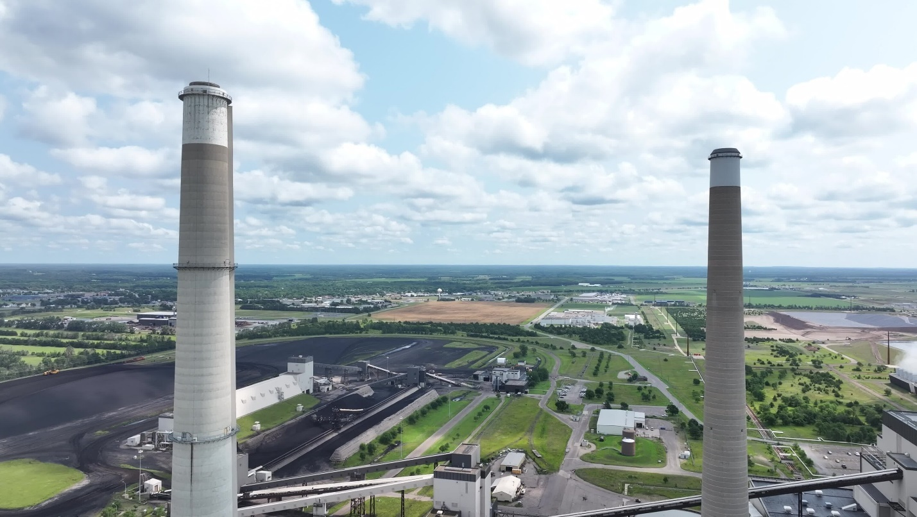

CreditCredit...

Image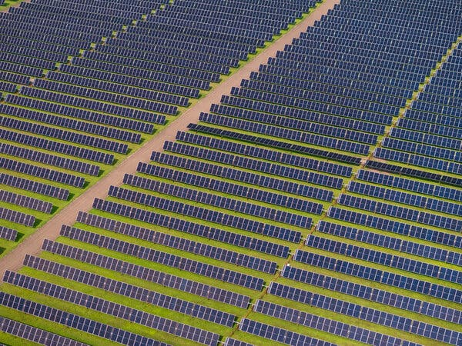

Becker crystallizes part of the legacy of the administration of Gov. Tim Walz, Vice President Kamala Harris’s running mate, and his commitment to Minnesota’s goal of [100 percent carbon-free electricity by 2040](https://mn.gov/commerce/news/?id=17-563384). And it tests how the energy transition could unfold on a nationwide scale for jobs at decades-old fossil fuel facilities, local tax revenues and agricultural businesses.

President Biden’s climate bill, the Inflation Reduction Act, aims to cut U.S. emissions at least 52 percent below 2005 levels by the end of this decade, and his administration is counting on solar power to play a significant role in decarbonizing electricity production. One Energy Department report concluded that solar energy could provide up to [40 percent of the nation’s electricity by 2035](https://www.nytimes.com/2021/09/08/business/energy-environment/biden-solar-energy-climate-change.html).

Minnesota is among the states that can benefit from the Inflation Reduction Act by using it as a tool to replace coal plants with sources like solar farms. Through the law, Sherco’s owner, Xcel Energy, received tax credits that reduced the cost of the solar project for the utility’s ratepayers.

Becker is also one of two sites where Xcel is installing [demonstration battery systems](https://stories.xcelenergy.com/ArticlePage/?id=Energy-101--How-energy-storage-makes-renewable-energy-more-reliable-) from Form Energy, a Massachusetts company. The systems — using readily available materials like water, air and iron — can store solar and wind-generated energy as a backup, with a capacity to power 2,000 homes for up to five days.

“This site is an incredibly valuable epicenter of the Upper Midwest,” Bob Frenzel, chairman and chief executive of Xcel Energy, said during a tour of the plant. “When you think about the geography of the grid, it’s incredibly valuable to maintain as an energy center.”

Besides power plants, much of the economy in and around Becker relies on agriculture, like Edling Farms.

For four generations, the Edling family made a living producing bags of potatoes for retail and wholesale customers, most of that time on land it either owned or leased near the coal plant.

Image

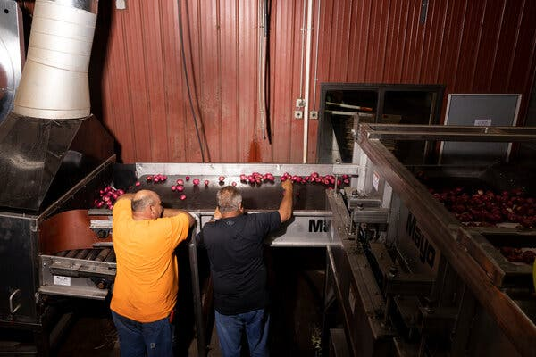

Image



Leasing has become too expensive because landowners can make four times as much from solar farm customers as they can from farmers. Farmers, the Edlings said, were paying a little more than $200 an acre on a lease, but solar developers began offering north of $900.

“Solar is a no-brainer,” said Jeff Edling, a co-owner of Edling Farms. “It’s a guaranteed check. You can’t blame them. Money talks.”

But the Edlings have no plans to quit the business their family began more than a century ago. They own the land used for the farm, though about 280 acres were leased and later lost to Xcel Energy’s solar project.

“They paid a lot of money for it,” Mr. Edling said. “So it is what it is. Everybody’s just kind of waiting to see what happens.”

Image



Jeff Edling.

Among skeptics of the energy transition, suspicion about solar runs as deep as the town’s cornfields are long. The Edlings said some residents questioned whether the solar farms would harm the soil with any chemicals and whether the renewable resource worked as well as the coal plant.

Many in the town still bristle at losing their precious plant, which supplied electricity to hundreds of thousands of homes in and around Minnesota for almost five decades. More than half the 240 jobs at the plant will soon be gone, though Xcel promises no layoffs.

Image

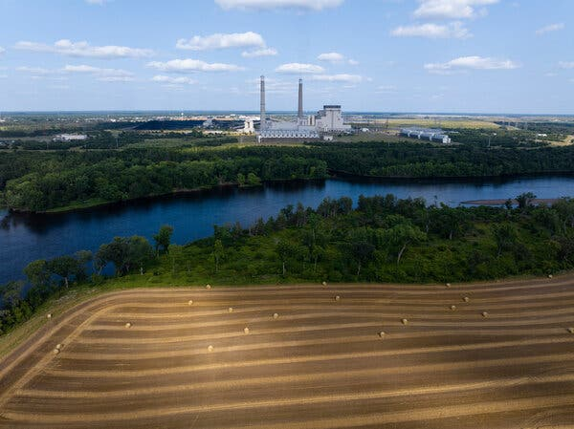

A lonely “Save Our Sherco” lawn sign continues a silent protest at a home near Ms. Bertram’s office at City Hall.

“It’s a culture transition in addition to an infrastructure transition,” said Leah Stokes, an associate professor of environmental politics at the University of California, Santa Barbara. “It may take a little while for people to understand the benefits. All of these things do take time.”

Some electricity providers have questioned the pace and breadth of changes that Minnesota has mandated.

“While we recognize the leadership demonstrated in passing policies aimed at reducing carbon emissions, we remain concerned about the legislation’s impact on affordability and reliability,” Darrick Moe, chief executive of the Minnesota Rural Electric Association, which includes 47 cooperatives that provide power to 1.7 million people, said in a statement.

But Matt Varilek, commissioner of the Minnesota Department of Employment and Economic Development, said Becker represented the kind of commitment the state was making to fight climate change and the need to ensure that the effort did not harm communities. Success in places like Becker could offer a template to help communities avoid collapse.

“We’re aware, of course, that when there’s a transition, that can cause economic dislocation, if there’s nothing to replace it,” Mr. Varilek said. With the kind of investments the state is making in Becker, “all of a sudden the clean energy transition looks a lot more palatable.”

Advertisement

[SKIP ADVERTISEMENT](https://www.nytimes.com/2024/08/19/business/energy-environment/coal-solar-power-minnesota.html#after-story-ad-1)

Most residents have resolved that the future has taken root in Becker, where a Dairy Queen arrived a year ago and a more hipster-style coffee shop and bar, Dueling Brews, has become a local gathering place.

One of the coal plant’s three coal units shut down at the end of last year. Xcel Energy plans to close the others in 2026 and 2030, adding to the decline not only in coal but in fossil fuels in general. (Some of the buildings are expected to be repurposed for future clean energy projects.) In all, the company said, it has closed 24 of its 36 coal-fired power plant units across the country.

That sharply reduces coal consumption, as a single burner in a power plant like Sherco can consume as much as 120,000 pounds of coal per hour to heat water and produce steam for turbines to generate electricity.

Image

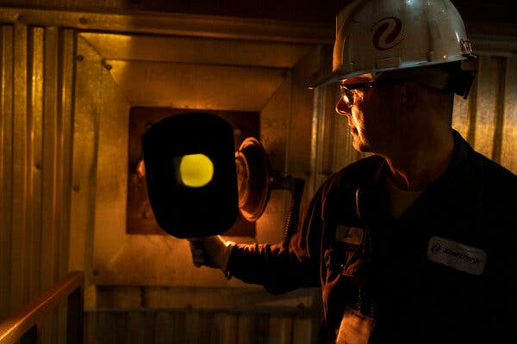

Video



CreditCredit...

Those closings contributed to a steep decline in electricity production from coal nationwide. By the end of last year, coal produced a little more than 16 percent of the nation’s electricity, down from 52 percent in 1990, and natural gas provided about 43 percent of the country’s power, according to [data](https://www.eia.gov/energyexplained/electricity/electricity-in-the-us-generation-capacity-and-sales.php#:~:text=In%201990%2C%20coal%2Dfired%20power,total%20utility%2Dscale%20electricity%20generation.) from the Energy Information Administration.

Campaigns like the Sierra Club’s [Beyond Coal](https://coal.sierraclub.org/) plan highlighted the environmental and climate hazards posed by fossil fuels and other carbon-emitting resources.

Over the next several decades, solar power is expected to replace natural gas as the single largest source of electricity production, not just in Becker but across the United States — a position once held by coal-fired generators.

The transition away from black gold, as coal has been known, has been felt on both sides of the train tracks that divide Becker into residential on the north side and industrial on the south.

Train cars loaded with coal roll through town only half as much as they used to, but the utility maintains a stockpile visible in the town — a giant mound on the plant site, weighing 1.9 million tons — that can operate the plant for as long as 100 days, Xcel Energy said.

**Editors’ Picks**

[[](https://www.nytimes.com/2025/06/16/arts/design/pigeon-fest-high-line.html)](https://www.nytimes.com/2025/06/16/arts/design/pigeon-fest-high-line.html)

[Crowning New York’s Top ‘Pigeon’](https://www.nytimes.com/2025/06/16/arts/design/pigeon-fest-high-line.html)

[[](https://www.nytimes.com/2025/06/13/t-magazine/summer-swimsuit-quiz.html)](https://www.nytimes.com/2025/06/13/t-magazine/summer-swimsuit-quiz.html)

[How to Choose the Perfect Swimsuit](https://www.nytimes.com/2025/06/13/t-magazine/summer-swimsuit-quiz.html)

[[](https://www.nytimes.com/2025/06/15/movies/how-to-train-your-dragon-mason-thames-interview.html)](https://www.nytimes.com/2025/06/15/movies/how-to-train-your-dragon-mason-thames-interview.html)

[The ‘How to Train Your Dragon’ Star Mason Thames Is Still Freaking Out](https://www.nytimes.com/2025/06/15/movies/how-to-train-your-dragon-mason-thames-interview.html)

[SKIP ADVERTISEMENT](https://www.nytimes.com/2024/08/19/business/energy-environment/coal-solar-power-minnesota.html#after-pp_edpick)

Advertisement

[SKIP ADVERTISEMENT](https://www.nytimes.com/2024/08/19/business/energy-environment/coal-solar-power-minnesota.html#after-story-ad-2)

Becker is among a half-dozen areas eligible to apply for funding from a $4.75 million state program to assist with redevelopment efforts, attract new businesses and train workers for new jobs in the move away from coal.

In addition, state investments of more than $20 million into Becker will help bring a new industrial park that includes as many as three data centers. Some power plant workers plan to relocate to a nearby nuclear plant the utility owns.

But letting go of the operation where many have spent their entire careers creates a sense of anxiety, even for those who say they understand the need to move to clean energy.

“You don’t want to see this place go,” said Rob Miller, a journeyman who has worked at the Sherco plant for 20 years. “There’s a lot of pride, blood, sweat that has gone in here. It’s sad to see it coming to an end.”

<https://www.nytimes.com/2024/08/19/business/energy-environment/coal-solar-power-minnesota.html>

#61

***Saudi Arabia Is a ‘Wrecking Ball’ in Global Climate Talks***

Despite endorsing a transition away from fossil fuels last year, Saudi officials have since worked to undermine it in at least five U.N. forums, diplomats said.

**Listen to this article · 8:11 min**[Learn more](https://help.nytimes.com/hc/en-us/articles/24318293692180)

* Share full article
* 42



Days after last year’s climate summit in Dubai, Saudi Arabia’s energy minister, Prince Abdulaziz bin Salman, began undermining the agreement.Credit...Martin Divisek/EPA, via Shutterstock

[](https://www.nytimes.com/by/lisa-friedman)

**By**[**Lisa Friedman**](https://www.nytimes.com/by/lisa-friedman)

Reporting from Washington

Published Nov. 18, 2024Updated Nov. 19, 2024

As United Nations climate talks enter their final week in Azerbaijan and G20 leaders gather in Brazil, diplomats from Saudi Arabia, [the world’s top oil exporter](https://www.nytimes.com/2022/11/21/climate/saudi-arabia-aramco-oil-solar-climate.html), are working to foil any agreement that renews a pledge to transition away from fossil fuels, negotiators said.

“Maybe they’ve been emboldened by Trump’s victory, but they are acting with abandon here,” said Alden Meyer, senior associate with E3G, a London-based climate research organization, who is at the talks in Azerbaijan. “They’re just being a wrecking ball.”

Negotiators say it’s part of a yearlong campaign by Saudi Arabia to stymie [an agreement made last year](https://www.nytimes.com/2023/12/13/climate/cop28-climate-agreement.html) by 200 nations to move away from oil, gas and coal, the burning of which is dangerously heating the planet.

Saudi Arabia was one of the signatories to that deal, but has been working ever since to bury that pledge and make sure it’s not repeated in any new global agreements, according to five diplomats who requested anonymity to discuss the closed-door negotiations.

Advertisement

[SKIP ADVERTISEMENT](https://www.nytimes.com/2024/11/18/climate/saudi-arabia-obstruction-fossil-fuels.html#after-story-ad-1)

With varying degrees of success, the Saudis have opposed transition language in at least five U.N. resolutions this year, the diplomats said. The Saudis fought it at a United Nations nuclear conference, at a summit of small island nations, during discussions of a U.N. blueprint for tackling global challenges, at a biodiversity summit and at a meeting of the Group of 20 finance ministers in Washington in October, according to the diplomats.

Saudi government officials did not immediately respond to requests for comment.

The election of Donald J. Trump has cast a pall over the climate negotiations in Azerbaijan, known as COP29. Mr. Trump has promised to withdraw the United States from the global fight against climate change and increase the American production of fossil fuels, which is already at record levels. That may be emboldening Saudi officials at the current climate talks, analysts say. On Saturday, Yasir O. Al-Rumayyan, the [chairman of the board at Saudi Aramco](https://www.aramco.com/en/about-us/our-leadership/board-of-directors), the state petroleum company, [sat ringside](https://www.foxbusiness.com/politics/trump-spotted-sitting-head-saudi-arabias-public-investment-fund-ufc-fight) with Mr. Trump at a U.F.C. fight in Madison Square Garden in New York City.

U.N. rules require that any agreement forged at climate summits be endorsed by all 198 participating nations. That means Saudi Arabia, or any other nation, can sink a deal.

**Editors’ Picks**

[[](https://www.nytimes.com/2025/06/16/arts/design/pigeon-fest-high-line.html)](https://www.nytimes.com/2025/06/16/arts/design/pigeon-fest-high-line.html)

[Crowning New York’s Top ‘Pigeon’](https://www.nytimes.com/2025/06/16/arts/design/pigeon-fest-high-line.html)

[[](https://www.nytimes.com/2025/06/13/t-magazine/summer-swimsuit-quiz.html)](https://www.nytimes.com/2025/06/13/t-magazine/summer-swimsuit-quiz.html)

[How to Choose the Perfect Swimsuit](https://www.nytimes.com/2025/06/13/t-magazine/summer-swimsuit-quiz.html)

[[](https://www.nytimes.com/2025/06/15/movies/how-to-train-your-dragon-mason-thames-interview.html)](https://www.nytimes.com/2025/06/15/movies/how-to-train-your-dragon-mason-thames-interview.html)

[The ‘How to Train Your Dragon’ Star Mason Thames Is Still Freaking Out](https://www.nytimes.com/2025/06/15/movies/how-to-train-your-dragon-mason-thames-interview.html)

[SKIP ADVERTISEMENT](https://www.nytimes.com/2024/11/18/climate/saudi-arabia-obstruction-fossil-fuels.html#after-pp_edpick)

Image



Diplomats inside the rooms in at the climate conference in Baku said the current Saudi opposition was unlike anything they had seen.Credit...Aziz Karimov/Reuters

Saudi Arabia isn’t the only country resisting the promise of a global transition away from fossil fuels or slowing progress in Baku. Countries are supposed to set new financial goals to help developing countries address global warming, and there are [deep divisions between rich and poor nations](https://www.nytimes.com/2024/11/18/climate/cop29-climate-summit-final-stretch.html) about how to move forward.

Advertisement

[SKIP ADVERTISEMENT](https://www.nytimes.com/2024/11/18/climate/saudi-arabia-obstruction-fossil-fuels.html#after-story-ad-2)

But diplomats inside the rooms in Baku said the current Saudi opposition was unlike anything they had seen. It is taking the form of procedural objections that have blocked almost every set of talks, whether on carbon markets, decarbonization, or scientific research. Saudi diplomats have blocked negotiating texts, some of which were years in the making, from being allowed to move forward and, in at least one case, flatly refused to join meetings.

**Want to stay updated on what’s happening in Saudi Arabia?** Sign up for Your Places: Global Update, and we’ll send our latest coverage to your inbox.

In one forum where diplomats were discussing how to help countries decarbonize, a Saudi diplomat accused other countries of negotiating in bad faith and told negotiators that they would not join in further meetings this week, according to one person in the room who was taking notes.

Joanna Depledge, an expert on climate negotiations at the University of Cambridge who has written extensively about Saudi Arabia, called the government “blatant and brazen” in its opposition to action on climate change.

“Whereas the U.S. might disagree strongly on something, they are usually well argued with some legal justification,” Ms. Depledge said. “But with the Saudis it’s literally a flat ‘no’ with no attempt to really justify or listen, or it uses procedural arguments that waste time.”

[**Trump Administration: Live Updates**](https://www.nytimes.com/live/2025/06/16/us/trump-news)

Updated

June 16, 2025, 9:30 p.m. ETJune 16, 2025

* [Trump renews his embrace of Putin amid his ongoing rift with his G7 allies.](https://www.nytimes.com/live/2025/06/16/us/trump-news#trump-g7-russia-ukraine)
* [The Senate proposal ends tax cuts for clean energy, disappointing climate advocates.](https://www.nytimes.com/live/2025/06/16/us/trump-news#senate-republicans-tax-package-clean-energy)
* [The Senate bill would make deep cuts to Medicaid, setting up a fight with the House.](https://www.nytimes.com/live/2025/06/16/us/trump-news#senate-bill-medicaid-cuts)

Saudi Arabia [fought efforts](https://www.nytimes.com/2023/12/10/climate/saudi-arabia-cop28-fossil-fuels.html) at COP28 to agree to a phase out of fossil fuels using tactics like giving long speeches that ate up nearly all the allotted meeting times, and inserting words into draft agreements that were considered poison pills by other countries.

Advertisement

[SKIP ADVERTISEMENT](https://www.nytimes.com/2024/11/18/climate/saudi-arabia-obstruction-fossil-fuels.html#after-story-ad-3)

Eventually, under enormous pressure from small island nations and the host government, the United Arab Emirates, the Saudis acquiesced to language [calling on nations](https://unfccc.int/sites/default/files/resource/cma2023_L17_adv.pdf) to contribute to “transitioning away from fossil fuels in energy systems, in a just, orderly and equitable manner.”

Almost immediately, Saudi Arabia appeared to work against the promise.

Days after the summit, the kingdom’s energy minister, Prince Abdulaziz bin Salman, declared that nations had [only agreed to an “à la carte menu.”](https://youtu.be/ofqW9SlQ8Fc) Posting the Dubai agreement on a faux French menu, he told attendees at a minerals conference in Riyadh that the section calling for a transition also asked nations to do several other things, like triple renewable energy, double energy efficiency measures and accelerate nuclear energy.

“What we have achieved is choices that people can pick,” the prince said.

His speech kicked off a yearlong Saudi effort to make sure that the transition language did not find its way into any other forum.

When the International Atomic Energy Agency held a first-ever nuclear summit in Brussels in March, Saudi delegates sought to block any language about an energy transition, according to two people with knowledge of the discussions.

Image



“We should abandon the fantasy of phasing out oil and gas.” Amin Nasser, the head of Saudi Aramco, told the audience at the CERAWeek oil summit in Houston.Credit...Mark Felix/Agence France-Presse — Getty Images

During the same month, Amin Nasser, the head of Saudi Aramco, which is the world’s biggest oil producer, told a gathering of the oil industry in Houston, “We should abandon the fantasy of phasing out oil and gas.”

Advertisement

[SKIP ADVERTISEMENT](https://www.nytimes.com/2024/11/18/climate/saudi-arabia-obstruction-fossil-fuels.html#after-story-ad-4)

The Saudi delegation continued its efforts in May at a meeting of the fourth International Conference on Small Island Developing States, diplomats said. They were largely successful: The summit ended with [a declaration](https://sdgs.un.org/sites/default/files/2024-05/n2409990.pdf) that referenced the need to develop renewable energy but nothing about a transition away from fossil fuels.

At the Summit of the Future 2024, a high-level U.N. event in September in New York aimed at creating a global consensus on how to address issues like climate change and international security, the Saudi delegation was less effective. Over Saudi objections, the [final pact](https://www.un.org/pga/wp-content/uploads/sites/109/2024/09/The-Pact-for-the-Future-final.pdf) called for movement away from fossil fuels.

But those present said the dispute was so fierce that, a month later when two countries at the Convention on Biological Diversity in Colombia tried to insert a provision linking fossil fuel emissions with biodiversity loss, few had the appetite for another fight. An energy transition never became part of the negotiating text, said Alex Rafalowicz, executive director of the Fossil Fuel Nonproliferation Treaty, a nonprofit group that works to persuade countries to phase out oil, gas, and coal. He said the Saudi opposition took place outside of public view.

Finally, in G20 meetings held in Washington in September, the Saudi team initially refused to support a task force on climate and finance if it included language on the fossil fuel transition.

Advertisement

[SKIP ADVERTISEMENT](https://www.nytimes.com/2024/11/18/climate/saudi-arabia-obstruction-fossil-fuels.html#after-story-ad-5)

Avinash Persaud, a climate adviser at the Inter-American Development Bank, said Saudi delegates at the G20 climate meeting argued that certain discussions about transitioning away from fossil fuels had to occur in other specific settings, not in the ones in which diplomats were negotiating at the time.

The final agreement “recalled” the fossil fuel transition but stopped short of endorsing it.

Mr. Rafalowicz said the repetition of agreements, like the transition away from fossil fuels, actually matters. Since climate deals are not legally binding, reinforcing agreements in other forums is the only way to cement countries’ promises, he said.

“When they say something once that’s an indication of direction,” Mr. Rafalowicz said. “When it gets reaffirmed at higher political levels, then it becomes clear that’s the standard and there’s no going back.”

<https://www.nytimes.com/2024/11/18/climate/saudi-arabia-obstruction-fossil-fuels.html>

#62

***As Russia Chokes Europe’s Gas, France Enters Era of Energy ‘Sobriety’***

The government is helping residents with soaring gas and electric costs, but some businesses are already shutting down amid fears of rationing and blackouts.

* Share full article



A Paris street. Some French cities plan to turn off streetlamps to conserve energy in winter.Credit...Filip Singer/European Pressphoto Agency

[](https://www.nytimes.com/by/liz-alderman)

**By**[**Liz Alderman**](https://www.nytimes.com/by/liz-alderman)

Liz Alderman, who covers business and economic issues in Europe, reported this article from Paris.

Published Sept. 5, 2022Updated Sept. 6, 2022

[Leer en español](https://www.nytimes.com/es/2022/09/08/espanol/rusia-europa-gas.html)

**The DealBook Newsletter**Our columnist Andrew Ross Sorkin and his Times colleagues help you make sense of major business and policy headlines — and the power-brokers who shape them. Get it sent to your inbox.

A factory making iconic French bistro glasses is idling its furnaces to offset soaring energy costs. Cities around France are turning off streetlamps and other outdoor lighting to curb electricity use. In Normandy, some schools will start heating classrooms by burning wood to conserve natural gas.

As Russia tightens its chokehold on Europe’s energy supplies, France is embarking on its biggest energy conservation effort since the 1970s oil crisis. President Emmanuel Macron’s government is calling on the French to prepare for a new era of energy “sobriety” to face down the threat of a hard winter, while reassuring households and businesses about the government’s ability to protect them.

“We have been confronted with a series of crises, one more grave than the other,” Mr. Macron said in a televised speech to the nation late last month. “The picture that I’m painting is one of the end of abundance,” he added. “We have reached a tipping point.”

The national effort calls for businesses and individuals to embrace energy conservation by increasing car-pooling, lowering thermostats and shutting off illuminated advertising signs at night — to name a few — or face the risk of rolling blackouts or energy rationing.

Advertisement

[SKIP ADVERTISEMENT](https://www.nytimes.com/2022/09/05/business/russia-gas-europe-france.html#after-story-ad-1)

On Friday, Agnès Pannier-Runacher, the energy transition minister, sought to reassure wary citizens, saying the government would try to “avoid restrictive measures” over energy use in the peak winter cold season.

The government has been spending lavishly — over 26 billion euros ($26 billion) since Russia’s invasion of Ukraine — to keep gas and electric bills affordable, and last week it announced that its cap on household energy bills would be extended until the end of the year. The moves to control energy costs, including the [re-nationalization of the energy provider EDF](https://www.nytimes.com/2022/07/06/world/europe/france-edf-renationalization.html), have helped give France one of the lowest inflation rates in Europe, at 6.5 percent. (The overall eurozone rate for August was 9.1 percent.)

But with food and fuel costs still straining French families, Prime Minister Élisabeth Borne has called on businesses to make the bulk of the nation’s energy savings — fast. Companies will be required to cut their energy use by 10 percent or face enforced rationing of electricity and gas.

Businesses will have to appoint an “ambassador of energy sobriety” this month, and present blueprints to the government for cutting their electricity consumption.

**Editors’ Picks**

[[](https://www.nytimes.com/2025/06/16/arts/design/pigeon-fest-high-line.html)](https://www.nytimes.com/2025/06/16/arts/design/pigeon-fest-high-line.html)

[Crowning New York’s Top ‘Pigeon’](https://www.nytimes.com/2025/06/16/arts/design/pigeon-fest-high-line.html)

[[](https://www.nytimes.com/2025/06/13/t-magazine/summer-swimsuit-quiz.html)](https://www.nytimes.com/2025/06/13/t-magazine/summer-swimsuit-quiz.html)

[How to Choose the Perfect Swimsuit](https://www.nytimes.com/2025/06/13/t-magazine/summer-swimsuit-quiz.html)

[[](https://www.nytimes.com/2025/06/15/movies/how-to-train-your-dragon-mason-thames-interview.html)](https://www.nytimes.com/2025/06/15/movies/how-to-train-your-dragon-mason-thames-interview.html)

[The ‘How to Train Your Dragon’ Star Mason Thames Is Still Freaking Out](https://www.nytimes.com/2025/06/15/movies/how-to-train-your-dragon-mason-thames-interview.html)

[SKIP ADVERTISEMENT](https://www.nytimes.com/2022/09/05/business/russia-gas-europe-france.html#after-pp_edpick)

Image



The French minister for energy transition, Agnès Pannier-Runacher, said France was taking steps to avoid rolling blackouts.Credit...Alain Jocard/Agence France-Presse — Getty Images

France is [hardly alone](https://www.nytimes.com/2022/07/29/world/europe/russia-europe-energy-gas.html?searchResultPosition=8) in scrambling to confront a severe energy crunch brought on by Russia’s grinding invasion of Ukraine.

Advertisement

[SKIP ADVERTISEMENT](https://www.nytimes.com/2022/09/05/business/russia-gas-europe-france.html#after-story-ad-2)

The apparent willingness of Russia’s president, Vladimir V. Putin, to [use energy as a weapon](https://www.nytimes.com/2022/07/26/world/europe/russia-gas-cuts-putin-eu.html?searchResultPosition=7) — last week Russia’s state-owned gas company, Gazprom, halted gas supplies to France — has sent oil and gas prices to record highs.

**Want to stay updated on what’s happening in France and Russia?** Sign up for Your Places: Global Update, and we’ll send our latest coverage to your inbox.

Countries including France have [increased reserves](https://www.nytimes.com/2022/09/03/world/europe/eu-germany-russia-natural-gas.html?searchResultPosition=2) as Gazprom turns off the taps: This weekend, France’s gas storage facilities were 92 percent full. Even so, energy bills for households and businesses [have soared](https://www.nytimes.com/2022/08/25/business/europe-electricity-prices.html?searchResultPosition=5), prompting European governments to resort to a range of offsets that few would have thought possible before the war.

Germany, Europe’s biggest user of Russian gas, reversed plans on Monday to shut down [two of its three remaining nuclear power plants](https://www.nytimes.com/2022/09/05/world/europe/germany-extend-life-nuclear-reactors.html) by the end of the year, and on Sunday announced a [$65 billion aid package](https://www.nytimes.com/2022/09/04/world/europe/scholz-germany-inflation-energy.html) to ease the burden of high energy costs on citizens. [Italy is looking to Algeria](https://www.nytimes.com/2022/07/20/world/europe/eu-gas-rationing-russia-war.html) as a potential new supplier of natural gas to replace Russian fuel. In Spain, the government has begun a huge effort to [improve energy efficiency](https://www.nytimes.com/2022/08/05/world/europe/spain-air-conditioning-limits.html) in buildings and in industry.

France would seem to be less vulnerable than its neighbors: It boasts the biggest nuclear energy arsenal of any European Union country, and is one of the least reliant on Russian natural gas. But France [faces an energy crisis of its own](https://www.nytimes.com/2022/06/18/business/france-nuclear-power-russia.html?searchResultPosition=6), as its nuclear industry addresses cracks, corrosion and other troubles that have forced EDF to temporarily shut down 32 of France’s 56 nuclear reactors.

Advertisement

[SKIP ADVERTISEMENT](https://www.nytimes.com/2022/09/05/business/russia-gas-europe-france.html#after-story-ad-3)

The outages at EDF, which is also Europe’s biggest electricity exporter, have sent France’s nuclear power output plunging to its lowest level in nearly three decades. In addition, France’s worst drought in 30 years this summer has lowered river levels, cutting supplies of hydroelectric power.

Image

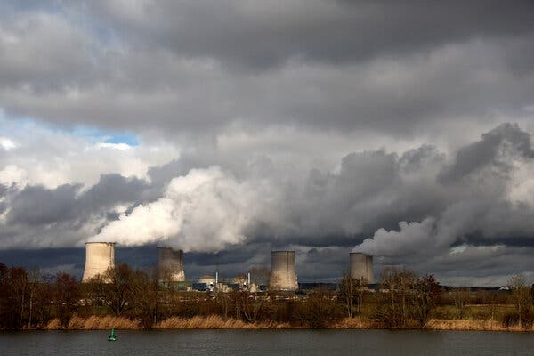

An EDF nuclear power plant in Cattenom, France. With half its nuclear power plants temporarily offline, France is more vulnerable to Europe’s energy crisis.Credit...Pascal Rossignol/Reuters

Instead of pumping vast amounts of electricity to Britain, Italy and other European countries pivoting from Russian fuel, France now faces the unsettling prospect of initiating rolling blackouts in winter and having to import power or resort to coal-fired plants to meet its energy needs — scenarios the government is desperate to avoid.

The crunch is already starting to force temporary shutdowns at energy-intensive companies, including steel, chemical and glass makers. On Friday, wholesale electricity prices for 2023 in France set a record, surging past €1,000 per megawatt-hour. Many French companies and retailers buy their electricity with three-year contracts that are set to expire, meaning they will have to be renewed at peak prices.

[Duralex International,](https://www.duralex.com/) the maker of classic bistro wine and water glasses, announced last week that it would put its furnaces on standby for at least four months starting in November and place its 250 employees on furlough to save energy and cash.

Advertisement

[SKIP ADVERTISEMENT](https://www.nytimes.com/2022/09/05/business/russia-gas-europe-france.html#after-story-ad-4)

The company said it had been facing “for several months very unfavorable financial production conditions, solely linked to the price of energy,” which exploded after the Russian invasion of Ukraine.

“Producing at the daily price energy rate would generate unsustainable losses,” José-Luis Llacuna, president of Duralex, said in the statement, adding that he didn’t expect the factory to restart until the second quarter of 2023.

Image

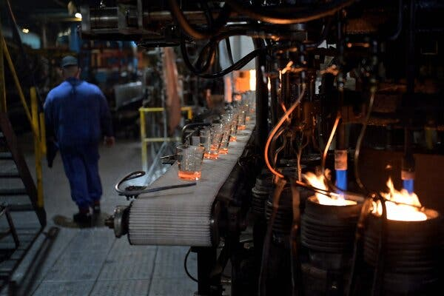

The Duralex glass factory in La Chapelle-Saint-Mesmin last year. The company said it would shut down operations for at least four months. Credit...Guillaume Souvant/Agence France-Presse — Getty Images

At [Cristal d’Arques](https://www.arc-intl.com/en/), the French maker of elegant crystal wine goblets, 1,650 of the company’s 5,000 employees will be put on partial furlough through year-end. Guillaume Rabel-Suquet, the communications director, told French television that the company’s gas bill quadrupled from the end of last year, to €75 million, and could reach €260 million in 2023 if prices don’t drop, making operations “economically unviable.”

The government has tried to offset some, but not all, of the pain for companies, although it recently announced a special €3 billion fund to help businesses that can’t pay their energy bills.

Advertisement

[SKIP ADVERTISEMENT](https://www.nytimes.com/2022/09/05/business/russia-gas-europe-france.html#after-story-ad-5)

President Macron, who faced a stiff presidential election campaign in April that saw the far-right challenger, Marine Le Pen, gain ground by addressing French families’ [worries over purchasing power](https://www.nytimes.com/2022/04/18/world/europe/france-election-economy.html?searchResultPosition=2), has focused on shielding households from rising energy costs.

A 4 percent cap on increases to household electricity prices that began last winter will be extended until the end of the year, and will continue into 2023 for vulnerable families, France’s finance minister, Bruno Le Maire, said last week. The price ceiling is a stark contrast to an [80 percent increase](https://www.nytimes.com/2022/08/26/business/uk-energy-price-cap.html) in energy bills that households in Britain are expected to face next month.

Without the cap, French inflation would be about three percentage points higher, the French statistics agency Insee said in a report issued Friday.

Nonetheless, French citizens will have to pull their weight, Ms. Borne cautioned. In recent days, the government issued announcements calling on the French to curb a range of activities, in hopes of collectively saving energy. Among them: refraining from running washers at night, keeping thermostats at 66 degrees Fahrenheit and increasing use of public transportation.

Image



A swimming pool in Marseille. Public pools across France have been closing more frequently to conserve energy.Credit...Dmitry Kostyukov for The New York Times

Advertisement

[SKIP ADVERTISEMENT](https://www.nytimes.com/2022/09/05/business/russia-gas-europe-france.html#after-story-ad-6)

Towns and cities across the land were urged to double down on energy savings in almost any way they saw fit. Many municipalities outside Paris started closing swimming pools intermittently this summer to save money. Other cities are restricting public lighting, which can account for over 40 percent of electricity bills.

The town of Thouars in western France has been turning off streetlights from 10 p.m. to 6 a.m. since June and plans to replace bulbs with LED lighting. Strasbourg, a mid-size city on the German border, will close museums two days a week instead of one.

In northern France, some high schools in Brittany will lower their thermostats, while the neighboring region of Normandy will experiment with using wood-burning furnaces for heat in some schools as an alternative to gas.

And businesses have until October to submit their plans for cutting electrical consumption by 10 percent.

“We need a radical change,” Ms. Borne said. “Everyone must ask themselves what they can do to consume less.”

<https://www.nytimes.com/2022/09/05/business/russia-gas-europe-france.html>

#64

***Fossil Fuels Aren’t Going Anywhere***

Exxon’s $60 billion acquisition doubles down on oil and gas.

* Share full article

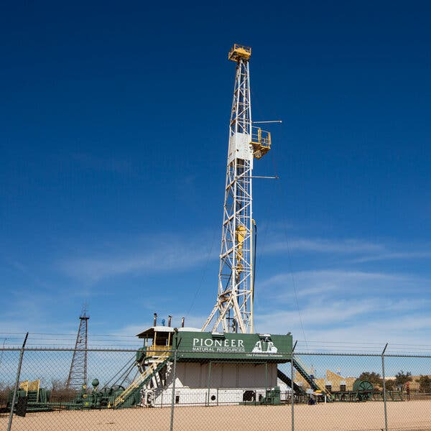

An oil rig in the Permian Basin, the most productive U.S. oil and gas field.Credit...Jacob Ford/Odessa American, via Associated Press

[](https://www.nytimes.com/by/david-gelles)

**By**[**David Gelles**](https://www.nytimes.com/by/david-gelles)

Oct. 12, 2023

**You’re reading the Climate Forward newsletter, for Times subscribers only.**News and insights for a warming world. Get it with a Times subscription.

It wasn’t long ago that big fossil fuel companies were making bold claims about their plans to embrace a low-carbon future. Yet over the past year, many of those companies have walked back those commitments as they reaped outsize profits and made ambitious plans to expand their production of oil and gas.

On Wednesday, [Exxon Mobil signed a $60 billion deal to buy Pioneer Natural Resources](https://www.nytimes.com/2023/10/11/business/economy/exxon-mobil-pioneer-natural-resources.html), a company that made its fortune through fracking. The acquisition — Exxon’s biggest in almost 25 years, and the biggest corporate purchase of 2023 — represents a very expensive bet that fossil fuels will remain a central part of the global economy for the foreseeable future.

“As the world looks to transition and find lower sources of affordable energy with lower emissions, fossil fuels oil and gas are going to continue to play a role over time,” [Exxon Mobil chief executive Darren Woods told CNBC](https://www.cnbc.com/video/2023/10/11/exxon-mobil-ceo-darren-woods-on-pioneer-deal-brings-higher-recovery-at-lower-costs.html). “That may diminish with time. The rate of that is, I think, not very clear at this stage. But it will be around for a long time.”

Like it or not, Exxon’s bet looks like a sound one. While wind turbines and solar panels are [proliferating faster than many people realize](https://www.nytimes.com/interactive/2023/08/12/climate/clean-energy-us-fossil-fuels.html), fossil fuel extraction is also expanding around the globe. [Hundreds of new oil and gas projects](https://www.nytimes.com/2023/04/06/climate/oil-gas-drilling-investment-worldwide-willow.html) have been approved in the past year.

Advertisement

[SKIP ADVERTISEMENT](https://www.nytimes.com/2023/10/12/climate/fossil-fuels-arent-going-anywhere.html#after-story-ad-1)

In the United States, that includes headline-grabbing new projects like the [Willow development in Alaska](https://www.nytimes.com/2023/04/06/climate/willow-alaska-oil-biden.html) and the [Mountain Valley Pipeline](https://www.nytimes.com/2023/05/30/climate/mountain-valley-pipe.html) in West Virginia. In places like Qatar, Norway, Brazil, China and India, new oil, gas and coal projects are getting approved practically every week. The United Arab Emirates, which is hosting the United Nations climate negotiations next month, has [said it would keep producing oil](https://www.nytimes.com/2023/09/14/climate/sultan-al-jaber-uae-cop28.html) “as long as the market demands it.”

**Supply and demand**

Scientists say that nations must stop approving new oil drilling and coal mining if the world has any hope of constraining global warming to relatively safe levels. But without a dramatic shift by governments and corporations around the world, the market will be demanding oil and gas for years to come.

The International Energy Agency notes that [for decades now](https://www.iea.org/reports/world-energy-outlook-2022/executive-summary), “the share of fossil fuels in the global energy mix has been stubbornly high, at around 80 percent.” The I.E.A. sees the beginnings of gradual decline, but estimates that fossil fuels will account for more than half of global energy production 20 years from now.

Volatile geopolitics are routinely cited as justification for continued fossil fuel production. Exxon reported a record profit of $56 billion last year thanks largely to the price spike caused by Russia’s war in Ukraine. That cash can now be used to invest in Pioneer’s shale oil fields in the Permian Basin, where fracking has turned the United States into [the world’s biggest oil producer](https://www.eia.gov/energyexplained/oil-and-petroleum-products/where-our-oil-comes-from.php).

Even if fewer fossil fuels are used for energy production, [the booming petrochemical business](https://www.nytimes.com/2023/09/20/climate/michael-blooomberg-climate-petrochemicals.html) could keep demand high. As my colleague Clifford Krauss reported, Exxon is a petrochemical powerhouse. It needs more oil and gas to turn into gasoline, diesel, plastics, liquefied natural gas, chemicals and other products.

**Editors’ Picks**

[[](https://www.nytimes.com/2025/06/16/arts/design/pigeon-fest-high-line.html)](https://www.nytimes.com/2025/06/16/arts/design/pigeon-fest-high-line.html)

[Crowning New York’s Top ‘Pigeon’](https://www.nytimes.com/2025/06/16/arts/design/pigeon-fest-high-line.html)

[[](https://www.nytimes.com/2025/06/13/t-magazine/summer-swimsuit-quiz.html)](https://www.nytimes.com/2025/06/13/t-magazine/summer-swimsuit-quiz.html)

[How to Choose the Perfect Swimsuit](https://www.nytimes.com/2025/06/13/t-magazine/summer-swimsuit-quiz.html)

[[](https://www.nytimes.com/2025/06/15/movies/how-to-train-your-dragon-mason-thames-interview.html)](https://www.nytimes.com/2025/06/15/movies/how-to-train-your-dragon-mason-thames-interview.html)

[The ‘How to Train Your Dragon’ Star Mason Thames Is Still Freaking Out](https://www.nytimes.com/2025/06/15/movies/how-to-train-your-dragon-mason-thames-interview.html)

[SKIP ADVERTISEMENT](https://www.nytimes.com/2023/10/12/climate/fossil-fuels-arent-going-anywhere.html#after-pp_edpick)

Advertisement

[SKIP ADVERTISEMENT](https://www.nytimes.com/2023/10/12/climate/fossil-fuels-arent-going-anywhere.html#after-story-ad-2)

“Fossil fuels are not ready to leave,” said Jon Creyts, chief executive of RMI, a nonprofit organization that supports clean energy. “And they’re going to continue to operate with full capital market support here for a while*.”*

**‘Bound to the returns’**

Fossil fuel companies, including Exxon, are optimistic about the promise of “advancements in technology” that could prevent carbon emissions from reaching the atmosphere or remove them once they are in the air. Yet this technology is currently prohibitively expensive, and while it might be effective at a small scale, it wouldn’t be able to offset the enormous volume of emissions on the horizon.

What’s more, there is no tax on carbon emissions, and no sign of the political will needed to enact one. That means that governments have no real way to financially penalize oil companies for their emissions.

Exxon is flush with cash and a record high stock price. But instead of investing in clean energy, it is choosing to produce more oil and gas. The ruthless logic of the marketplace is pushing Exxon and other big oil companies to double down on fossil fuels instead of investing in green technologies.

“They are absolutely bound to the returns,” Creyts said. “They’re bound to perform relative to market expectations. And any attempt to create a venture business that does not provide the returns that are expected as a large company gets penalized.”

Advertisement

[SKIP ADVERTISEMENT](https://www.nytimes.com/2023/10/12/climate/fossil-fuels-arent-going-anywhere.html#after-story-ad-3)

There will be grave implications for the planet, which has already warmed by about 1.2 degrees Celsius above preindustrial levels. This year is shaping up to be the hottest on record, with record heat on land and the ocean fueling extreme weather around the world.

The continued growth of emissions means that this warming trend is all but certain to continue. “We need to be ready for a hotter planet,” Creyts said. “We need to be ready for tipping points to be crossed.”

Image



Ajay Banga, president of the World Bank, has focused on climate change.Credit...Tony Karumba/Agence France-Presse — Getty Images

**Can the World Bank help Africa?**

For the first time in half a century, the World Bank and the International Monetary Fund are holding their annual meetings in Africa.

Advertisement

[SKIP ADVERTISEMENT](https://www.nytimes.com/2023/10/12/climate/fossil-fuels-arent-going-anywhere.html#after-story-ad-4)

The arrival of officials from financial institutions from around the world in Marrakesh, Morocco, this week is part of an effort to give African countries a bigger voice in institutions that play a huge role in their economies. Both the I.M.F. and the World Bank are [considering adding an extra seat](https://www.lemonde.fr/en/economy/article/2023/10/06/sub-saharan-africa-set-for-stronger-voice-at-imf-georgieva_6152827_19.html) for the continent on their boards.

But inclusion alone won’t give African leaders what they desperately need as they try to build their economies and grapple with climate change: A way out of crippling debt that they owe to international lenders.

“Debt is one of the biggest topics at the annual meetings of the I.M.F. and the World Bank in Marrakesh this week,” my colleague Alan Rappeport told me from Morocco. “It’s been a brewing crisis for many of the world’s poorest countries and there’s been growing pressure on China, the world’s largest creditor, to offer some relief by restructuring these loans.”

[African leaders have called for a pause](https://www.nytimes.com/2023/10/08/opinion/climate-change-africa-debt.html) in repayments because their debt burden has risen for reasons beyond their control, such as the aftershocks of the pandemic and rising food and fuel prices.

As Ajay Banga, the new head of the World Bank, tries to reshape the role of his institution to address climate change, he is finding that debt is a [more complicated problem](https://www.nytimes.com/2023/05/09/climate/ajay-banga-world-bank.html) than ever. Countries owe to a more diverse set of creditors, including governments, multilateral institutions and private investors, and getting all of them to agree on a deal with a single country is hard. It [took Zambia three years](https://www.reuters.com/world/africa/zambia-seals-63-billion-debt-restructuring-deal-2023-06-22/), and that was considered progress. This morning, China and Sri Lanka also announced a tentative agreement to [restructure the debt that Sri Lanka owes to China’s Export-Import Bank](https://www.bloomberg.com/news/articles/2023-10-10/china-says-exim-bank-sri-lanka-reached-preliminary-debt-deal-lnk4c38i).

Advertisement

[SKIP ADVERTISEMENT](https://www.nytimes.com/2023/10/12/climate/fossil-fuels-arent-going-anywhere.html#after-story-ad-5)

The impasse goes to the heart of why developing countries are the most impacted by climate change. It’s not just that many are heating up faster [than the world average](https://public.wmo.int/en/media/press-release/africa-suffers-disproportionately-from-climate-change#:~:text=%E2%80%9CGiven%20Africa's%20high%20exposure%2C%20fragility,to%20be%20felt%20more%20severely.). They also lack the financial resources to protect their citizens against climate-related disasters.

“Countries in the West often plead with us to invest in the kind of ambitious resilience projects we need to survive in a warming world,” wrote William Ruto, president of Kenya, along with the heads of two multilateral institutions, in a [Times Opinion essay this week](https://www.nytimes.com/2023/10/08/opinion/climate-change-africa-debt.html). “But in Africa, we can’t fix the climate issue unless we fix the debt issue.”

Banga, who has only been on the job since May, says it will be a long road to solve the problem.

“I wish there was a magic wand that said, abracadabra, we’ll just wipe the debt out of the system, but I don’t think that is likely to happen,” [he said](https://www.youtube.com/watch?v=FxGt03umhjA). “This is hard work, and it needs to be done the right way.” — *Manuela Andreoni*

<https://www.nytimes.com/2023/10/12/climate/fossil-fuels-arent-going-anywhere.html>

#65

***The U.S. Urgently Needs a Bigger Grid. Here’s a Fast Solution.***

A rarely used technique to upgrade old power lines could play a big role in fixing one of the largest obstacles facing clean energy, two reports found.

**Listen to this article · 8:04 min**[Learn more](https://help.nytimes.com/hc/en-us/articles/24318293692180)

* Share full article
* 875

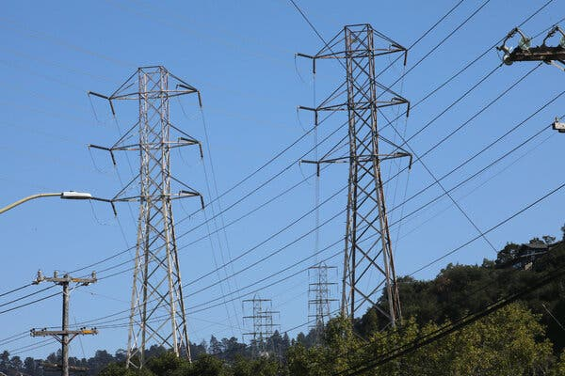

Replacing existing power lines with cables made from state-of-the-art materials could roughly double the capacity of the electric grid in many parts of the country.Credit...Jim Wilson/The New York Times

[](https://www.nytimes.com/by/brad-plumer)

**By**[**Brad Plumer**](https://www.nytimes.com/by/brad-plumer)

Published April 9, 2024Updated April 14, 2024

One of the biggest obstacles to expanding clean energy in the United States is a lack of power lines. Building new transmission lines can take a decade or more because of permitting delays and local opposition. But there may be a faster, cheaper solution, [according to two reports released Tuesday](https://www.2035report.com/reconductoring/).

Replacing existing power lines with cables made from state-of-the-art materials could roughly double the capacity of the electric grid in many parts of the country, making room for much more wind and solar power.

This technique, known as “advanced reconductoring,” is widely used in other countries. But many U.S. utilities have been slow to embrace it because of their unfamiliarity with the technology as well as regulatory and bureaucratic hurdles, researchers found.

“We were pretty astonished by how big of an increase in capacity you can get by reconductoring,” said Amol Phadke, a senior scientist at the University of California, Berkeley, who contributed to one of the reports released Tuesday. Working with GridLab, a consulting firm, researchers from Berkeley looked at what would happen if advanced reconductoring were broadly adopted.

Advertisement

[SKIP ADVERTISEMENT](https://www.nytimes.com/2024/04/09/climate/electric-grid-more-power.html#after-story-ad-1)

“It’s not the only thing we need to do to upgrade the grid, but it can be a major part of the solution,” Dr. Phadke said.

Today, most power lines consist of steel cores surrounded by strands of aluminum, a design that’s been around for a century. In the 2000s, several companies developed cables that used smaller, lighter cores such as carbon fiber and that could hold more aluminum. These advanced cables can carry up to twice as much current as older models.

Replacing old lines can be done relatively quickly. In 2011, AEP, a utility in Texas, urgently needed to deliver more power to the Lower Rio Grande Valley to meet soaring population growth. It would have taken too long to acquire land and permits and to build towers for a new transmission line. Instead, AEP [replaced 240 miles of wires on an existing line](https://www.quantaenergized.com/wp-content/uploads/2015/05/EEI-Energy-Biz_pages.pdf) with advanced conductors, which took less than three years and increased the carrying capacity of the lines by 40 percent.

In many places, upgrading power lines with advanced conductors could nearly double the capacity of existing transmission corridors at less than half the cost of building new lines, researchers found. If utilities began deploying advanced conductors on a nationwide scale — replacing thousands of miles of wires — they could add four times as much transmission capacity by 2035 as they are currently on pace to do.

That would allow the use of much more solar and wind power from thousands of projects [that have been proposed but can’t move forward](https://www.nytimes.com/2023/02/23/climate/renewable-energy-us-electrical-grid.html) because local grids are too clogged to accommodate them.

**Editors’ Picks**

[[](https://www.nytimes.com/2025/06/16/arts/design/pigeon-fest-high-line.html)](https://www.nytimes.com/2025/06/16/arts/design/pigeon-fest-high-line.html)

[Crowning New York’s Top ‘Pigeon’](https://www.nytimes.com/2025/06/16/arts/design/pigeon-fest-high-line.html)

[[](https://www.nytimes.com/2025/06/13/t-magazine/summer-swimsuit-quiz.html)](https://www.nytimes.com/2025/06/13/t-magazine/summer-swimsuit-quiz.html)

[How to Choose the Perfect Swimsuit](https://www.nytimes.com/2025/06/13/t-magazine/summer-swimsuit-quiz.html)

[[](https://www.nytimes.com/2025/06/15/movies/how-to-train-your-dragon-mason-thames-interview.html)](https://www.nytimes.com/2025/06/15/movies/how-to-train-your-dragon-mason-thames-interview.html)

[The ‘How to Train Your Dragon’ Star Mason Thames Is Still Freaking Out](https://www.nytimes.com/2025/06/15/movies/how-to-train-your-dragon-mason-thames-interview.html)

[SKIP ADVERTISEMENT](https://www.nytimes.com/2024/04/09/climate/electric-grid-more-power.html#after-pp_edpick)

Advertisement

[SKIP ADVERTISEMENT](https://www.nytimes.com/2024/04/09/climate/electric-grid-more-power.html#after-story-ad-2)

Installing advanced conductors is a promising idea, but questions remain, including how much additional wind and solar power can be built near existing lines, said Shinjini Menon, the vice president of asset management and wildfire safety at Southern California Edison, one of the nation’s largest utilities. Power companies would probably still need to build lots of new lines to reach more remote windy and sunny areas, she said.

“We agree that advanced conductors are going to be very, very useful,” said Ms. Menon, whose company has already embarked on multiple reconductoring projects in California. “But how far can we take it? The jury’s still out.”

Experts broadly agree that the sluggish build-out of the electric grid is the Achilles’ heel of the transition to cleaner energy. The Energy Department estimates that the nation’s network of transmission lines [may need to expand by two-thirds or more](https://www.nytimes.com/2023/10/30/climate/energy-department-electric-grid.html) by 2035 to meet President Biden’s goals to power the country with clean energy.

But building transmission lines has become a brutal slog, and it can take a decade or more for developers to site a new line through multiple counties, receive permission from a patchwork of different agencies and address lawsuits about spoiled views or damage to ecosystems. Last year, the United States added just [251 miles of high-voltage transmission lines](https://cms.ferc.gov/media/energy-infrastructure-update-december-2023), a number that has been declining for a decade.

The climate stakes are high. In 2022, Congress approved hundreds of billions of dollars for solar panels, wind turbines, electric vehicles and other nonpolluting technologies to tackle global warming as part of the Inflation Reduction Act. But if the United States can’t add new transmission capacity more quickly, roughly half the emission reductions expected from that law [may not materialize](https://repeatproject.org/docs/REPEAT_Climate_Progress_and_the_117th_Congress.pdf), researchers at the Princeton-led REPEAT Project found.

Advertisement

[SKIP ADVERTISEMENT](https://www.nytimes.com/2024/04/09/climate/electric-grid-more-power.html#after-story-ad-3)

The difficulty of building new lines has led many energy experts and industry officials to explore ways to squeeze more out of the existing grid. That includes [“grid-enhancing technologies”](https://www.pnas.org/doi/10.1073/pnas.2322803121) such as sensors that allow utilities to send more power through existing lines without overloading them and advanced controls that allow operators to ease congestion on the grid. Studies have found these techniques can increase grid capacity by 10 to 30 percent at a low cost.

Countries like Belgium and the Netherlands have been widely deploying advanced conductors in order to integrate more wind and solar power, said Emilia Chojkiewicz, one of the authors of the Berkeley report.

“We talked with the transmission system planners over there and they all said this is a no-brainer,” Ms. Chojkiewicz said. “It’s often difficult to get new rights of way for lines, and reconductoring is much faster.”

If reconductoring is so effective, why don’t more utilities in the United States do it? That question was the focus of the second report released Tuesday, by GridLab and Energy Innovation, a nonprofit organization.

One problem is the fragmented nature of America’s electricity system, which is actually three grids run by 3,200 different utilities and a complex patchwork of regional planners and regulators. That means new technologies — which require careful study and worker retraining — sometimes spread more slowly than they do in countries with just a handful of grid operators.

Advertisement

[SKIP ADVERTISEMENT](https://www.nytimes.com/2024/04/09/climate/electric-grid-more-power.html#after-story-ad-4)

“Many utilities are risk averse,” said Dave Bryant, the chief technology officer for CTC Global, a leading manufacturer of advanced conductors that has projects in more than 60 countries.

There are also mismatched incentives, the report found. Because of the way in which utilities are compensated, they often have more financial incentive to build new lines rather than to upgrade existing equipment. Conversely, some regulators are wary of the higher upfront cost of advanced conductors — even if they pay for themselves over the long run. Many utilities also have little motivation to cooperate with one another on long-term transmission planning.

“The biggest barrier is that the industry and regulators are still caught in a short-term, reactive mind-set,” said Casey Baker, a senior program manager at GridLab. “But now we’re in an era where we need the grid to grow very quickly, and our existing processes haven’t caught up with that reality.”

That may be starting to change in some places. In Montana, Northwestern Energy recently replaced part of an aging line with advanced conductors to reduce wildfire risk — the new line sagged less in the heat, making it less likely to make contact with trees. Pleased with the results, Montana legislators [passed a bill](https://energycentral.com/c/tr/montana-legislature-supports-use-advanced-conductors-improve-td-efficiency) that would give utilities financial incentives to install advanced conductors. A bill in Virginia [would require utilities](https://lis.virginia.gov/cgi-bin/legp604.exe?241+ful+HB862H1) to consider the technology.

With electricity demand [beginning to surge for the first time in two decades](https://www.nytimes.com/interactive/2024/03/13/climate/electric-power-climate-change.html) because of new data centers, factories and electric vehicles, creating bottlenecks on the grid, many utilities are getting over their wariness about new technologies.

“We’re seeing a lot more interest in grid-enhancing technologies, whether it’s reconductoring or other options,” said Pedro Pizarro, the president and chief executive of Edison International, a California power company, and the chairman of the Edison Electric Institute, a utility trade organization. “There’s a sense of urgency.”

<https://www.nytimes.com/2024/04/09/climate/electric-grid-more-power.html>

#66

***Dead Chicks and Rotting Meat: South Africa Declares ‘Disaster’ Over Power Cuts***

President Cyril Ramaphosa, facing rising public wrath, on Thursday declared a “state of disaster” and pledged to end an energy crisis that threatens economic and political stability.

* Share full article
* 54

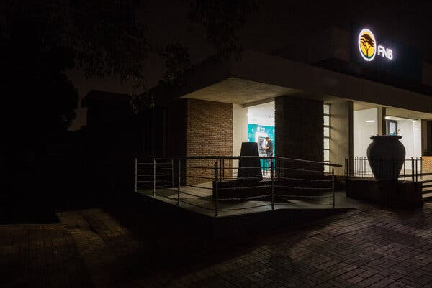

Bank ATMs providing light from solar power in an otherwise dark city center because of power cuts in Meyerton, South Africa, on Thursday.Credit...Ilan Godfrey for The New York Times

[](https://www.nytimes.com/by/lynsey-chutel)

**By**[**Lynsey Chutel**](https://www.nytimes.com/by/lynsey-chutel)

Lynsey Chutel interviewed business owners and customers in Meyerton, South Africa, outside Johannesburg, to report this article.

Feb. 9, 2023

With South Africa enduring daily power outages of up to 10 hours, President Cyril Ramaphosa declared a nationwide “state of disaster” on Thursday to address an electricity crisis so dire that day-old chicks are freezing to death, supermarket owners are rushing to sell meat before it spoils and many businesses have been forced to shut down.

The blackouts are caused by an aging fleet of coal-fired power stations that the dysfunctional state power company, Eskom, is struggling to keep online. Power cuts have been a part of life in South Africa for nearly 16 years, but the past several months have been the darkest yet.

From large industries to mom-and-pop stores, many businesses have closed or laid off workers in a country where one in three people is already jobless. With the outages driving up the cost of doing business, prices for everyday goods have shot up, as has the frustration of a populace losing faith in the government.

“We are therefore declaring a national state of disaster to respond to the electricity crisis and its effect,” Mr. Ramaphosa announced in his state-of-the-nation speech. “The people of South Africa want action; they want solutions.”

The blackouts have consumed the president and his party, the African National Congress, which had promised to reinvigorate South Africa’s collapsing economy.

Political opponents and civic organizations have staged large street protests and dragged the government to court for failing to uphold its constitutional mandate as the outages have interrupted trade, education and health care.

Despite the dramatic “disaster” declaration, effective immediately, Mr. Ramaphosa did not offer any new plan to end the crisis. He said that he was appointing a minister of electricity, and that the declaration would allow the government to accelerate power projects and exempt food producers and other critical industries from power cuts.

For all the political bluster, the crisis plays out in life’s most mundane rituals, in places like Meyerton, a town 34 miles southwest of Johannesburg surrounded by farms and factories.

**Editors’ Picks**

[[](https://www.nytimes.com/2025/06/16/arts/design/pigeon-fest-high-line.html)](https://www.nytimes.com/2025/06/16/arts/design/pigeon-fest-high-line.html)

[Crowning New York’s Top ‘Pigeon’](https://www.nytimes.com/2025/06/16/arts/design/pigeon-fest-high-line.html)

[[](https://www.nytimes.com/2025/06/13/t-magazine/summer-swimsuit-quiz.html)](https://www.nytimes.com/2025/06/13/t-magazine/summer-swimsuit-quiz.html)

[How to Choose the Perfect Swimsuit](https://www.nytimes.com/2025/06/13/t-magazine/summer-swimsuit-quiz.html)

[[](https://www.nytimes.com/2025/06/15/movies/how-to-train-your-dragon-mason-thames-interview.html)](https://www.nytimes.com/2025/06/15/movies/how-to-train-your-dragon-mason-thames-interview.html)

[The ‘How to Train Your Dragon’ Star Mason Thames Is Still Freaking Out](https://www.nytimes.com/2025/06/15/movies/how-to-train-your-dragon-mason-thames-interview.html)

Image



Rebecca Mokhemisa, second from right, a supermarket cook in Meyerton, frying up thawing meat to minimize the losses that small businesses like this one have suffered during the country’s energy crisis.Credit...Ilan Godfrey for The New York Times

At Foodzone, a corner supermarket just off the main road, when the clock struck noon on a recent day, the music stopped abruptly, the refrigerators stopped humming and the fluorescent lights went dark.

“Oh, see, there it goes,” said Karina da Silva, the store’s co-owner.

It was the second power outage of the day, and the refrigerators were as warm as a cupboard. Ms. da Silva and her husband, Eddie da Silva, rifled through packs of sausages, chicken and burger patties, checking their expiration dates. Mr. da Silva fired up a generator to keep the cash registers going, and the supermarket’s cooks fried up the thawing meat on a gas burner to sell at a discount to customers whose stoves at home would be useless during the outage. The store has taken most of its egg dishes off the menu.

**Want to stay updated on what’s happening in South Africa?** Sign up for Your Places: Global Update, and we’ll send our latest coverage to your inbox.

“You don’t want a rotten egg in your store,” said Mr. da Silva, tapping his nose.

Laying off their already lean staff of 14 would make running the store impossible, and the da Silvas are not sure how they will survive.

“I don’t think things are going to change for us; it’s not going to get better,” Ms. da Silva said.

Since 2007, power outages have become so common that Eskom, the national electricity supplier, has devised a schedule to cut the power to different neighborhoods at different times. It calls these periods of national frustration “loadshedding.”

Image



Residents lined up in the parking lot of the Meyerton License Department during a scheduled power outage.Credit...Ilan Godfrey for The New York Times

Eskom’s troubles are the result of a century of poor management, experts on energy and economics said in interviews. During apartheid, the utility, which mostly supplied the country’s white minority, subsidized the cost of electricity for big industries like mining, meaning that many lucrative companies did not pay their fair share.

That legacy of low tariffs continues to hamper Eskom’s ability to cover basic costs like maintenance, said Jesse Burton, a researcher in the Energy Systems Research Group at the University of Cape Town.

When the A.N.C. came to power in 1994, it failed to expand the utility at a time when the fleet began to buckle under growing demand and shrinking revenue. Corruption and incompetence in the construction of new power plants only made things worse. Mismanagement in successive presidential administrations hobbled Eskom until it collapsed.

“It’s institutional failure at every level,” said Ms. Burton. “They’re in a debt spiral, and they’re in a maintenance spiral.”

Since taking office five years ago, Mr. Ramaphosa created a broad-reaching strategy to save Eskom. It included a plan to fix existing power stations, introduce renewable energy and allow private companies to produce power.

But the plan has produced few visible results. Those charged with solving the problem are bitterly divided. Gwede Mantashe, South Africa’s energy minister and one of Mr. Ramaphosa’s top lieutenants in the A.N.C., accused Andre de Ruyter, the chief executive of Eskom, in December of trying to undermine the A.N.C.-led government.

Image

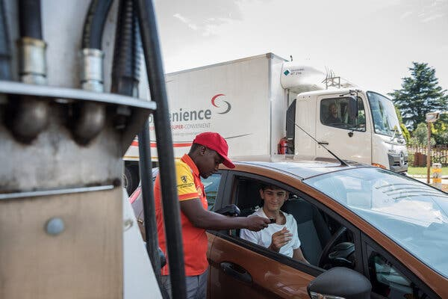

Tumelo Motaung, 31, taking a card payment from Xander Koekemoer, 18, who bought fuel to keep his parents’ home generator running in Meyerton this week. Card payment systems can be affected by outages.Credit...Ilan Godfrey for The New York Times

Mr. de Ruyter, tapped by Mr. Ramaphosa to save Eskom, quit a week later. He said in an [interview](https://www.ft.com/content/2c3cb585-a4c9-4a26-9ea4-c22e1aded598) with The Financial Times that someone had tried to assassinate him by lacing his coffee with cyanide. Eskom declined to comment on the allegation, and Mr. de Ruyter did not respond to a message seeking comment.

The fatal flaw in Mr. Ramaphosa’s effort to rescue Eskom is that he has tried to do too many things at once, said Khaya Sithole, an economic analyst in Johannesburg. His plan, like those of previous administrations, failed to focus on the fundamental challenge: maintenance.

“Maintenance does not amount to a new project, so if it’s not a new project, you’re not going to have a P.R. exercise where you’re cutting a ribbon,” Mr. Sithole said.

Analysts say that solving the energy crisis would require bold measures, like going into debt or putting in place a tiered tariff system in which the poor are subsidized while big companies pay more.

“The people who will suffer most acutely from all of these problems are the poor and the marginalized, and that’s where the seeds of a social revolution are going to be planted,” said Mr. Sithole.

The power crisis has created some winners, though. During outages, copper thieves have ripped out wiring to sell, leaving neighborhoods without power for days. In Meyerton, a general supply store is trying to capitalize on the need for alternative energy sources by selling solar panels alongside dog food and laundry detergent.

Still, there is mostly suffering.

The prolonged power outages are threatening the food supply. The South African Poultry Association and other agricultural groups lobbied the government to exempt them from loadshedding, said Izaak Breitenbach, head of the association.

Image



With heaters going out during power cuts, some chicks are freezing to death, including at a small farm owned by Dawit Goji outside Meyerton.Credit...Ilan Godfrey for The New York Times

In December, KFC announced that it was temporarily closing some of its stores because of a chicken shortage. The price of chicken in stores has increased, along with eggs and other food. Public attention turned to farms when images of hundreds of dead birds began to circulate in the local news and on social media.

With heaters going out during power cuts, some chicks are freezing.

On a small farm outside Meyerton recently, Dawit Goji picked up two lifeless chicks in a pen inside a concrete building, shooing away the hundreds that were chirping around them. The power had gone out early that morning, and a crush of chicks stampeded into a corner of the building in an effort to stay warm.

Mr. Goji, who is farming chickens for the first time this year, bent over a chick lying on its side.

“He’s about to go,” Mr. Goji said, stroking the chick.

<https://www.nytimes.com/2023/02/09/world/africa/south-africa-power-energy-crisis.html>

#67

***Inside the Saudi Strategy to Keep the World Hooked on Oil***

The kingdom is working to keep fossil fuels at the center of the world economy for decades to come by lobbying, funding research and using its diplomatic muscle to obstruct climate action.

A solar farm at the King Abdullah Petroleum Studies and Research Center in Riyadh, the Saudi capital.Credit...Iman Al-Dabbagh for The New York Times

* Share full article
* 382

[](https://www.nytimes.com/by/hiroko-tabuchi)

**By**[**Hiroko Tabuchi**](https://www.nytimes.com/by/hiroko-tabuchi)

Tabuchi reported from the Saudi capital, Riyadh, to examine the kingdom’s vision for an oil-rich future.

* Nov. 21, 2022

Shimmering in the desert is a futuristic research center with an urgent mission: Make Saudi Arabia’s oil-based economy greener, and quickly. The goal is to rapidly build more solar panels and expand electric-car use so the kingdom eventually burns far less oil.

But Saudi Arabia has a far different vision for the rest of the world. A major reason it wants to burn less oil at home is to free up even more to sell abroad. It’s just one aspect of the kingdom’s aggressive long-term strategy to keep the world hooked on oil for decades to come and remain the biggest supplier as rivals slip away.

In recent days, Saudi representatives pushed at the [United Nations global climate summit](https://www.nytimes.com/article/cop27-climate-change-summit.html) in Egypt to block a call for the world to burn less oil, according to two people present at the meeting, saying that the summit’s final statement “should not mention fossil fuels.” The effort prevailed: After objections from Saudi Arabia and a few other oil producers, the statement failed to include a call for nations to phase out fossil fuels.

The kingdom’s plan for keeping oil at the center of the global economy is playing out around the world in Saudi financial and diplomatic activities, as well as in the realms of research, technology and even education. It is a strategy at odds with the scientific consensus that the world must swiftly move away from fossil fuels, including oil and gas, to avoid the worst consequences of global warming.

The dissonance cuts to the heart of the Saudi kingdom. The government-controlled oil company, Saudi Aramco, already produces one out of every 10 of the world’s barrels of oil and envisions a world where it will be selling even more. Yet climate change and rising temperatures are already threatening life in the desert kingdom like few other places in the world.

**Sign up for the Climate Forward newsletter**Your must-read guide to the climate crisis. Get it with a Times subscription.

Saudi Aramco has become a prolific funder of research into critical energy issues, financing almost 500 studies over the past five years, including research aimed at keeping gasoline cars competitive or casting doubt on electric vehicles, [according to the Crossref database](https://search.crossref.org/funding?q=501100007809&from_ui=yes), which tracks academic publications. Aramco has collaborated with the United States Department of Energy on high-profile research projects including a six-year effort to develop [more efficient gasoline](https://www.energy.gov/eere/bioenergy/articles/co-optima-findings-impact-report) and engines, as well as studies on [enhanced oil recovery](https://www.osti.gov/biblio/1776712) and other methods to bolster oil production.

Aramco also runs a global network of research centers including a lab near Detroit where it is developing a mobile “carbon capture” device — equipment designed to be attached to a gasoline-burning car, trapping greenhouse gases before they escape the tailpipe. More widely, Saudi Arabia has poured $2.5 billion into American universities over the past decade, making the kingdom one of the nation’s top contributors to higher education.

**Editors’ Picks**

[[](https://www.nytimes.com/2025/06/16/arts/design/pigeon-fest-high-line.html)](https://www.nytimes.com/2025/06/16/arts/design/pigeon-fest-high-line.html)

[Crowning New York’s Top ‘Pigeon’](https://www.nytimes.com/2025/06/16/arts/design/pigeon-fest-high-line.html)

[[](https://www.nytimes.com/2025/06/13/t-magazine/summer-swimsuit-quiz.html)](https://www.nytimes.com/2025/06/13/t-magazine/summer-swimsuit-quiz.html)

[How to Choose the Perfect Swimsuit](https://www.nytimes.com/2025/06/13/t-magazine/summer-swimsuit-quiz.html)

[[](https://www.nytimes.com/2025/06/15/movies/how-to-train-your-dragon-mason-thames-interview.html)](https://www.nytimes.com/2025/06/15/movies/how-to-train-your-dragon-mason-thames-interview.html)

[The ‘How to Train Your Dragon’ Star Mason Thames Is Still Freaking Out](https://www.nytimes.com/2025/06/15/movies/how-to-train-your-dragon-mason-thames-interview.html)

Image

Visitors to a Saudi forum at the United Nations climate conference in Sharm el Sheikh, Egypt, this month.Credit...Kelvin Chan/Associated Press

Saudi interests have spent close to $140 million since 2016 on lobbyists and others to influence American policy and public opinion, making it one of the top countries spending on U.S. lobbying, according to disclosures to the Department of Justice tallied by the Center for Responsive Politics.

Much of that has focused on bolstering the kingdom’s overall image, particularly after the murder of the journalist Jamal Khashoggi in 2018 by Saudi operatives. But the Saudi effort has also extended to building alliances in American Corn Belt states that produce ethanol — a product also threatened by electric cars.

Behind closed doors at global climate talks, the Saudis have worked to obstruct climate action and research, in particular objecting to calls for a rapid phaseout of fossil fuels. In March, at a United Nations meeting with climate scientists, Saudi Arabia, together with Russia, pushed to delete a reference to “human-induced climate change” from an official document, in effect disputing the scientifically established fact that the burning of fossil fuels by humans is the main driver of the climate crisis.

“People would like us to give up on investment in hydrocarbons. But no,” said Amin Nasser, Saudi Aramco’s chief executive, because such a move would only wreak havoc with oil markets. The bigger threat was the “lack of investment in oil and gas,” he said.

Image



A hydrogen vehicle fueling up in Dhahran, Saudi Arabia.Credit...Maya Siddiqui/Bloomberg

In a statement, the Saudi Ministry of Energy said it expected that hydrocarbons such as oil, gas and coal would “continue to be an essential part of the global energy mix for decades,” but at the same time the kingdom had “made significant investments in measures to combat climate change.” The statement added, “Far from blocking progress at climate change talks, Saudi Arabia has long played a major role” in negotiations as well as in oil and gas industry groups working to lower emissions.

Saudi Arabia has said it supports the Paris climate agreement, which aims to prevent global temperatures from rising 1.5 degrees Celsius above preindustrial levels, and intends to generate half its electricity from renewables by 2030. The kingdom also plans to plant 10 billion trees in the coming decades, and is building Neom, a futuristic carbon-free city that features speedy public transit, vertical farms and a ski resort.

And Saudi Arabia is hedging its bets. The government has invested in Lucid, the American electric vehicle company, and recently said it would form its own electric vehicle company, Ceer. It is investing in hydrogen, a cleaner alternative to oil and gas.

Still, the green transition at home has been slow. Saudi Arabia still generates less than 1 percent of its electricity from renewables, and it isn’t clear how it plans to plant billions of trees in one of the world’s driest regions.

All the while, the climate threat is getting harder to ignore. At current rates, human survival in the region [will be impossible](https://repository.kaust.edu.sa/handle/10754/669868) without continuous access to air-conditioning, researchers said last year.

Among researchers at the King Abdullah Petroleum Studies and Research Center, a space station-like compound powered by 20,000 solar panels where discussion focuses on solar and wind projects or technologies like carbon capture, the more immediate trade-off is clear.

“If we keep consuming our own oil,” said Anvita Arora, who directs the center’s transport team, “we won’t have any oil left to sell.”

Image



Inside the King Abdullah research center in Riyadh.Credit...Iman Al-Dabbagh for The New York Times

**Saudis and the Corn Belt**

In early 2020, Rob Port, who hosts the podcast “Plain Talk” on politics and current events in North Dakota, got a call from people representing the Saudi Embassy. Would he be interested in interviewing a Saudi spokesman about oil markets?

The call came from Dan Lederman at the LS2 group, a lobbying agency in Iowa that has also worked for agricultural and ethanol groups, and one of the few lobbying firms that stuck with the Saudis as others cut ties after the Khashoggi murder.

In May of that year, Fahad Nazer, a Saudi Embassy spokesman, [appeared on Mr. Port’s podcast](https://robport.libsyn.com/159-saudi-arabia-talks-to-north-dakota). “They were talking about how they have the same interests we do,” Mr. Port said, particularly an interest in “a thriving global oil market.”

That outreach was part of a major effort by LS2group, on behalf of the kingdom, that has reached states including the Dakotas, Texas, Iowa and Ohio. For a retainer of more than $125,000 a month, LS2group targeted local radio hosts, academics, event planners, sports-industry officials, a former football player and a ski and snowboard club owner, according to filings with the Justice Department.

Image



LS2, a lobbying firm in Iowa, has helped promote Saudi interests in corn-producing states.Credit...Kathryn Gamble for The New York Times

Much of that campaign has been on general topics, like the history of close relations with the United States. However, states like Iowa, the nation’s top ethanol producer, could be fertile ground for the Saudis’ view on electric vehicles, said Jeff M. Angelo, a former Iowa state senator who now hosts a talk show and was approached by Saudi representatives.

“Ethanol producers here in Iowa are saying the same thing: ‘Isn’t it terrible that the Biden administration is forcing you to buy an electric car when we could be producing biofuels right here in Iowa, and making money, and supporting our farmers, and being energy independent?’” he said.

Another facet in Saudi Aramco’s effort to perpetuate gasoline cars is the research center near Detroit. There, researchers are working on an innovative device. Attached to a car, it would suck some of the planet-warming carbon dioxide from the exhaust before it can rise into the atmosphere and warm the world.

The prototype, developed by an Aramco lab, traps only a portion of emissions. But it is part of an effort to keep gasoline cars competitive. Transportation uses two-thirds of the world’s petroleum, so any shift away from gasoline vehicles would greatly eat into oil demand.

It is a shift that Aramco does not want to see.

Image



In Detroit, Aramco is working on carbon-capture devices that would fit on vehicles.Credit...Cydni Elledge for The New York Times

“Are electric vehicles going to doom oil?” Khalid A. Al-Falih, Saudi Arabia’s minister of investment and former chairman of Saudi Aramco, said at an energy forum in 2019. “The answer is no.”

Saudi Aramco has teamed up with major automakers, like Hyundai, to develop an “ultra lean-burn” fuel for hybrid gas-electric vehicles that would still use petroleum. And some Saudi funded research [throws doubt on electric vehicles](https://timesofindia.indiatimes.com/auto/policy-and-industry/electric-vehicles-in-india-more-polluting-than-petrol/diesel-ones-study/articleshow/92970794.cms?from=mdr).

In June, the Department of Energy also [released the findings](https://www.energy.gov/eere/bioenergy/articles/co-optima-findings-impact-report) of its six-year initiative to research cleaner gasoline engines and fuels, which said that gasoline cars “will dominate new vehicle sales for decades.” Aramco and the department have also collaborated on [technical papers](https://www.osti.gov/biblio/1610106) on methods to increase the flow of oil from wells.

**Sequel to ‘La La Land’**

Image



Prince Abdulaziz bin Salman, the Saudi energy minister.Credit...Tamir Kalifa for The New York Times

Prince Abdulaziz bin Salman, Saudi Arabia’s energy minister, was incredulous. The International Energy Agency, set up a half-century ago to ensure the security of global energy supplies, had just sounded oil’s death knell: It said the world would need to immediately [stop approving new oil and gas fields](https://www.nytimes.com/2021/05/18/climate/climate-change-emissions-IEA.html), and to quickly phase out gasoline vehicles, to avert the worst effects of climate change.

Prince Abdulaziz compared that notion to a Hollywood movie. “It’s a sequel to ‘La La Land,’” he quipped at a news conference.

Saudi Arabia continues to explore for oil and gas. It pumps oil at an extremely low price of about $7.50 a barrel, beating almost every major rival. Compared to fracking in the United States, for example, and the extensive flaring of methane that entails, Saudi production is also cleaner than competitors.

Last year, Saudi Arabia joined the United States, Canada, Norway and Qatar on a plan to further reduce drilling emissions. Saudi Aramco said last year it would reach “net zero” by 2050, essentially pledging to stop adding greenhouse gases to the atmosphere from oil extraction and production. However, that pledge excludes oil’s main source of planet-warming emissions, those produced by burning it.

“They see that as an advantage. They think that if buyers start discriminating between dirtier barrels and cleaner barrels, Saudi Arabia looks a lot better than oil produced in the Permian Basin in the United States” or other places, said Ben Cahill, senior fellow at the Center for Strategic and International Studies.

Saudi officials say that a rapid transition to renewables and to cleaner electric vehicles would bring economic chaos, a view they say has been vindicated by the recent turmoil in the global energy market amid a supply shortfall and surging prices.

“Adopting unrealistic policies to reduce emissions by excluding main sources of energy will lead in coming years to unprecedented inflation and an increase in energy prices, and rising unemployment and a worsening of serious social and security problems,” Saudi Arabia’s crown prince, Mohammed bin Salman, said in July at a United States-Arab summit in Jeddah.

Image

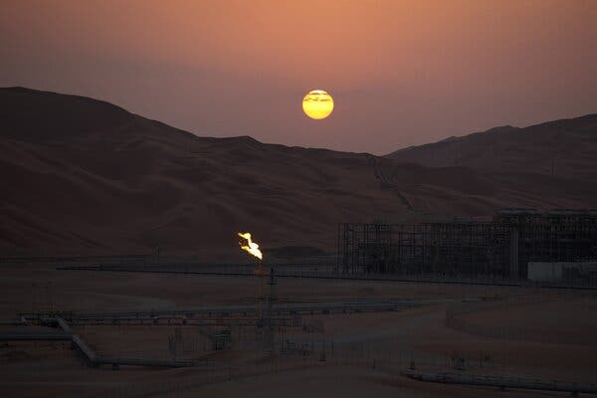

A gas flare at a processing plant in Shaybah, Saudi Arabia. Leaders have pledged to cut back on methane emissions.Credit...Simon Dawson/Bloomberg

Saudi Arabia’s strategy is playing out at global climate talks.

Back in March, when, Saudi Arabia and Russia pushed to delete a reference to “human-induced climate change” from a policy document at a United Nations meeting, Valérie Masson-Delmotte, a French climate scientist leading the session, fought back and won.

“It is unequivocal that human influence has warmed the climate,” she later said. “This is the reason why I took the floor to argue.”

The Saudi intervention was the latest example of what other negotiators describe as a yearslong effort to slow progress by homing in on scientific uncertainties, downplaying the consequences, emphasizing the costs of climate action and delaying negotiations on procedural points.

Last year, Saudi Arabia successfully helped strike a sentence from [a United Nations report](https://www.nytimes.com/2022/02/28/climate/climate-change-ipcc-un-report.html) that called for an active phaseout of fossil fuels. The statement “limits options for decision makers,” a Saudi adviser to the kingdom’s minister of Petroleum and Mineral Resources said, according to documents leaked by the environmental group Greenpeace. “Omit the sentence.”

“They have a strategic agenda,” said Saleemul Huq, director of the International Center for Climate Change and Development in Bangladesh, “which is they don’t want anything to happen.”

At the latest round of talks in Egypt, Saudi Arabia highlighted an alternative vision, one that relies on large-scale carbon capture and storage. By 2027, the kingdom will build a facility capable of storing as much carbon dioxide as 2 million gasoline cars would emit in a year.

That would be a breakthrough, because carbon capture has yet to be proven at scale. Yet it was Saudi Arabia’s way of preparing for a warming world, said Adel al-Jubeir, the kingdom’s climate envoy. “In Saudi Arabia, we’re committed to being ahead of it.”

<https://www.nytimes.com/2022/11/21/climate/saudi-arabia-aramco-oil-solar-climate.html>

#68

***The Climate Fix: Solutions for a Warming World***

In our new weekly series, we’re covering the vast amount of investment, ingenuity and scientific expertise going toward stopping climate change.

* Share full article

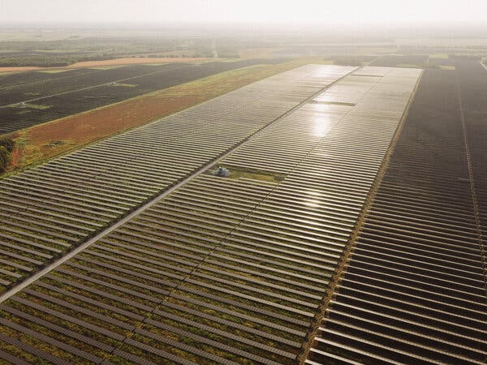

In recent years, the world has begun making strides toward a cleaner, more resilient future, one in which modern society is powered with renewable energy.Credit...Mason Trinca for The New York Times

[](https://www.nytimes.com/by/david-gelles)

**By**[**David Gelles**](https://www.nytimes.com/by/david-gelles)

Published Oct. 3, 2024Updated Oct. 29, 2024

**You’re reading the Climate Forward newsletter, for Times subscribers only.**News and insights for a warming world. Get it with a Times subscription.

As we report on climate change, it’s all too easy to get caught up in the often troubling news.

Ferocious storms wreak havoc around the globe. Planet warming-[emissions keep rising](https://www.nytimes.com/interactive/2024/04/20/upshot/carbon-dioxide-growth.html). Scientists warn of catastrophic [tipping points](https://www.nytimes.com/interactive/2024/08/11/climate/earth-warming-climate-tipping-points.html).

Yet those headlines, crucially important as they are, often overshadow a different, equally important narrative: In recent years, the world has begun making rapid strides toward a cleaner, more resilient future, one in which modern society is powered with renewable energy, and the challenges of a hotter planet are not quite so perilous. This year alone, investments in clean energy will hit $2 trillion, according to the [International Energy Agency](https://www.iea.org/news/investment-in-clean-energy-this-year-is-set-to-be-twice-the-amount-going-to-fossil-fuels).

Today, in an effort to highlight some of the progress underway, we’re introducing a new regular feature in our coverage, The Climate Fix.

Each Thursday, as part of this newsletter, we’ll focus on at least one new solution that has the potential to make a meaningful difference.

Sometimes, this might be a new technology that is making our energy system more efficient. Other weeks, it could be a policy change that is reshaping how people think about allocating money to climate adaptation. We also plan to cover nature-based solutions, emissions reductions plans, scientific breakthroughs and legal developments.

There’s no shortage of material for us to write about. On every continent and in every conceivable industry, there are projects making our energy systems cleaner, our transportation systems more efficient and our agricultural systems more resilient. And our reporters are already in the field, tracking developments in geothermal energy, electric vehicles, [rice farming](https://www.nytimes.com/interactive/2023/05/20/climate/rice-farming-climate-change.html), [tree planting](https://www.nytimes.com/2022/11/20/us/utah-spruce-forests.html) and much more. Just in the last few weeks, we’ve covered efforts to support [nuclear energy](https://www.nytimes.com/2024/09/30/climate/michigan-nuclear-plant-palisades.html), mine [critical minerals](https://www.nytimes.com/2024/09/30/business/energy-environment/uranium-russia-united-states.html) and the impact of [individual actions](https://www.nytimes.com/2024/09/25/climate/carbon-reduction-strategies.html).

Beyond simply highlighting potentially game-changing solutions, The Climate Fix will bring a critical eye to them, evaluating what stands in the way of their widespread adoption, and peering ahead to understand what comes next.

Thanks for reading, and welcome to The Climate Fix.

**Editors’ Picks**

[[](https://www.nytimes.com/2025/06/16/arts/design/pigeon-fest-high-line.html)](https://www.nytimes.com/2025/06/16/arts/design/pigeon-fest-high-line.html)

[Crowning New York’s Top ‘Pigeon’](https://www.nytimes.com/2025/06/16/arts/design/pigeon-fest-high-line.html)

[[](https://www.nytimes.com/2025/06/13/t-magazine/summer-swimsuit-quiz.html)](https://www.nytimes.com/2025/06/13/t-magazine/summer-swimsuit-quiz.html)

[How to Choose the Perfect Swimsuit](https://www.nytimes.com/2025/06/13/t-magazine/summer-swimsuit-quiz.html)

[[](https://www.nytimes.com/2025/06/15/movies/how-to-train-your-dragon-mason-thames-interview.html)](https://www.nytimes.com/2025/06/15/movies/how-to-train-your-dragon-mason-thames-interview.html)

[The ‘How to Train Your Dragon’ Star Mason Thames Is Still Freaking Out](https://www.nytimes.com/2025/06/15/movies/how-to-train-your-dragon-mason-thames-interview.html)

Image



THE CLIMATE FIX

**The fund that wants to pay billions to protect forests — and generate returns**

**The problem:**Every year over the last two decades, countries have been losing about nine million acres of tropical forest that are crucial to curbing climate change. Markets for selling carbon credits and other financial mechanisms have not significantly changed that trend globally.

**The fix:**Officials from Brazil are finalizing a proposal for a new financial product called the Tropical Forests Forever Facility, which aims to raise $125 billion from investors, countries and philanthropic organizations.

Its structure is unique: investors would loan the fund money, which would be paid back with interest. That money would then be invested in a diversified portfolio that would generate a return. Those excess returns would be used to pay roughly 70 developing countries $4 for every hectare of tropic forest they protect — including for forests that are not under immediate threat and which have historically received very little funding.

The structure means T.F.F.F. is more like a return-generating investment than traditional foreign aid, which the fund’s creators think could help make it more palatable for countries and philanthropies.

“We have long talked about the advantages of conservation, but haven’t been able to, let’s say, translate that into concrete things people can feel,” said Marina Silva, Brazil’s environment minister.

**The obstacles:**Getting $125 billion in investments is an enormous challenge to say the least. If the T.F.F.F. were to raise $125 billion it would be, by some measures, the biggest climate fund in the world. There are also concerns about who would — or could — govern such a large financial portfolio. And then there’s the risk of a financial crash, which could hurt the fund’s abilities to pay countries for forest protection.

**What’s next:**Officials in the U.S., Norway, France and other wealthy nations are evaluating the idea, as is the World Bank. The project, first presented at the global climate summit in Dubai, last November, is now in its final stages of design.  
  
Under the plan’s terms, countries with a lot of forest could get a significant boost in their budgets. Brazil, for example, would have been paid around $600 million this year if the fund was operational.*— Manuela Andreoni*

[**Read the full article here**](https://www.nytimes.com/2024/10/03/climate/brazil-climate-fund-trees.html)**.**

Image



**Turning rivers and oceans into giant sponges for carbon dioxide**

**The problem:**To keep climate change at tolerable levels, countries will probably have to do more than just slash emissions — they’ll also need to remove hundreds of billions of tons of carbon dioxide from the atmosphere this century.

**The fix:**In Nova Scotia, a startup called CarbonRun is grinding up limestone and sprinkling it into rivers poisoned by acid rain. Not only does this technique help local salmon populations, it also helps pull greenhouse gases from the sky.

Typically, rivers contain carbon dioxide that is constantly escaping into the air, where it traps heat and warms the planet. But adding limestone converts some of that carbon dioxide into a stable molecule that instead stays underwater and washes into the sea, where it should remain trapped for thousands of years.

**The potential:**There are hundreds of acidified rivers worldwide, and CarbonRun estimates that this process, known as river liming, could remove hundreds of millions of tons of carbon each year.

That might just be a start. If similar techniques could be done in the ocean — adding an alkaline substance like limestone or magnesium oxide to seawater, for example — humanity could potentially remove billions of tons each year.

So far, oceans have been tougher to work in. It’s tricky to prove that adding alkalinity actually removes carbon in the turbulent high seas, and early research efforts have faced public backlash. Some scientists hope CarbonRun can be a pioneer, because it’s easier to verify carbon removal happens in rivers, and river liming has been highly popular with local communities, since it can help revive devastated fisheries.

**The obstacles:**CarbonRun needs to cut costs, which means figuring out how to inexpensively mine and transport limestone. The company needs about two tons of rock for every ton of carbon it removes.

The company also needs buyers. Right now, only a handful of wealthy tech companies, like Microsoft and Stripe, are willing to pay startups to remove carbon from the air. Some experts say carbon removal should be considered a public good and governments should pay for it, but it’s still early days.

One policy twist: Congress offers a generous tax credit — worth $180 per ton — for companies that remove carbon from the air using complex direct air capture machines, but that subsidy does not cover techniques that involve oceans or rivers.

**What’s next:**CarbonRun has received $25 million to remove an initial 55,442 tons of carbon dioxide from the atmosphere and is starting to scale up. Elsewhere, researchers in Halifax and Massachusetts are studying whether alkalinity enhancement can work in the oceans. — *Brad Plumer*

[**Read the full article here**](https://www.nytimes.com/2024/09/23/climate/oceans-rivers-carbon-removal.html)**.**

Image

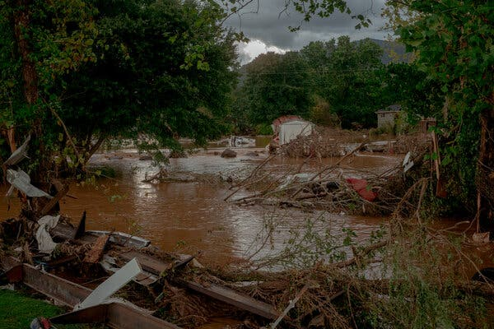

Floodwaters from Hurricane Helene in Swannanoa, N.C., on Sept. 27.Credit...Mike Belleme for The New York Times

**3 Things to Read on Hurricane Helene**

[**How the North Carolina Legislature Left Homes Vulnerable to Helene**](https://www.nytimes.com/2024/10/03/climate/north-carolina-homes-helene-building-codes.html): “Over the past 15 years, North Carolina lawmakers have rejected limits on construction on steep slopes, which might have reduced the number of homes lost to landslides; blocked a rule requiring homes to be elevated above the height of an expected flood; weakened protections for wetlands, increasing the risk of dangerous storm water runoff; and slowed the adoption of updated building codes, making it harder for the state to qualify for federal climate-resilience grants.” *— Christopher Flavelle*

[**After Flooding, FEMA Aid Is Arriving. But Some Are Still on Their Own**](https://www.nytimes.com/2024/10/02/us/fema-floods-north-carolina.html): “In the western mountains of North Carolina outside of Asheville, the small communities of Cruso and Canton, wrecked by Hurricane Helene, were not waiting for help from the state or the federal government.”

Local restaurants were dispatching food deliveries to homes each evening. Some residents were driving excavators and tractors to clear debris from roads, while others were checking on who had power and who did not. No one was sure whether any disaster relief was coming anytime soon.” *— Emily Cochrane, J. David Goodman, Edgar Sandoval and Christopher Flavelle*

[**After Helene, Lawyers Gear Up for Battles Over Who Should Pay**](https://www.nytimes.com/2024/10/02/climate/legal-aid-lawyers-helene-storm.html): “As the colossal scale of damage wrought by Hurricane Helene becomes clear, legal aid groups are steeling themselves for yearslong battles to help people rebuild their lives and homes.

“It’s going to be a massive effort,” said Alicia Edwards, who directs the Disaster Relief Project for Legal Aid of North Carolina, which serves low-income clients.

They’re mobilizing to help people navigate a maze of post-disaster bureaucracy — fights with landlords, insurers, contractors and even federal relief agencies themselves. But first, legal groups in the area need to account for their own people.” *— Karen Zraick*

<https://www.nytimes.com/2024/10/03/climate/the-climate-fix-solutions-for-a-warming-world.html>

#68

**How One Restaurateur Transformed America’s Energy Industry**

Charif Souki’s longshot bet on liquid natural gas, or L.N.G., paid off handsomely — and turned the United States into a leading fossil-fuel exporter.

Charif Souki in London in June.Credit...Sebastian Nevols for The New York Times

* Share full article
* 120

**By Jake Bittle**

* Published July 6, 2022Updated June 15, 2023

**Listen to This Article**

Listen · 30:26 min

If you wantedto tell the story of how the United States became one the world’s largest exporters of fossil fuels, you could start in the Middle Devonian period, around 400 million years ago, when a warm inland sea dense with primitive aquatic organisms covered parts of the northeastern United States and Appalachia; you could explain that as these creatures lived, reproduced and died, their remains settled on the ocean floor and were compressed beneath layers of sedimentary rock, until eventually they transformed into a gas trapped thousands of feet below what is now Pennsylvania.

Or you could start with the murder of Nicole Brown Simpson.

On June 12, 1994, Simpson ate dinner with some family members at an Italian restaurant called Mezzaluna in the Brentwood neighborhood of Los Angeles. Simpson’s mother left her glasses there, so a waiter from the restaurant, Ron Goldman, went to Simpson’s home to return them. Shortly after midnight, [Goldman was found dead with Simpson](https://www.nytimes.com/1994/06/14/us/o-j-simpson-s-ex-wife-slain-at-her-condo-in-los-angeles.html) outside her condo. In the aftermath of the murders, reporters and photographers descended on Mezzaluna, followed by buses full of gawking tourists. People walked in to pester employees for details about Simpson’s final evening, even asking waiters what she ordered for her last supper (apparently rigatoni). An owner of the restaurant, a Lebanese American entrepreneur named Charif Souki, was disgusted by the media frenzy — “the morbid curiosity, the lack of taste and decency of people, was pretty astonishing,” he would say later. He decided to sell Mezzaluna and went on to try his hand at something new. After some deliberating, he settled on the oil-and-gas industry.

With a mop of unkempt hair and a penchant for elegant double-breasted suits, Souki didn’t look the part of a Houston wildcatter. He also didn’t know anything about drilling for oil or gas. But he did have a thick Rolodex from his posh Beirut upbringing, his days as an investment banker and his tenure as restaurateur to the stars. Why not raise a little money and give it a try? The infrastructure that moved fossil fuels around and converted them into energy was unfathomably complex, but the people in the business did something relatively simple: They borrowed money, dug up fuel and tried to sell it. That didn’t sound so hard to Souki.

At the turn of the century, growth in the American energy sector had leveled off. Major oil producers like Exxon Mobil and Chevron had staked out the Gulf of Mexico for almost all the oil and natural gas it could yield, and there didn’t seem to be an obvious next place to drill, so there wasn’t much new money flowing in. In fact, some experts and commentators were worried that the United States would struggle to find enough oil and gas to meet rising demand. Buying more oil would be easy enough, because millions of barrels of crude moved all around the world every day on tanker ships, but natural gas was different. The United States was already importing around one-fifth of its annual consumption, mostly from Canada, and the pipelines could carry only so much. Unless the United States could find more gas within its own borders, the price of the fuel would skyrocket.

There is another way to move natural gas around, though. If you cool it down to minus 260 degrees Fahrenheit, it transforms into a liquid. This liquefied natural gas — L.N.G. for short — takes up about one six-hundredth of the space that regular gas does, which means you can load it onto tanker ships and send it across the ocean. The United States had never had much need to import liquefied natural gas before, but Souki figured that rising demand would soon justify the costs. He had already built a small energy company called Cheniere, part of an unsuccessful attempt to find new oil and gas in the Gulf of Mexico, and he decided to put his chips on L.N.G. He called friends from his investment-banking days and pitched them on a solution to America’s energy woes: a gas-processing plant that could “regasify” L.N.G. as it arrived from countries like Qatar, then pump it into domestic pipelines. A lot of people thought he was crazy, but eventually he found the money, and it wasn’t long before he identified a site for the $2 billion facility on a swampy section of the Louisiana-Texas border, not far from a fishing community called Sabine Pass.

The only problem was that he was completely wrong. Around 2007, just as his terminal was nearing completion, a group of energy moguls made a series of breakthroughs in a new method for extracting gas from deep layers of landlocked shale. Hydraulic fracturing, or fracking, had the potential to unlock enough gas to satisfy American energy demand for generations and turn the nation into the world’s largest producer of oil and gas. It also made Souki’s import terminal virtually worthless. In his book “The Frackers,” the reporter Gregory Zuckerman later recounted how Souki looked out at the crowd during the ribbon-cutting ceremony for the Sabine Pass facility only to see his investors and supporters staring at their BlackBerrys. They were watching Cheniere’s stock price plummet in real time.

The only way for Souki to save the investment was to turn the facility around, reconfiguring it to liquefy the natural gas from fracking and prepare it for shipping. This was not a matter of flipping a switch. Condensing natural gas into a liquid is much more complicated and energy-intensive than converting liquid back to gas, and retrofitting the terminal required Souki to raise an astonishing $20 billion from bankers and investors, many of whom had been involved in the first round of financing and hadn’t yet recouped their initial investment. Furthermore, the idea of an export terminal cut against most people’s understanding of America’s role in the global energy ecosystem. In the decades since the 1970s oil embargo, the United States had tried and failed to achieve energy independence. It seemed ludicrous to think that the nation should now hawk natural gas to other countries when just a few years earlier it was scrambling to find enough of it. “This is somebody who enjoys being on a roller coaster,” one oil analyst told a Times reporter in 2011, referring to Souki. “It is more likely to see snow in New York in July than to see exports of gas from L.N.G. terminals in the United States.”

Souki pushed ahead, though, and soon Cheniere’s gargantuan export facility was rising up out of the bayou, its hulking steel pipeline arrays and rotund storage tanks looming over the swampy water. Even before its first shipment left, it was clear that Souki had finally placed the right bet. Overseas demand for natural gas was only getting stronger as countries began to shift away from their reliance on coal power. European countries could get most of their gas by pipeline from Russia, but giant Asian economic powers like China, Japan and South Korea needed another way to import the fuel. When completed, Cheniere’s export facility would be the only such facility in the mainland United States, giving Souki an effective monopoly on the market. In 2013, he became the nation’s highest-paid chief executive, netting an annual compensation of $142 million.

“From here on,” [he told a Houston newspaper at the time,](https://www.houstonchronicle.com/business/energy/article/A-head-start-lets-Cheniere-Energy-catch-up-5043288.php) “it’s either good or better.”

**The United States** is now one of the largest exporters of liquefied natural gas, dominating the global market alongside countries like Qatar and Australia. As of April, the nation was shipping out around 12 billion cubic feet of liquefied gas per day, equivalent to the daily gas consumption of Britain. There are now seven active liquefaction terminals, and as many as a dozen more are in various stages of planning and construction from Brownsville, Texas, to Jacksonville, Fla. The United States has flooded the world with supply, helping to double the global volume of L.N.G. exports between 2015 and 2019. Japan and South Korea have built dozens of regasification terminals over the past decade, and China has quintupled its natural-gas imports over the same period. Natural gas has emerged as a kind of Goldilocks fuel for power generation: less polluting than coal and less disruptive than switching to renewables. In other words, it’s the best of the worst.

**Editors’ Picks**

[[](https://www.nytimes.com/2025/06/16/realestate/ireland-raffle-house-winner.html)](https://www.nytimes.com/2025/06/16/realestate/ireland-raffle-house-winner.html)

[‘By Chance, Did You Win a Cottage in Ireland?’](https://www.nytimes.com/2025/06/16/realestate/ireland-raffle-house-winner.html)

[[](https://www.nytimes.com/interactive/2025/06/12/travel/things-to-do-east-london.html)](https://www.nytimes.com/interactive/2025/06/12/travel/things-to-do-east-london.html)

[36 Hours in East London](https://www.nytimes.com/interactive/2025/06/12/travel/things-to-do-east-london.html)

[[](https://www.nytimes.com/2025/06/14/arts/national-history-day.html)](https://www.nytimes.com/2025/06/14/arts/national-history-day.html)

[At National History Day, Students Get Competitive About the Past](https://www.nytimes.com/2025/06/14/arts/national-history-day.html)

Gas is also the most recent arrival to the world’s energy markets. Like its elder siblings coal and oil, it forms over tens of millions of years under the surface of the earth, but unlike these fuels, natural gas is mostly methane, which contains fewer atoms of carbon than the molecules that make up oil and coal. Burning it releases less carbon dioxide into the air as a result. To the extent that we replace coal power with gas power, we reduce carbon emissions by about half. This is already happening in the United States, where power-sector emissions fell by about one-third from to 2005 to 2019 as a result of coal-to-gas switching, and in China, where a state-led program to phase out coal has improved air quality in Beijing.

**Sign up for Your Places: Global Update.**All the latest news for any part of the world you select. Get it sent to your inbox.

In the early 2000s, gas producers and energy-friendly politicians pointed to the relatively low carbon profile of gas as evidence that it could serve as a “bridge fuel” that could fulfill the world’s energy needs while we transition from fossil fuels to renewables like solar and wind. Souki makes another moral pitch for liquefied natural gas, which is that it can also displace fuels in the developing world that pose more immediate health dangers. “People in Africa die from indoor pollution because they use wood and cardboard to prepare their meals,” Souki told me. “There are people in India that die of outdoor pollution.” There, dozens of coal-fired plants operate 24 hours a day, blackening the skies over New Delhi and Mumbai, leading to almost 80,000 premature deaths per year, according to one analysis. “So if you restrain or restrict energy to the people who need it, you’re killing them.”

Image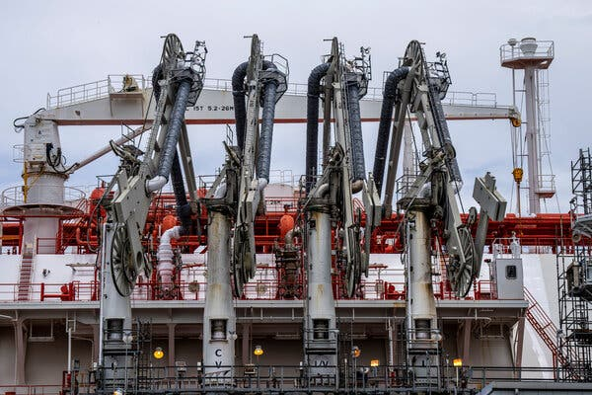

Cheniere’s Sabine Pass liquefied natural gas facility in Cameron, La. Growing demand abroad has driven a rapid expansion of L.N.G. infrastructure.Credit...Benjamin Lowy for The New York Times

This is a somewhat unorthodox pitch for a fossil-fuel tycoon to make, but Souki has never been an ordinary tycoon. He is as easy to find in Aspen, Colo., as he is in Houston; he frequently talks to reporters and is frank about climate change. In 2012, as Exxon Mobil’s chief executive, Rex Tillerson, was calling environmental groups “manufacturers of fear” about global warming, Souki was declaring his support for a carbon tax. As the rest of the world has sought gas as a substitute for coal, the American L.N.G. industry has begun to position itself as a purveyor of clean energy. Cheniere, for example, hired one of President Barack Obama’s climate advisers, Heather Zichal, to serve on its board of directors. A former senior vice president of the company was a deputy assistant energy secretary in the Obama administration; its vice president for public affairs used to work for Senator Edward J. Markey of Massachusetts, a noted climate hawk.

One wrinkle in the bridge-fuel argument, though, is that unburned methane itself is also a greenhouse gas — in fact, during the first 20 years after its release, it is more than 80 times as powerful as carbon dioxide at warming the climate. You don’t have to be a chemistry professor to understand the conundrum. If you can get the gas out of the ground and into a power plant without letting it leak, it releases less carbon than coal or oil. If you let too much of it escape into the atmosphere while producing it, though, you might damage the climate more than if you just left it in the ground and burned coal instead.

[Methane leaks](https://www.nytimes.com/interactive/2019/12/12/climate/texas-methane-super-emitters.html) are possible at almost every point in the supply chain. The point of production carries the biggest risk, when frackers push the gas out of the ground and shove it into pipelines. Still, leaks can also happen as the fracked gas travels through hundreds of miles of pipeline on its way to the Gulf of Mexico: In January, a satellite spotted a large methane plume that seemed to be emanating from a cluster of pipelines in central Louisiana. There’s also the potential for methane to escape at the liquefaction facilities themselves. An export plant in Louisiana owned by a company called Venture Global leaked almost 100 tons of natural gas over the course of two days in January. The methane involved had the potential to warm the earth roughly as much as 1,000 cars do over an entire year.

Critics also say the facilities pose significant risks for those who live near them. In June, an export facility in Freeport, Texas, had a leak that resulted in a “vapor cloud” of natural gas that exploded in the open air, an accident that is expected to put the plant out of commission for three months. These vapor-cloud explosions have occurred at a few oil facilities in recent years, and safety experts have expressed concern about the potential for even larger blasts at liquefaction plants. Souki has been frank about the nastiness of the business that has made him so wealthy too: “I wouldn’t want an L.N.G. terminal next to my home,” he told Forbes in 2005.

Nevertheless, the growing demand abroad for American gas has driven a rapid expansion of L.N.G. export infrastructure in the United States, which has rewritten the rules for the global energy marketplace. For a long time, natural gas was burned close to where it was produced, but the explosive growth of the L.N.G. industry has turned the fuel into a commodity like oil, something that almost every country needs but that comes from only a select group. The countries that control the largest gas reserves also control whether hundreds of millions of people can keep their lights on and their furnaces lit. The geopolitical significance of this fact has become startlingly clear over the last few months. The Russian invasion of Ukraine sent global energy markets into turmoil overnight, severing a link between the powerhouse economies of the West and one of the world’s main suppliers of oil and gas. It was easy enough for countries like Germany and Britain to agree that they would give up Russian oil, because they could buy oil on tankers coming from anywhere, but finding more gas was not so simple. Almost half the continent’s supply came from Russian pipelines, and European nations couldn’t simply stop burning gas — not if they wanted to keep the lights on.

The United States wasted no time in positioning itself as a kind of white knight for Europe’s energy needs. As countries like Germany and Italy scrambled to find enough gas for next winter, the Biden administration promised to fill about one-third of the threatened Russian supply. The White House didn’t frame this rescue mission in climate terms, but selling gas to Europe is arguably one of the most significant climate policies enacted by the Biden administration. The substitute gas would keep European economies from falling back on coal, but it could also ease the pressure on governments to further build out renewable energy sources like solar and wind. Back in the United States, meanwhile, it would make gas companies very wealthy, even as the rapid pace of L.N.G. exports drove up domestic natural-gas prices and raised American energy bills.

**Even though it**was Souki’s audacious bet that helped create the L.N.G. boom, he may not end up benefiting from the crisis brought about by the war in Ukraine. That’s because, at least for the moment, he doesn’t actually own a liquefaction facility. In late 2015, just two months before the first gas shipment left Cheniere’s plant in Sabine Pass, the company’s board ousted him. The move came at the behest of the activist investor Carl Icahn, who had acquired a 13.8 percent stake in the company and thought Souki was taking it in the wrong direction. Souki wanted to use the proceeds from the first terminal to build another terminal in Southwestern Louisiana and expand into other ventures; Icahn wanted to cut spending and pay dividends. After a 10-hour private session that Souki was not invited to, the board sided with Icahn.

Souki retreated to Aspen, but his time in the wilderness didn’t last very long. A few months later, he teamed up with another L.N.G. executive to found a new company called Tellurian and laid out plans to build an export terminal in Southwestern Louisiana — indeed on the very same site he had been pitching while still at Cheniere. He had a new financing scheme in mind, one that would entail greater risk but also yield mind-boggling profits: While Cheniere had charged frackers a fee to turn their gas into liquid, Souki wanted to start his own fracking operation, liquefy his own gas and sell it directly to overseas buyers.

**‘The world is screaming for natural gas, and I would like to be able to deliver natural gas as soon as possible.’**

“I felt that there was one more chapter to be written,” Souki told me. “The real business model would be to own the American molecules and sell them on the global market.”

As he searched for financing, Souki turned himself into an online evangelist for liquefied natural gas, posting regular updates on YouTube (“Two minutes with Charif Souki on supporting our European friends”). These videos have helped attract many of the same retail investors who poured money into companies like GameStop and AMC, and who now believed that Tellurian’s stock was underpriced relative to the potential payout. One video showed Souki flying in a helicopter over Louisiana, pointing out the vacant field where Tellurian’s facility would someday stand. Getting it up and running was imperative: Tellurian had a productive fracking operation in the woods of the northern part of the state but still no way to bring the gas to market.

Souki still didn’t when I met him in early February at Tellurian’s office in downtown Houston. The company has a small space in a building owned by the oil supermajor TotalEnergies, and from the upper-story conference room, Souki and I could look out and see the distant expanse of the Texas City oil complex, a warren of storage tanks and refineries spewing bright orange flames. Despite all the hurdles Tellurian was facing, Souki had an unflappable air about him and spoke with the kind of blasé confidence one might expect from a man accustomed to raising billions of dollars for long-shot projects. He was wearing one of his trademark double-breasted suits, along with a pink tie, and as he talked he sometimes removed a retractable ballpoint pen from his jacket and fidgeted with its clicker.

I wondered why Souki was so determined to get back into the L.N.G. business. After all, he had already made a fortune, and the industry he started was reaching maturity. Tellurian was still several years and billions of dollars away from being able to profit off it again. Why didn’t he just stay home in Aspen?

“The world is screaming for natural gas,” he said, “and I would like to be able to deliver natural gas as soon as possible.” There was already an energy shortage in Europe over the winter, a result of a fast pandemic rebound, and people in Britain were worried about paying their gas bills — how could he not want to supply them with more fuel? Moreover, he said, “the emerging countries are going to add two billion people, and their standards of living are improving all the time. They’re not going to say, ‘I don’t want to live like you.’”

As Souki sees it, the need to provide the world with energy in the short term outweighs the long-term demand of acting on carbon emissions. The world may be facing energy and climate crises, he said, “but one is going to happen this month, and the other one is going to happen in 40 years.” He added: “If you tell somebody, ‘You are going to run out of electricity this month,’ and then you talk to the same person about what’s going to happen in 40 years, they will tell you, ‘What do I care about 40 years from now?’”

Two weeks later, Russia invaded Ukraine. The booming American L.N.G. industry rushed in to fill the gap left by Russian gas, turning its focus from Asia to Europe. Cargoes that had already left American export facilities bound for Japan or China changed course and headed to France and the Netherlands, fetching multiple times the price they would have just days earlier. A few weeks after the invasion began, the United States and the European Commission announced a long-term agreement to help Europe free itself from Russian gas, with American producers promising to supply at least one-third of what Russia had once provided the continent. Bulgaria, Germany and Greece all raced to build new import terminals so they could accept American gas before winter, as Russia cut off gas deliveries to one country after another; eventually, Germany was moving to flip on old coal plants. Just a few months earlier, at the United Nations Climate Change Conference in Glasgow, these same European governments had affirmed their intention to give up fossil fuels, but now they had to shelve those ambitions.

I met Souki again in April in New York, at the downtown offices of a media-strategy company. Souki was taking advantage of the chaos in energy markets to again make his moral case for sending fracked gas all over the globe: He was stopping in New York to talk to potential investors and develop a new media strategy for Tellurian before he went down to Washington to meet with policymakers and legislators. We huddled together at a conference table in the lobby.

“All of a sudden, Europe has put all of its climate aspiration on the back burner,” he told me, reviewing the early events of the war. Countries like the Czech Republic, Italy and Romania were warning that they might have to reactivate their shuttered coal plants or extend the life spans of those that had been scheduled to close. “We’re going to need gas,” he said, “*especially* if you’re serious about climate issues.”

He was quick to clarify that this wasn’t his concern. “As a company, I couldn’t care less about the climate,” he said. “Of course I care, OK? But my responsibility is not to care about the climate. My job is to make a product that people need and sell it to them at the cheapest possible price to me.” This was not going to be very difficult, provided Souki could finish his new facility. By the summer, gas prices in Europe were six times as high as in the United States; once Souki’s terminal was up and running, he would be able to reap the entirety of that price differential, a jaw-dropping arbitrage. Yet again, he would have proved everyone wrong.

Still, the facility in Louisiana would need to export gas for years to pay itself off, which meant that Tellurian would need to keep fracking more gas to supply it, and that people around the world would need to keep buying and burning that gas, dumping more methane and carbon dioxide into the atmosphere. Souki’s gamble depended on the energy transition moving at a very specific pace, neither too fast nor too slow — his customers were countries that wanted to move away from the dirtiest fuels but weren’t ready or willing to shift toward altogether clean energy. For as long as the transition moved at this halting pace, it would be gamblers and tycoons like him who set the course of global climate policy, selling people the fuels they wanted for as long as they wanted them. Souki himself might have an exit strategy, but the industry he created would outlast him, spraying flames into the night sky for decades to come.

I asked Souki what he thought the long-term trajectory of the L.N.G. boom might be. The fuel might be necessary right now, but what about in 20, 30, 40 years? He was betting that the world wasn’t ready to give up fossil fuels. But someday it would, and the facilities he built would be effectively useless. What would happen then?

He smirked and waved his hand, as if to swat the question away.

“I’ll be dead,” he said, “so it won’t matter.”

<https://www.nytimes.com/2022/07/06/magazine/us-export-liquid-natural-gas.html>

#69

***A Climate Scientist Is Voted President of an Oil Country. Now What?***

Claudia Sheinbaum, Mexico’s next leader, is an academic and a politician. Here’s what her track record reveals.

**Listen to this article · 4:55 min**[Learn more](https://help.nytimes.com/hc/en-us/articles/24318293692180)

* Share full article



President-elect Claudia Sheinbaum has a doctorate in energy engineering.Credit...Fred Ramos for The New York Times

[](https://www.nytimes.com/by/somini-sengupta)

**By**[**Somini Sengupta**](https://www.nytimes.com/by/somini-sengupta)

June 3, 2024

[Leer en español](https://www.nytimes.com/es/2024/06/04/espanol/claudia-sheinbaum-mexico-cambio-climatico.html)

Mexico is the world’s 11th-largest oil producer. It has been gripped by a [deadly heat wave.](https://www.nytimes.com/2024/05/22/climate/howler-monkeys-mexico-heat.html?searchResultPosition=1) Now, it’s elected as its president a woman with a rare pedigree: a left-of-center climate scientist with a doctorate in energy engineering named Claudia Sheinbaum.

Ms. Sheinbaum is no stranger to politics nor to environmental crises. She was mayor of Mexico City, a vibrant metropolitan area of 23 million that faces [a dire water crisis.](https://www.nytimes.com/2024/05/18/world/americas/mexico-city-water.html?searchResultPosition=1) She helped write the Intergovernmental Panel on Climate Change reports, the sweeping United Nations documents that have warned the world about the hazards of burning fossil fuels.

Ms. Sheinbaum will have to balance numerous, sometimes contradictory, tests as she takes office. Federal budgets are tight. Energy demands are rising. Mexico’s national oil company is heavily indebted. She’ll face the challenges of poverty, migration, organized crime and relations with the next president of the United States.

It would be folly to predict what she will do, but it’s worth looking at what she has said and done on energy and environmental issues so far in her career.

Advertisement

[SKIP ADVERTISEMENT](https://www.nytimes.com/2024/06/03/climate/claudia-sheinbaum-climate-scientist-mexico.html#after-story-ad-1)

First, her record.

As mayor of Mexico City, she began electrifying the city’s public bus fleet. She set up a huge rooftop solar array on the city’s main wholesale market. She expanded bike lanes, making permanent several kilometers of pandemic-era pop-up paths.

She has been criticized by environmentalists for backing one of the country’s most controversial infrastructure projects, the 1,500-kilometer so-called Maya Train corridor, which cuts across forests and archaeological sites to connect tourist sites like Cancún to rural areas on the Yucatán Peninsula.

Image

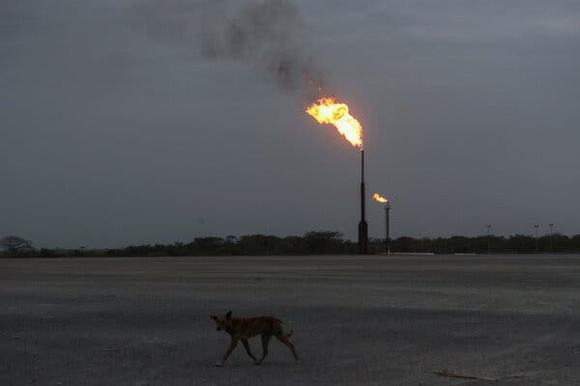

A Pemex plant in Tierra Blanca, Mexico. The giant oil company is heavily indebted.Credit...Raquel Cunha/Reuters

As for Mexico’s energy sector, Ms. Sheinbaum said on the campaign trail she wanted to expand renewable energy infrastructure, unlike her predecessor, Andrés Manuel López Obrador. But she also said she would continue to support the Mexican state-owned oil company, Petróleos Mexicanos, or Pemex, and keep it under state control.

Pemex produces just under 2 million barrels of oil a day. Ms. Sheinbaum has said she would maintain those levels, while also expanding the company’s mission to include lithium production. Lithium is a key component in electric batteries and pivotal to the global transition to cleaner energy.

Advertisement

[SKIP ADVERTISEMENT](https://www.nytimes.com/2024/06/03/climate/claudia-sheinbaum-climate-scientist-mexico.html#after-story-ad-2)

Mr. López Obrador has limited private investments in renewable energy projects, including from the United States, and if Ms. Sheinbaum were to continue that policy, that could significantly slow down the country’s clean energy transition.

“Claudia is an environmental scientist and unlike her mentor, AMLO, believes in decarbonization and in boosting renewables,” said Shannon O’Neil, a Mexico specialist at the Council on Foreign Relations, referring to Mr. López Obrador by his initials. “But she is also a statist, wanting Mexico’s energy transition to be led and controlled by cash-strapped, state-owned enterprises.”

Pemex is heavily indebted, and whether the government can continue to prop it up remains unclear. “The next president will need to find a solution to ‘fix’ the company’s problems as its condition today is unsustainable,” S&P Global, a commodities research firm, said in an analysis this year.

[[](https://www.nytimes.com/interactive/2023/climate/climate-change-faq.html)](https://www.nytimes.com/interactive/2023/climate/climate-change-faq.html)

**[Have Climate Questions? Get Answers Here.](https://www.nytimes.com/interactive/2023/climate/climate-change-faq.html)**

[What’s causing global warming? How can we fix it? This interactive F.A.Q. will tackle your climate questions big and small.](https://www.nytimes.com/interactive/2023/climate/climate-change-faq.html)

Ms. Sheinbaum will also have to weigh what role Mexico wants to play to further the ambitions of the United States to be the world’s leading supplier of liquefied gas. U.S. gas companies are [angling to build export terminals](https://www.nytimes.com/2024/02/13/climate/mexico-natural-gas-biden.html) along the Mexican coast to ship gas to Asia. If they are all built, as planned, that would hugely expand the emissions of planet-heating greenhouse gases and, according to environmental campaigners, threaten sensitive ecosystems.

Advertisement

[SKIP ADVERTISEMENT](https://www.nytimes.com/2024/06/03/climate/claudia-sheinbaum-climate-scientist-mexico.html#after-story-ad-3)

Among Ms. Sheinbaum’s many published scholarly works are papers that examine how Mexico can make the energy transition from one that’s based almost exclusively on fossil fuels to renewables like wind, solar and geothermal.

Her academic work also explores the social consequences. A [2015 paper](https://www.sciencedirect.com/science/article/pii/S1364032115016937?casa_token=6vdX3LbGDoIAAAAA:_hWMV28j6BazOn2ESpzGglPW8Efg5Sv8iofQWSO5aPCb9DvPxxCzzhp-6NMs1TWke_8c-Oh4), for instance, looked at the conflicts that erupted in the relatively poor and heavily Indigenous state of Oaxaca after a wind project came in. It recommended establishing national policy based on the feedback of local communities.

“[Wind energy development](https://www.sciencedirect.com/topics/engineering/wind-energy-development) in Mexico has been complex and contentious; the large increase of wind energy in Oaxaca has created social conflicts in Oaxaca, which even might stop further wind project development in the region,” the paper said, adding that the case shows “the need for a national and regional policy.”

Her work as president will have to consider similar trade-offs. Except they will not be academic.

<https://www.nytimes.com/2024/06/03/climate/claudia-sheinbaum-climate-scientist-mexico.html>

#70

***Energy Tax Credits, Meant to Help U.S. Suppliers, May Be Hard to Get***

The Inflation Reduction Act contains tax breaks for solar and wind companies to buy American equipment. Qualifying won’t be easy.

* Share full article
* 12

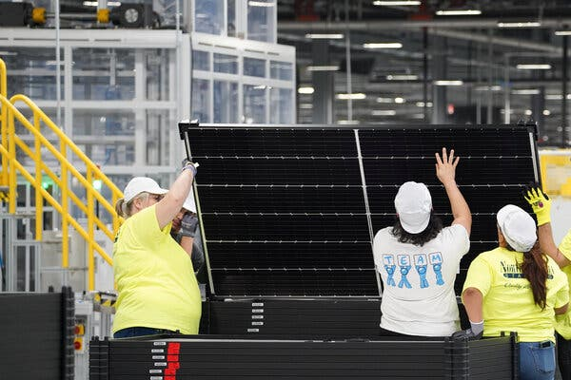

Workers at Qcells, a solar panel factory in Dalton, Ga. Incentives under the Inflation Reduction Act are meant to promote U.S. manufacturing of solar equipment.Credit...Megan Varner/Reuters

[](https://www.nytimes.com/by/lydia-depillis)

**By**[**Lydia DePillis**](https://www.nytimes.com/by/lydia-depillis)

Published June 9, 2023Updated June 12, 2023

**The DealBook Newsletter**Our columnist Andrew Ross Sorkin and his Times colleagues help you make sense of major business and policy headlines — and the power-brokers who shape them. Get it sent to your inbox.

In April, Vice President Kamala Harris visited Qcells, a solar panel manufacturing facility in Dalton, Ga., [to announce](https://www.seattletimes.com/business/harris-to-announce-huge-community-solar-deal-in-ga-visit/) an early triumph of the Inflation Reduction Act: Summit Ridge Energy, one of the nation’s largest developers of community solar projects, would purchase 2.5 million U.S.-made solar panels.

Subsidies under the new law brought the price in line with that of imported panels, allowing the companies to fight climate change and promote American manufacturing in one fell swoop.

A month later, the Treasury Department issued guidance that functionally would require the solar cells — not just the panels — to be made in the United States for Summit Ridge to have confidence that it will get its 10 percent tax credit on installations that use them. Qcells won’t be able to produce cells until late 2024, sending Summit Ridge scrambling to find cheaper components for projects currently in its pipeline.

“There’s not a single solar manufacturer who fully qualifies for this at this moment in time, which makes it difficult and is actually starting to cool investment,” said Leslie Elder, Summit Ridge’s vice president of political and regulatory affairs. “Now we have to re-evaluate based on what can pencil.”

On paper, the Inflation Reduction Act is transformative for electricity generation in the United States.

The law offers tax credits that could cover up to 70 percent of a renewable energy project’s cost if it checks several boxes meant to support American workers and communities. [A new analysis](https://doi.org/10.5281/zenodo.7942444) finds that those incentives more than offset the additional expense associated with using domestically produced goods and paying prevailing wages.

But guidance rolling out from the Biden administration — presaging formal rules — has raised alarm among energy companies that some of the credits might be difficult if not impossible to use, at least in the near term. The resulting frustration is emblematic of the current stage of climate action: an eye-straining haze of technical rule-making that reflects a tension between urgency and ensuring that the benefits of the energy transition are widely shared.

**Sign up for Your Places: Global Update.**All the latest news for any part of the world you select. Get it sent to your inbox.

Wally Adeyemo, the deputy secretary of the Treasury, expressed confidence that in combination, the rules would strike that balance.

“We have a great deal of clarity about the strategic objectives, and we’re already seeing the impact of that in terms of the economy,” Mr. Adeyemo said. “It isn’t about any one rule. It’s about an ecosystem of rules that have been created under the I.R.A. that put us in a position to go from a country that had underinvested in the clean energy transition to being at the head of the pack.”

**Editors’ Picks**

[[](https://www.nytimes.com/2025/06/16/realestate/ireland-raffle-house-winner.html)](https://www.nytimes.com/2025/06/16/realestate/ireland-raffle-house-winner.html)

[‘By Chance, Did You Win a Cottage in Ireland?’](https://www.nytimes.com/2025/06/16/realestate/ireland-raffle-house-winner.html)

[[](https://www.nytimes.com/interactive/2025/06/12/travel/things-to-do-east-london.html)](https://www.nytimes.com/interactive/2025/06/12/travel/things-to-do-east-london.html)

[36 Hours in East London](https://www.nytimes.com/interactive/2025/06/12/travel/things-to-do-east-london.html)

[[](https://www.nytimes.com/2025/06/14/arts/national-history-day.html)](https://www.nytimes.com/2025/06/14/arts/national-history-day.html)

[At National History Day, Students Get Competitive About the Past](https://www.nytimes.com/2025/06/14/arts/national-history-day.html)

The analysis, overseen by professors at [Princeton](https://mae.princeton.edu/people/faculty/jenkins) and [Dartmouth](https://engineering.dartmouth.edu/community/faculty/erin-mayfield) experienced in modeling climate policy’s effects, finds that the incentive aimed at U.S. manufacturers makes domestic solar panels more than 30 percent less costly to produce than imports. With incentives claimed by clean energy developers that meet labor standards and use domestic content, the total cost of generating utility-scale solar electricity could be lowered by 68 percent, and onshore wind energy by 77 percent.

The study was funded by the BlueGreen Alliance, a partnership of unions and environmental groups. The organization has championed elements of the Biden administration’s climate agenda that support domestic manufacturing, particularly in places hurt by globalization, automation and the decline of fossil fuels.

“Until now, the moral case and the business case did not always align,” said Ben Beachy, the organization’s vice president for industrial policy. “The I.R.A. changes that by offering developers an airtight business case for supporting high-paying jobs and a stronger and fairer U.S. manufacturing base.”

The impact of the climate law is already evident, with announcements of 47 new plants to make batteries, solar panels and wind turbines since it was passed, [according to](https://cleanpower.org/wp-content/uploads/2023/05/CleanEnergy_ImpactReport_230505.pdf) American Clean Power, a trade association. Other analyses, including a [paper](https://www.nber.org/papers/w31267) by economists and engineers at the Electric Power Research Institute, the Federal Reserve Bank of Minneapolis and the University of California, Berkeley, found that the law would encourage more low-emissions projects eligible for uncapped tax credits than anticipated, potentially making the costs to the government substantially higher than earlier estimates.

Image

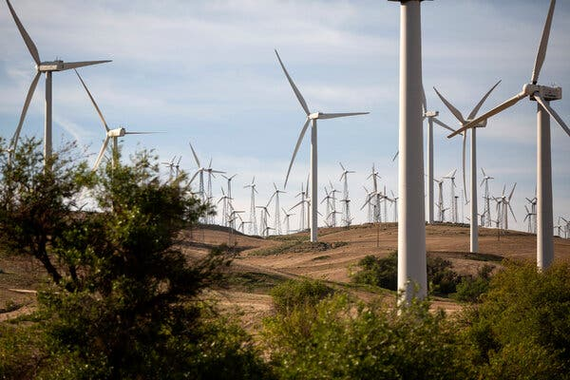

A recent study found that federal incentives could reduce the total cost of utility-scale onshore wind energy generation by 77 percent.Credit...Alisha Jucevic for The New York Times

But the BlueGreen Alliance’s study shows significant uncertainty about the impact of rising material costs as demand for domestically sourced aluminum, steel and concrete increases, and doesn’t account for profits manufacturers might command before more competition enters the market. It also projects 1.6 million more jobs will be available in wind and solar energy by 2035 than if the I.R.A. hadn’t passed — more than three times the current employment base — but does not model whether labor supply will measure up.

“I find some of their key results to be highly optimistic, and that they likely underestimate some of the economywide costs associated with this scale of clean energy deployment,” said Daniel Raimi, a fellow at the think tank Resources for the Future who reviewed the analysis.

At the same time, clean energy companies are digesting the administration’s guidance on how the tax credits will be allocated, and finding some unworkable in ways that may slow deployment.

Take the bonus of up to 20 percent for developers that locate projects in low-income communities (which is separate from a bonus of 10 percent for locating in areas [struggling with the transition away from fossil fuels](https://energycommunities.gov/energy-community-tax-credit-bonus/)). The Treasury Department, wanting to ensure that credits give rise to projects that wouldn’t otherwise happen, will award them only to projects not yet completed. Solar installers would have to sell the system and then wait to see if they got the credit before starting work.

“I think we will lose some development in low-income communities this year because of the way that credit has been constructed,” said Sean Gallagher, a vice president for policy at the Solar Energy Industries Association. “Either the developer is going to absorb that difference, or they’ll have to go back to the customer to renegotiate the price, or the project’s not going to happen.”

An even thornier issue is the [extra 10 percent for using domestically manufactured components](https://home.treasury.gov/news/press-releases/jy1477).

Manufacturers are concerned that while effectively requiring solar cells to be made in the United States to qualify for the credit, the Treasury Department did not require their [foundational component](https://www.energy.gov/eere/solar/articles/pv-cells-101-primer-solar-photovoltaic-cell) — the wafer, a thin slice of silicon that conducts energy — to be domestically produced. That could allow Chinese factories to continue to dominate a key part of the supply chain.

“The prices they’re ultimately getting from the developers are undermined because the Chinese wafer manufacturers can [crash the prices](https://www.bloomberg.com/news/articles/2023-05-30/longi-fuels-price-war-in-solar-industry-by-cutting-wafer-costs),” said Mike Carr, the executive director of the Solar Energy Manufacturers for America Coalition.

Developers are upset because receiving the credit will, in most cases, require a complex calculation of the cost of each component to reach the threshold of 40 percent U.S.-produced content, and manufacturers are loath to disclose sensitive pricing information. Many also expected a more gradual phase-in process that would allow some of the current U.S. factory output to qualify for the credit, while planning for more stringent requirements.

Brett Bouchy is the chief executive of Freedom Forever, a residential solar installation company that did more than $1 billion in business last year. He had planned to build a solar module and cell manufacturing plant in Arizona, which would cost $100 million and employ 1,000 people, to supply his own operations. After the guidance came out, he halted those plans — he couldn’t be confident his panels would qualify for the domestic content credit on top of the [7 cents per watt available to manufacturers](https://www.energy.gov/eere/solar/federal-tax-credits-solar-manufacturers).

“We cannot make it work,” Mr. Bouchy said. “There is no benefit, because that 7 cents is eaten up with increased U.S. labor costs. Why would you invest $100 million when you really can’t get a return?”

Those who support the administration’s approach emphasize that the bonus tax credits are just that: bonuses, not requirements, to offset costs associated with going the extra mile. Developers already get a 30 percent base incentive — and at least 10 years of certainty — for paying prevailing wages and employing apprentices, which most don’t consider very difficult.

Todd Tucker, the director of industrial policy and trade at the Roosevelt Institute, said high standards were necessary to make investors confident that new U.S. factories would have enough orders to stay in business.

“Once you start indicating that you’re going to allow some flexibility, that, by definition, softens the market signal,” he said.

The Treasury Department is still taking comments on the rules for all of the credits, and industry trade associations are vying to change them. Even so, most companies say that the Inflation Reduction Act overall is a powerful force for decarbonization, and that companies have a strong incentive to seek every credit it allows.

“It’s amazing how focusing this is for the mind, when people start throwing these kinds of dollars around,” said Sheldon Kimber, the chief executive of Intersect Power, a clean energy developer. “We’re being asked to do a hard thing, but there’s a lot of money in it for us.”

<https://www.nytimes.com/2023/06/09/business/economy/energy-tax-credits.html>

#71  
***Oil Giants Sell Dirty Wells to Buyers With Looser Climate Goals, Study Finds***

The transactions can help major oil and gas companies clean up their own production by transferring polluting assets to a different firm, the analysis said.

* Share full article
* 57

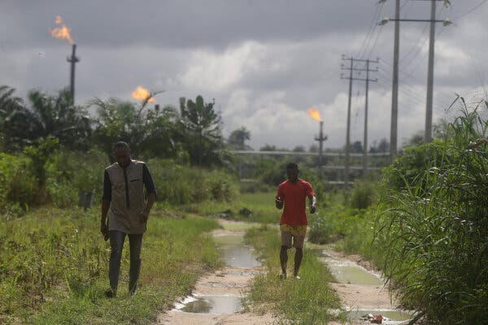

Flares burning in the Niger Delta region of Nigeria in 2021.Credit...Sunday Alamba/Associated Press

[](https://www.nytimes.com/by/hiroko-tabuchi)

**By**[**Hiroko Tabuchi**](https://www.nytimes.com/by/hiroko-tabuchi)

May 10, 2022

When Royal Dutch Shell sold off its stake in the Umuechem oil field in Nigeria last year, it was, on paper, a step forward for the company’s climate ambitions: Shell could clean up its holdings, raise money to invest in cleaner technologies, and move toward its goal of net zero emissions by 2050.

As soon as Shell left, however, the oil field underwent a change so significant it was detected from space: a surge in [flaring](https://www.iea.org/reports/flaring-emissions), or the wasteful burning of excess gas in towering columns of smoke and fire. Flaring emits planet-warming greenhouse gases, as well as soot, into the atmosphere.

Around the world, many of the largest energy companies are expected to sell off [more than $100 billion](https://www.rystadenergy.com/newsevents/news/press-releases/energy-transition-could-push-oil-majors-to-sell-or-swap-oil-and-gas-assets-of-more-than-$100-billion/) of oil fields and other polluting assets in an effort to cut their emissions and make progress toward their corporate climate goals. However, they frequently sell to buyers that disclose little about their operations, have made few or no pledges to combat climate change, and are committed to ramping up fossil fuel production.

New [research](https://business.edf.org/insights/transferred-emissions-risks-in-oil-gas-ma-could-hamper-the-energy-transition/) to be released Tuesday showed that, of 3,000 oil and gas deals made between 2017 and 2021, more than twice as many involved assets moving from operators with net-zero commitments to those that didn’t, than the reverse. That is raising concerns that the assets will continue to pollute, perhaps even at a greater rate, but away from the public eye.

“You can move your assets to another company, and move the emissions off your own books, but that doesn’t equal any positive impact on the planet if it’s done without any safeguards in place,” said Andrew Baxter, who heads the energy transition team at the Environmental Defense Fund, which performed the analysis.

Transactions like these expose the messy underside of the global energy transition away from fossil fuels, a shift that is imperative to avoid the most [catastrophic effects of climate change](https://www.nytimes.com/2022/04/04/climate/climate-change-ipcc-un.html).

For the four years before the Umuechem sale in Nigeria, satellites had spotted no routine flaring from the field, which Shell, together with the European energy giants Total and Eni, operated in the Niger Delta. But immediately after those companies sold the field to a private-equity backed firm, Trans-Niger Oil & Gas, an operator with no stated net zero goals, levels of flaring quadrupled, according to data from [the VIIRS satellite](https://www.nesdis.noaa.gov/current-satellite-missions/currently-flying/joint-polar-satellite-system/jpss-mission-and-2) collected by EDF as part of the analysis. Trans-Niger said last year it intends to triple production at the field.

**Editors’ Picks**

[[](https://www.nytimes.com/2025/06/16/realestate/ireland-raffle-house-winner.html)](https://www.nytimes.com/2025/06/16/realestate/ireland-raffle-house-winner.html)

[‘By Chance, Did You Win a Cottage in Ireland?’](https://www.nytimes.com/2025/06/16/realestate/ireland-raffle-house-winner.html)

[[](https://www.nytimes.com/interactive/2025/06/12/travel/things-to-do-east-london.html)](https://www.nytimes.com/interactive/2025/06/12/travel/things-to-do-east-london.html)

[36 Hours in East London](https://www.nytimes.com/interactive/2025/06/12/travel/things-to-do-east-london.html)

[[](https://www.nytimes.com/2025/06/14/arts/national-history-day.html)](https://www.nytimes.com/2025/06/14/arts/national-history-day.html)

[At National History Day, Students Get Competitive About the Past](https://www.nytimes.com/2025/06/14/arts/national-history-day.html)

According to the EDF research, top buyers in recent years have included state-owned oil and gas corporations such as Indonesia’s Pertamina, Qatar Energy and China’s CNOOC, as well as Diversified Energy, an Alabama-based company that has amassed tens of thousands of aging oil and gas wells across Appalachia.

Other top buyers included a handful of less well-known companies. And in a sign of the difficulty of tracking these transactions, the acquirers in numerous other deals weren’t known. Overall, the study showed that the number of transactions that took fossil-fuel assets from public to private ownership comprised the largest share of deals, exceeding the number of private-to-public transfers by 64 percent.

In response to questions Shell said it looked forward to seeing the full EDF report. The Dutch company [has said that](https://reports.shell.com/sustainability-report/2020/servicepages/downloads/files/shell-sustainability-report-2020.pdf) divestments “are a key part of our efforts to refresh and upgrade our portfolio” as it seeks to reach net zero emissions, which refers to a corporate pledge to not add more greenhouse gases to Earth’s atmosphere than the amount it takes out.

Eni spokeswoman Marilia Cioni referred questions to the local operator, and added that it did not consider asset sales as a tool to reduce emissions. Total and Trans-Niger Oil & Gas didn’t respond to requests for comment on Monday.

This phenomenon, where the production of emissions that drive climate change are transferred from one company to another, is also hindering the cleanup of fossil fuel infrastructure.

Image

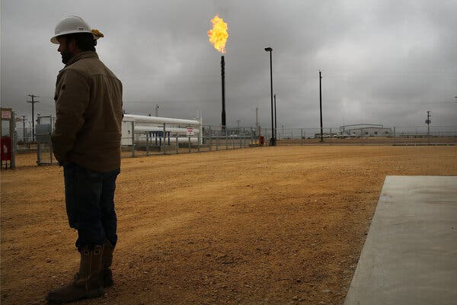

A facility in the Permian Basin near Garden City, Texas, in 2015.Credit...Spencer Platt/Getty Images

In July 2021, the oil and gas driller Apache, which had been struggling with its operations in Texas’s vast Permian Basin, sold about 2,100 wells to a little-known Louisiana operating company, Slant Energy, according to state and federal filings analyzed by ESG Dynamics, a sustainability data firm.

Roughly 40 percent of those wells were inactive. Before Apache sold the lot, the Houston-based company had been plugging an average of 169 wells a year to prevent them from leaking toxic chemicals into groundwater or from emitting methane, a potent greenhouse gas, into the atmosphere. That pace would have meant Apache could finish plugging the backlog of inactive wells in about nine years.

Since Slant took over, it has plugged only two wells, according to the filings. At that pace, it would take 120 years to plug all of the current inactive wells.

The Environmental Protection Agency estimates that each inactive, unplugged well causes greenhouse gas emissions equivalent to between 17,000 to 50,000 miles driven by an average gasoline-powered passenger vehicle. There are already [1.6 million unplugged wells](https://www.aaas.org/epi-center/management-of-wells) throughout the United States, according to industry tallies, and an increasing number of them are abandoned.

Slant spokesman Sean P. Gill said the numbers from EDF “did not appear to be accurate,” without providing further details. Slant had only recently taken over those wells and “continues to evaluate the economic development of the assets in an environmentally responsible way,” he added.

Apache said it wasn’t valid to assume that a company purchasing its wells would have the same schedule for plugging them.

The concerns raised by emissions that are transferred to different companies also puts a renewed focus on global banking corporations that play a critical role in facilitating coal, oil and gas mergers, acquisitions and other transactions. Climate campaigners calling for divestment from fossil fuels have so far focused on banks’ direct financing of fossil fuel projects. But the recent examples show their mergers-and-acquisitions business can also have significant climate consequences.

Shell, a publicly-traded company, said that it discloses emissions from both its operations and the oil and gas that it produces, has corporate targets for reducing greenhouse gas emissions, and has committed to zero flaring across its operations. But when it sells an oil or gas field, those targets and commitments can fall away for that field.

The new owners of the Umuechem project have said they will focus instead [on rapidly ramping up production](https://www.theafricareport.com/88736/nigeria-oml-17-allows-tony-elumelus-heirs-to-take-on-seplat/), which can strain the oil field’s facilities and require significant amounts of flaring. That’s because rapidly increasing oil production often also releases more natural gas, overwhelming the field’s ability to collect the additional gas.

As major oil and gas producers sell more fossil fuel assets, experts and campaigners say, companies and their bankers need to enter into contracts or agreements that commit the buyers to similar disclosures and emissions-reduction targets. And in the case of oil and gas wells and other assets nearing the end of their lives, they argue, corporations shouldn’t be allowed to hand off cleanup responsibilities to operators that may not have the resources, or intent, to invest in the cleanup work.

Kathy Hipple, finance professor at the Bard MBA in Sustainability and senior research analyst at the Ohio River Valley Institute, said one solution would be for auditors or regulators to start scrutinizing every sale, and challenge a transaction if environmental or cleanup obligations or targets aren’t accounted for.

She pointed to Diversified, an operator listed in London, that has become the largest owner of oil and gas wells in the United States in recent years by buying up aging wells, which Prof. Hipple said uses accounting methods that can potentially push cleanup costs far into the future. For example, Diversified has said that its wells will be productive through 2095, allowing it to delay its cleanup costs for decades.

Diversified said that its business model “takes often overlooked or neglected assets, optimizes production, improves environmental performance and responsibly retires” them. It said it aimed to achieve net-zero emissions in 2040.

<https://www.nytimes.com/2022/05/10/climate/oilfield-sales-pollution.html>

#72

As Solar Power Surges, U.S. Wind Is in Trouble

**By**[**Brad Plumer**](https://www.nytimes.com/by/brad-plumer)**and**[**Nadja Popovich**](https://www.nytimes.com/by/nadja-popovich)

 June 4, 2024



**Solar power** projects in the U.S. have taken off in recent years.

30 gigawatts

Inflation Reduction Act passed

20

10

Capacity additions per year

2000

2005

2010

2015

2020

2024

(est)

But new **wind** **power**projects have slowed down.

20 gigawatts

I.R.A.

10

2000

2005

2010

2015

2020

2024

(est)

Source: U.S. Energy Information Administration

Notes: Annual utility-scale power capacity additions are shown. Estimates for 2024 include projects scheduled to come online this year.

When President Biden signed the [2022 Inflation Reduction Act](https://www.nytimes.com/2024/02/21/climate/inflation-reduction-act-progress-climate.html), it was expected to set off a boom in renewable energy, with hefty tax breaks that would make solar and wind power cheaper than fossil fuels.

So far, however, that dream has only come partly true. Solar panel installations are indeed soaring to record highs in the United States, as are [batteries that can store energy](https://www.nytimes.com/interactive/2024/05/07/climate/battery-electricity-solar-california-texas.html) for later. But wind power has struggled, both on land and in the ocean.

The country is now adding less wind capacity each year than before the law was passed.

Some factors behind the wind industry’s recent slowdown may be temporary, such as snarled supply chains. But wind power is also more vulnerable than solar power to many of the biggest logistical hurdles that hinder energy projects today: a lack of transmission lines, a lengthy permitting process and a growing backlash against new projects in many communities.

If wind power continues to stagnate, that could make the fight against global warming much harder, experts say. [Many](https://www.nrel.gov/analysis/100-percent-clean-electricity-by-2035-study.html) [plans](https://netzeroamerica.princeton.edu/the-report) for quickly shifting the country away from fossil fuels envision a large expansion of both solar and wind, because the two sources generate electricity at different hours and can complement each other. A boom in solar power alone, which runs only in daytime, isn’t enough.

Some of the [early predictions](https://www.nytimes.com/interactive/2022/08/02/climate/manchin-deal-emissions-cuts.html) that the Inflation Reduction Act would help slash U.S. greenhouse gas emissions roughly 40 percent below 2005 levels by 2030 depended on a rapid acceleration of both solar and wind power this decade. But it is now far less certain that will happen:

**Solar is on pace to meet targets. Wind? Not so much.**

Average capacity additions per year for 2022-24 compared with post-I.R.A. projections



0 gigawatts

20

40

60

**Solar**

2022-24

average

Expected average additions

per year, 2027-30

**Wind**

2022-24

average

Exected average additions

per year, 2027-30

Source: Clean Investment Monitor

Note: Expected ranges are based on the projected effects of the Inflation Reduction Act from three modeling groups: the Rhodium Group, Energy Innovation and the REPEAT project

“Right now, solar is pretty much in line” with what experts projected, said Trevor Houser, a partner at the Rhodium Group, a research firm that has tried to model the effects of the climate law. “But wind really needs to grow by quite a bit. Going forward, we’re definitely much more concerned about wind.”

**Why Wind Power Is Struggling**

Wind and solar power are often lumped together, but they have important differences that partly explain why one is slowing and the other is thriving right now.

For one, wind power is much more sensitive to location. Wind turbines in a gusty area can [generate eight times as much electricity](https://home.uni-leipzig.de/energy/energy-fundamentals/15.htm#:~:text=The%20wind%20power%20increases%20with,important%20for%20a%20wind%20turbine.) as turbines in an area with just half the breeze. For solar power, the difference between sunny spots and less sunny spots is considerably smaller. That means developers can’t just build wind farms anywhere.

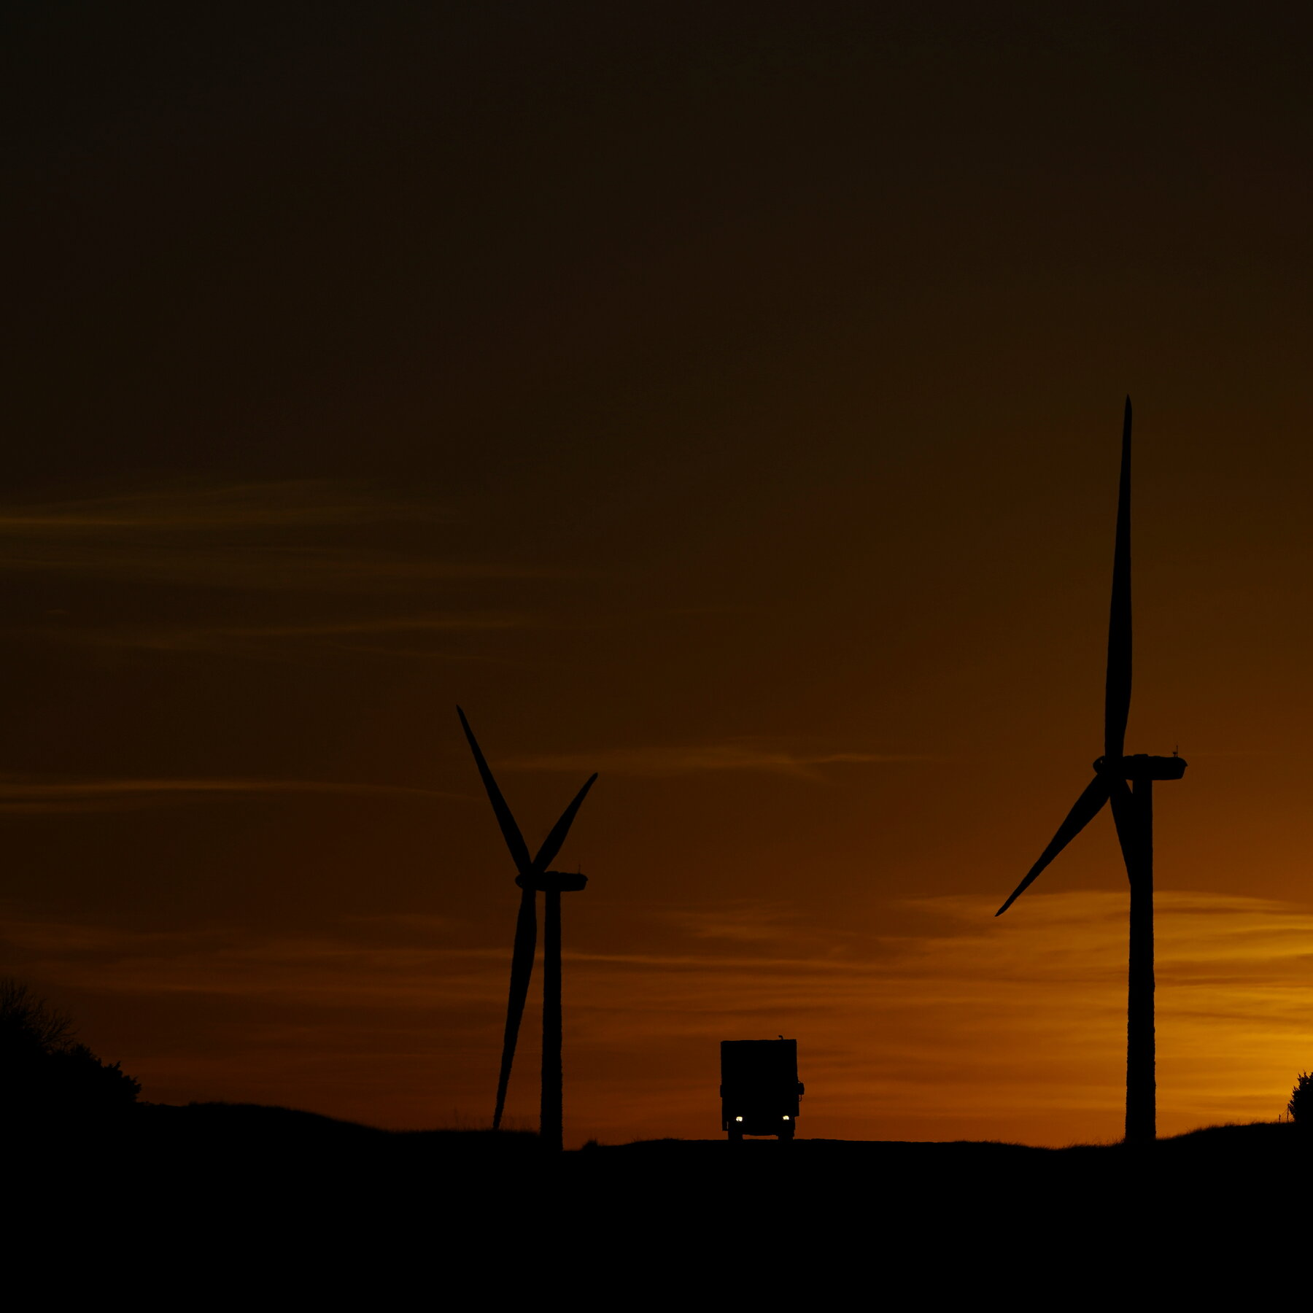

A lot more wind power is needed to reach U.S. climate goals, experts say, especially if the country wants to do it quickly and cheaply.

Eric Gay/Associated Press

In the United States, the best places for wind tend to be in the blustery Midwest and Great Plains. But many areas are now crowded with turbines and [existing electric grids are clogged](https://www.spglobal.com/marketintelligence/en/news-insights/research/curtailment-congestion-costs-rise-as-transmission-upgrades-lag-renewable-growth), making it difficult to add more projects. Energy companies want to expand the grid’s capacity to transport even more wind power to population centers, but getting permits for transmission lines and building them has become a brutal slog [that can take more than a decade](https://www.nytimes.com/interactive/2023/06/12/climate/us-electric-grid-energy-transition.html).

“Getting wind projects built is getting a lot harder,” said Sandhya Ganapathy, chief executive of EDP Renewables North America, a leading wind and solar developer. “The low-hanging fruit, the easier access places are gone.”

Because they can reach the height of skyscrapers, wind turbines are more noticeable than solar farms and often attract more intense opposition from local communities. In Idaho, [the entire State Legislature has opposed](https://www.risch.senate.gov/public/index.cfm/2023/10/risch-leads-bill-to-stop-widely-opposed-lava-ridge-wind-energy-project#:~:text=Idaho's%20State%20legislature%20unanimously%20passed,turbine%20project%20spanning%20146%2C000%20acres.) a new wind farm that would be visible from a World War II historic site. A few years ago, [hundreds of residents were arrested](https://www.staradvertiser.com/2019/11/12/breaking-news/3-more-wind-farm-protesters-arrested-in-kalaeloa/) on Oahu, Hawaii, for blocking the construction of a relatively small wind project.

“We have not seen examples of people being willing to risk arrest to stop solar projects,” said Matthew Eisenson, who [tracks opposition to renewable energy](https://climate.law.columbia.edu/content/opposition-renewable-energy-facilities-united-states-may-2023-edition) at the Sabin Center for Climate Change Law at Columbia University.

Across the country, [hundreds of local governments have restricted or banned](https://www.usatoday.com/story/graphics/2024/02/27/renewable-energy-sources-ban-map/72630315007/) wind or solar projects. If a county blocks a solar array, a developer might be able to move next door. But it’s not always as easy to find a new location for wind farms.



Wind turbines are more visible than solar farms and often attract more intense opposition.

Mason Trinca for The New York Times

The wind industry [has also been hampered by soaring equipment costs](https://www.canarymedia.com/articles/wind/chart-wind-turbine-prices-surged-to-decade-high-in-2022) after the pandemic wrecked supply chains and inflation spiked. While those factors initially hurt solar, too, the solar industry has adjusted much faster, with China [nearly doubling its manufacturing capacity for panels](https://www.iea.org/reports/renewable-energy-market-update-june-2023/is-there-enough-global-wind-and-solar-pv-manufacturing-to-meet-net-zero-targets-in-2030) over the last two years. Wind supply chains, which are dominated by a few manufacturers in China, Europe and the United States, have yet to fully recover.

The cost increases have been devastating for offshore wind projects in the Northeast, where developers [have canceled more than half the projects](https://www.nytimes.com/2023/12/11/business/energy-environment/offshore-wind-energy-east-coast.html) they planned to build this decade.

Wind isn’t languishing only in the United States. While a record 117 gigawatts of new wind capacity came online last year globally, [virtually all of that growth was in China](https://www.bloomberg.com/opinion/articles/2024-04-20/china-accounts-for-all-the-world-s-wind-power-growth?sref=UBrhZ1ro). In the rest of the world, developers weren’t installing wind turbines any faster than they were in 2020.

**The Case for Wind Power**

Wind power can be incredibly useful for cutting the greenhouse gas emissions that are rapidly heating the planet, experts say.

That may surprise some: After all, the wind doesn’t always blow when it’s needed, and the average turbine only runs at maximum power about one-third of the time.

But when energy modelers have studied the lowest-cost ways to eliminate U.S. emissions, they [have](https://netzeroamerica.princeton.edu/the-report) [often](https://www.nrel.gov/analysis/100-percent-clean-electricity-by-2035-study.html) [concluded](https://www.iea.org/reports/net-zero-by-2050) that it would be invaluable to get about one-third or more of the nation’s electricity from wind, up from about 10 percent today, alongside a mix of other technologies like solar, batteries, nuclear power, hydrogen and gas plants that can capture and bury their carbon.

That’s because wind turbines provide very cheap electricity, and they often ramp up at night, when solar power is unavailable. (As the energy writer Michael Thomas [recently showed](https://x.com/curious_founder/status/1793304167882133899), this is readily apparent in Texas, where wind and solar power complement each other.)

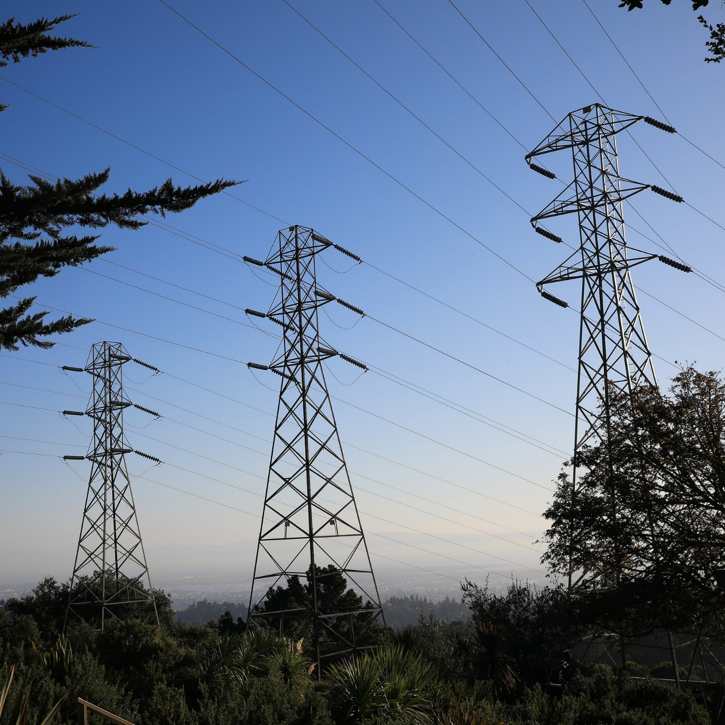

New, long-distance transmission lines are crucial for unlocking American wind energy, but permitting and building them has become a brutal slog.

Jim Wilson/The New York Times

If wind power can’t expand as quickly as many proponents hope, the United States would need to rely much more heavily on other technologies that can supply carbon-free power throughout the day, such as [new nuclear reactors](https://www.nytimes.com/interactive/2023/11/12/climate/nuclear-reactors-clean-energy.html) or [advanced geothermal power](https://www.nytimes.com/2023/08/28/climate/geothermal-energy-projects.html). But those technologies are still in earlier stages of development and are currently more expensive than wind.

“Limiting wind is the worst possible thing you could tell me we have to overcome” in trying to cut emissions to zero, said Ben Haley, a co-founder of [Evolved Energy Research](https://www.evolved.energy/research), an energy modeling firm.

**Can Wind Make a Comeback?**

It’s still possible that wind power could rebound. In fact, some experts argue that the recent slowdown is only a temporary artifact of tax policy.

It can take years to develop a wind farm and most companies had raced to finish projects by the end of 2021, which is when the last big federal tax credit for wind power [was set to expire](https://www.eia.gov/todayinenergy/detail.php?id=46576). The following year, Congress approved new subsidies in the Inflation Reduction Act, but it will take time for companies to refill the pipeline of wind projects in response.

“There are signs that wind is starting to turn the corner,” said John Hensley, vice president for markets and policy analysis at the American Clean Power Association, a renewable industry trade group.

Mr. Hensley said that U.S. wind manufacturing was beginning to ramp up thanks to new tax incentives, while costs were starting to come down. Last year, orders for new turbines increased by 130 percent, although many of them won’t be delivered until 2025 or later.

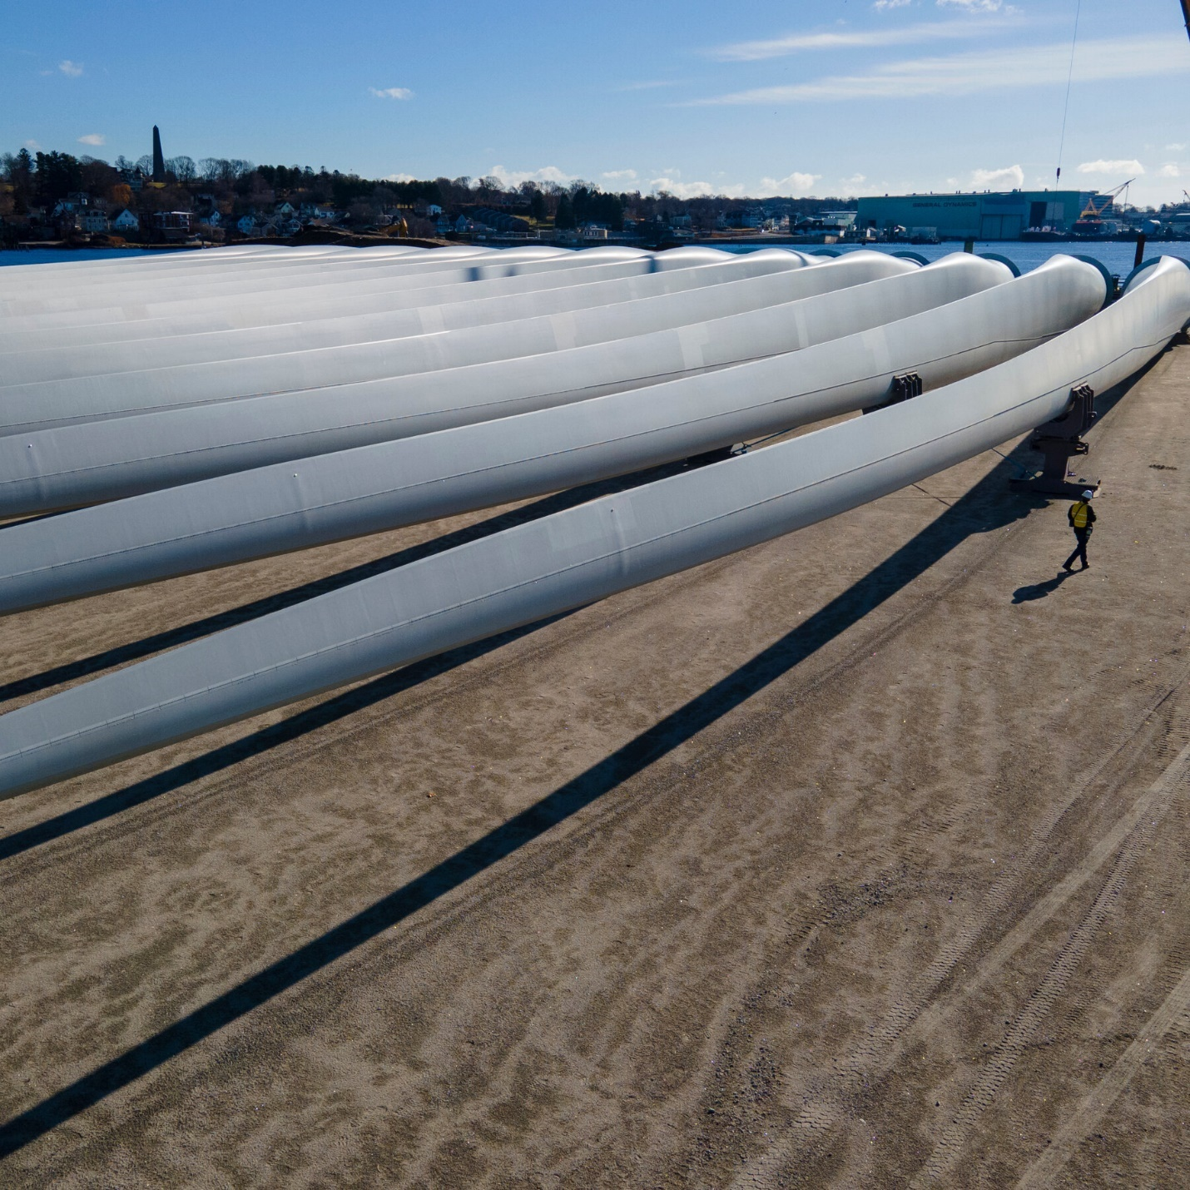

The wind industry has been struggling with soaring equipment costs after the pandemic wrecked supply chains and interest rates spiked.

Ted Shaffrey/Associated Press

Some states are now trying to make it easier to build renewable energy: [Illinois](https://www.jdsupra.com/legalnews/illinois-enacts-new-law-to-standardize-4587029/#:~:text=Illinois%20Enacts%20New%20Law%20to%20Standardize%20Local%20Permitting%20for%20Renewable%20Energy%20Facilities,-Amy%20Antoniolli%2C%20Ryan&text=On%20Friday%2C%20January%2027%2C%202023,wind%20and%20solar%20energy%20facilities.), [Michigan](https://www.fredlaw.com/alert-michigan-to-adopt-state-level-permitting-of-large-scale-renewable-energy-projects) and [Minnesota](https://news.bloomberglaw.com/environment-and-energy/minnesota-governor-approves-renewable-energy-permitting-reform) have all passed laws making it harder for local governments to restrict wind and solar. The federal government has issued new rules [to accelerate the planning of transmission lines](https://www.nytimes.com/2024/05/13/climate/electric-grid-overhaul-ferc.html).

Demand for wind could also rise as a growing number of states, tech companies and hydrogen producers are trying to secure clean electricity around the clock, rather than just a burst of solar power in the daytime.

California is a case in point. While the state leads the nation in drawing electricity from the sun, it still relies heavily on natural gas after dark. Batteries[can help shift some of that solar power into the evening](https://www.nytimes.com/interactive/2024/05/07/climate/battery-electricity-solar-california-texas.html?affff), but to meet its climate goals, California is counting on several giant new transmission lines that will import electricity from sprawling wind farms in [New Mexico](https://www.utilitydive.com/news/pattern-energy-sunzia-transmission-wind/703508/) and [Wyoming](https://www.latimes.com/business/story/2023-06-21/wyoming-to-california-power-line).

Even if the economics improve, wind power still faces political hurdles. Many experts say federal legislation is still needed to ease the process of building high-voltage transmission lines. But that’s unlikely to happen in a sharply divided Congress. And the November election looms, with former President Donald J. Trump, the presumptive Republican nominee, promising to [obstruct offshore wind farms](https://www.bloomberg.com/news/articles/2024-05-12/trump-vows-day-one-executive-order-targeting-offshore-wind?sref=UBrhZ1ro) if he returns to the White House.

The fate of the wind industry could be a test for whether the country can build large energy projects more generally, said Ryan Jones, a co-founder of Evolved Energy Research. “If we can’t,” he said, “getting to zero emissions is pretty darn challenging.”

<https://www.nytimes.com/interactive/2024/06/04/climate/us-wind-energy-solar-power.html>

#73

***Germany’s Energy Crisis Is a Cue to Chop Wood and Stock Up***

The high cost of natural gas and electricity is prompting many to prepare for outages and shortages. For some, it’s been a way of life for years.

Leo Bäumler in his woodshed. He uses his wood stove to heat his house and cook meals.Credit...

* Share full article

**By**[**Melissa Eddy**](https://www.nytimes.com/by/melissa-eddy)

**Photographs by Valentin Goppel**

* Dec. 25, 2022

Tightly stacked cords of wood line the side of a couple’s home in southern Germany, while another family farther north has lined their basement with shelves stacked with pasta, rice, cooking oil and cans of chickpeas, lentils and tomatoes.

In central Germany, a man long wary of relying on the government has ensured that he can make it through weeks without power or heat; he’s filled his attic with coolers to hold food, along with a camping stove, gas canisters and solar power equipment to keep the lights on and stay connected online. Others brave the chilly waters of a local lake for a daily dip, forgoing a hot shower at home.

Across Europe’s largest economy, people are stocking up and battening down. Even as the authorities publish lists of essential items to prepare for power outages or natural gas rationing, many Germans are taking matters into their own hands to ensure that they have a warm home and food on the table through the winter.

A majority of Germans, a full 60 percent, trust their government, according to the Organization for Economic Cooperation and Development. But with a seemingly endless barrage of Russian-fired missiles falling on Ukraine, helping to send prices for energy and food at home soaring, many Germans have decided that if faced with the worst, they might be on their own. They want to be prepared.

Advertisement

[SKIP ADVERTISEMENT](https://www.nytimes.com/2022/12/25/business/germanys-energy-crisis-is-a-cue-to-chop-wood-and-stock-up.html#after-story-ad-1)

**The Woodsman**

Image

Mr. Bäumler splits logs into firewood for the stove that he uses to heat his home. Germans are increasingly turning to alternative fuels amid fears of outages or natural gas rationing.

Leo Bäumler spends his afternoons splitting logs from trees that he fells in a forest that is owned by his sister, near his home near Weiden, in the southern state of Bavaria. He stacks them in his woodshed until he feeds them into the stove in the kitchen of the low-slung house where he grew up.

While thousands of people across Germany have reopened sealed-off fireplaces and installed wood-burning stoves to avoid burning natural gas, which doubled in price over the past year, Mr. Bäumler heats his rooms, boils water for his morning coffee and bakes pizza with his wood-burning stove as ever.

Years ago, he recalls, his father refused to install a gas-fired central heating system, back when the first pipelines reached his home region, connecting Siberian gas fields with then-West Germany, across the Iron Curtain. For decades, natural gas piped in from Russia was abundant and cheap. Half the homes in Germany use gas for their heating.

**Editors’ Picks**

[[](https://www.nytimes.com/2025/06/16/realestate/ireland-raffle-house-winner.html)](https://www.nytimes.com/2025/06/16/realestate/ireland-raffle-house-winner.html)

[‘By Chance, Did You Win a Cottage in Ireland?’](https://www.nytimes.com/2025/06/16/realestate/ireland-raffle-house-winner.html)

[[](https://www.nytimes.com/interactive/2025/06/12/travel/things-to-do-east-london.html)](https://www.nytimes.com/interactive/2025/06/12/travel/things-to-do-east-london.html)

[36 Hours in East London](https://www.nytimes.com/interactive/2025/06/12/travel/things-to-do-east-london.html)

[[](https://www.nytimes.com/2025/06/14/arts/national-history-day.html)](https://www.nytimes.com/2025/06/14/arts/national-history-day.html)

[At National History Day, Students Get Competitive About the Past](https://www.nytimes.com/2025/06/14/arts/national-history-day.html)

[SKIP ADVERTISEMENT](https://www.nytimes.com/2022/12/25/business/germanys-energy-crisis-is-a-cue-to-chop-wood-and-stock-up.html#after-pp_edpick)

Image



Sabine Roth, Mr. Bäumler’s partner, helps him load logs from a forest owned by his sister. Credit...Valentin Goppel for The New York Times

Even before the Russian army invaded Ukraine in February, flows of Russian gas had started to dwindle, causing the wholesale price to more than double. But German leaders, citing the reliable deliveries since the Soviet era, refused to believe that President Vladimir V. Putin would deprive Europe of gas in retaliation for the European Union’s support for Ukraine. Many Germans, though, whose bills were already beginning to soar at the end of 2021, began to prepare.

Advertisement

[SKIP ADVERTISEMENT](https://www.nytimes.com/2022/12/25/business/germanys-energy-crisis-is-a-cue-to-chop-wood-and-stock-up.html#after-story-ad-2)

By the time Russia had made their first cut to gas deliveries in late spring, the government began floating the idea that Germans might have to face rationing come winter. That sent many people to heating supply stores to purchase wood stoves, and since then the price of cords of wood and wood pellets has jumped by more than 87 percent compared with 2021.

But Mr. Bäumler hasn’t noticed.

“Since I live in the middle of the forest in eastern Bavaria, surrounded by trees,” he said, “I don’t have to worry that I will run out of wood.”

**The Ice Bather**

Image



Gregor Ranz, left, uses a morning skinny dip in a lake near his home instead of a shower to start his day.

While some Germans are readying for an eventual blackout or gas stoppage, still others are focusing on ways to conserve energy. The country’s economy minister, Robert Habeck, became the butt of jokes over the summer when he encouraged Germans to take shorter, cooler showers.

Advertisement

[SKIP ADVERTISEMENT](https://www.nytimes.com/2022/12/25/business/germanys-energy-crisis-is-a-cue-to-chop-wood-and-stock-up.html#after-story-ad-3)

Gregor Ranz and his friends didn’t need the encouragement. Every morning between 8 and 9, they meet to skinny dip into a lake in the Wedemark district, north of Hanover. They have been holding their morning ritual since well before the energy crisis — even when the temperatures dip below freezing.

Although the gathering is social as well, Mr. Ranz said that once the energy crisis set in, it made more sense. Bathing nude — [common in much of Germany](https://www.nytimes.com/2019/08/31/world/europe/germany-nudism.html) — each morning served as effectively taking the cold shower approach to the extreme.

“I shower once a week, when I go to the sauna,” he said. “Of course I have a shower at home, but I don’t use it. A washcloth works just fine.”

**Making Connections**

Image

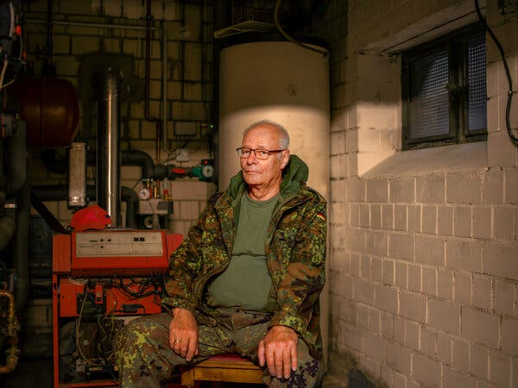

Bernd Sebastian uses less natural gas now that he’s connected a wood stove to his boiler.

Bernd Sebastian has relied on a 25-year-old gas furnace to power the boiler that provides warm water and heating for his home. When the price of gas began to rise, he upgraded his furnace, but he also hooked up his wood-burning stove to heat the water in his main boiler.

Advertisement

[SKIP ADVERTISEMENT](https://www.nytimes.com/2022/12/25/business/germanys-energy-crisis-is-a-cue-to-chop-wood-and-stock-up.html#after-story-ad-4)

“We sit in front of our fireplace every day, and it warms the water in my boiler and the heater draws from that,” he said. When the fireplace is off, the gas furnace kicks in.

He said that he contemplated getting [a heat pump](https://www.nytimes.com/2022/12/02/world/europe/germany-heat-pumps.html), which draws warmth from the air. “That would be ideal, but that runs on electricity and with power prices going up, it wouldn’t save me money unless I installed solar panels, which is another outlay.”

Image



Roswitha Sebastian in the living room with the family’s wood stove. Her husband, Bernd, has been stacking firewood wherever he can.

Mr. Sebastian gathers wood from a nearby forest that is managed by a friend who alerts him when trees have fallen or been felled. Then he gathers it up and brings it home to be split and stacked.

Since last year, he has been stocking up, stacking it in every patch he can find in and around his home, including some outdoor space used by his wife, Roswitha. At 76, he’s worried that he might not be able to keep enough of it chopped and ready to keep their fireplace going and avoid using gas.

Advertisement

[SKIP ADVERTISEMENT](https://www.nytimes.com/2022/12/25/business/germanys-energy-crisis-is-a-cue-to-chop-wood-and-stock-up.html#after-story-ad-5)

“I’ve had to steal two flower beds from my wife,” he said. “And the third is up for discussion.”

**Leaving the Grid**

Image

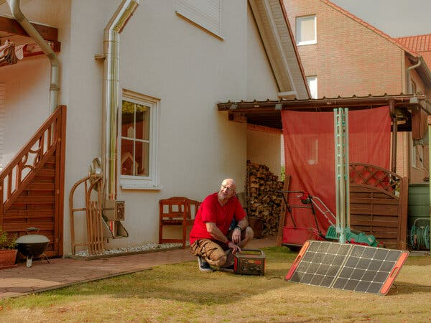

To deal with power outages, Bernward Schepers has folding solar panels and a battery.

Bernward Schepers did not wait for the government to begin urging citizens to stock up on nonperishable food and 20 liters of water per person. For months, he has been collecting supplies and pivoting his heating and power away from fossil fuels.

“Thank God I bought a wood-burning stove years ago,” he said. Over the past year, he has acquired an electric heater and a large battery with portable solar panels that can be folded out to generate energy.

More and more Germans were drawn to solar energy in 2022. The amount of power generated from solar panels increased by one-third in the first part of the year, amid fears of potential blackouts.

“If we were to lose electricity, that way at least we can power some of the small things and keep the food in the refrigerator from spoiling,” he said. “I also bought a small stove with a gas canister, so that if needed we can cook.”

Advertisement

[SKIP ADVERTISEMENT](https://www.nytimes.com/2022/12/25/business/germanys-energy-crisis-is-a-cue-to-chop-wood-and-stock-up.html#after-story-ad-6)

Image

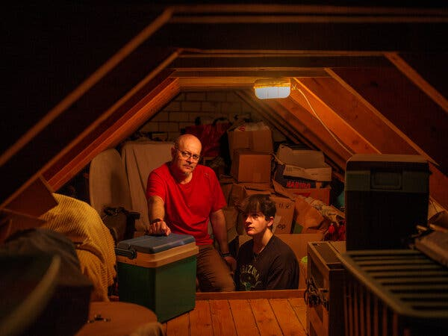

Bernward Schepers and his son, Bastian, with coolers and other gear in their attic.

When he first talked of readying for the worst, Mr. Schepers’ son, Bastian Schepers, rolled his eyes. For a while, his family poked fun at his preparations. Not anymore.

He also has been sharing his knowledge with colleagues and friends, who have approached him for advice.

“You just have to make sure that you always have your food stocks up to scratch, that you have enough there,” Mr. Schepers said. “Then you are good, whatever happens.”

**The Stockpilers**

Image



Advertisement

[SKIP ADVERTISEMENT](https://www.nytimes.com/2022/12/25/business/germanys-energy-crisis-is-a-cue-to-chop-wood-and-stock-up.html#after-story-ad-7)

It was the first Covid lockdowns that sent the Arndt family into preparation mode. “It started with toilet paper,” said Lars Arndt, who lives at home with his parents, brother and grandfather in Johannesberg, southeast of Frankfurt.

That was when his mother, Claudia Arndt, decided they needed to turn their basement, where the family had stored a variety of things, including some nonperishable items like jam and tinned vegetables, into a storage unit. As the lockdowns in Germany progressed in 2020 and 2021, the family began stockpiling more items, adding flour, pasta and a tank holding 100 liters of drinking water.

They also changed the way they heat the house. After years of relying on a gas-fired furnace for central heating, this winter they reverted to their main wood-burning stove which only heats the dining and living rooms on the main floor of the house. The other rooms are unheated.

“We have been thinking more and more,” he said, about “what we can do to make sure that we are able to provide for ourselves.”

“We don’t want to be dependent on others for what we need,” he added. “But to be able to take things into our own hands.”

<https://www.nytimes.com/2022/12/25/business/germanys-energy-crisis-is-a-cue-to-chop-wood-and-stock-up.html>

#74

The Clean Energy Future Is a Battle for Hearts and Minds

A broad, and sometimes quixotic, retail effort to win the fight against global warming is playing out one person at a time, with nary a mention of climate change.

* Share full article
* 356

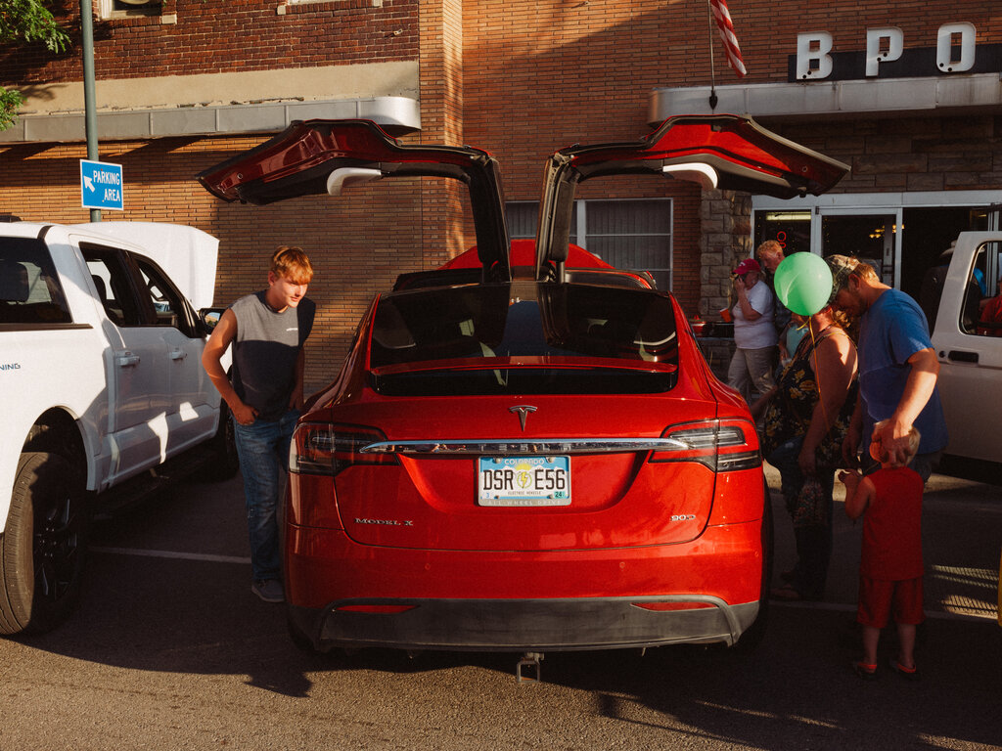

[**Jack Ewing**](https://www.nytimes.com/by/jack-ewing) reported from the Kansas City area, [**Clifford Krauss**](https://www.nytimes.com/by/clifford-krauss) from Wyoming and [**Lisa Friedman**](https://www.nytimes.com/by/lisa-friedman) from the Southeast to assess shifting attitudes toward green technology. Photographs by **Mason Trinca**.

This is the third article in a three-part series examining the [**speed**](https://www.nytimes.com/interactive/2023/08/12/climate/clean-energy-us-fossil-fuels.html), [**challenges**](https://www.nytimes.com/interactive/2023/08/12/climate/wind-solar-clean-energy.html) and [**politics**](https://www.nytimes.com/interactive/2023/08/12/climate/electric-car-politics-chevy-general-motors.html) of the American economy moving toward clean energy.

Aug 17, 2023

Like many people driving an electric car for the first time, Mikey Marohn had questions: Could he drive hundreds of miles to visit his father without stopping? Where would the chargers be? How did you turn it on?

“I’m anxious,” said Mr. Marohn, a 34-year-old carpenter, as he settled behind the wheel of a Chevrolet Bolt near Grand Teton National Park in Wyoming.

But after a test drive with Alicia Cox, executive director of Yellowstone-Teton Clean Cities, a nonprofit group that promotes green transportation, Mr. Marohn had gone from skeptical to curious.

“I would consider it,” he said after Ms. Cox explained that he could save $3,000 a year in fuel costs if he replaced his Chevy Impala with a Bolt. “I’d like to save money and help the planet.”

Green energy and transportation have advanced faster than many experts thought possible a few years ago. But many hurdles remain, including efforts by conservative politicians to prolong the use of coal, oil and gas and campaigns by environmentalists and local residents to block new wind turbines, transmission lines and mines.

Just as important will be persuading people like Mr. Marohn that electric cars, renewable energy and electric heaters and stoves are practical, economical and exciting.

Ms. Cox, who travels Wyoming offering free rides in the Chevy Bolt, is part of a broad, and sometimes quixotic, retail effort to win hearts and minds in the fight against climate change, one person at a time. Biden administration officials are trying to highlight to voters the economic benefits of his energy and industrial policies. Corporations like General Motors, which makes the Bolt, are spending billions of dollars to build electric vehicles they hope to sell everywhere, even in conservative states like Wyoming.

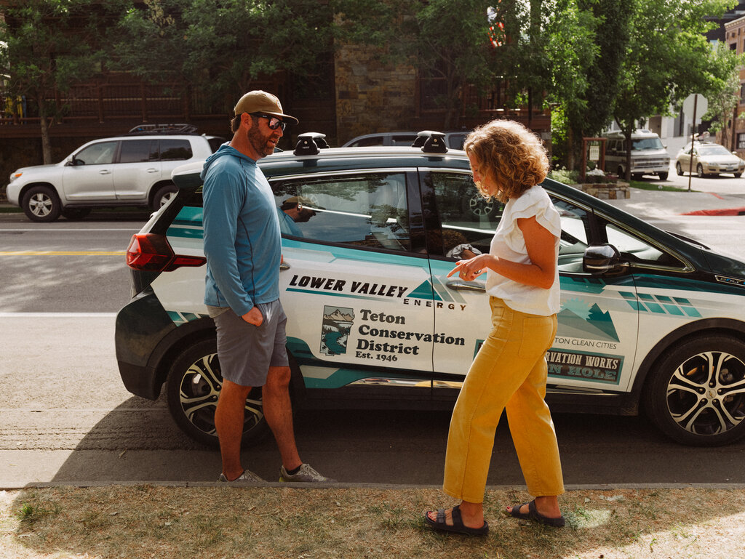

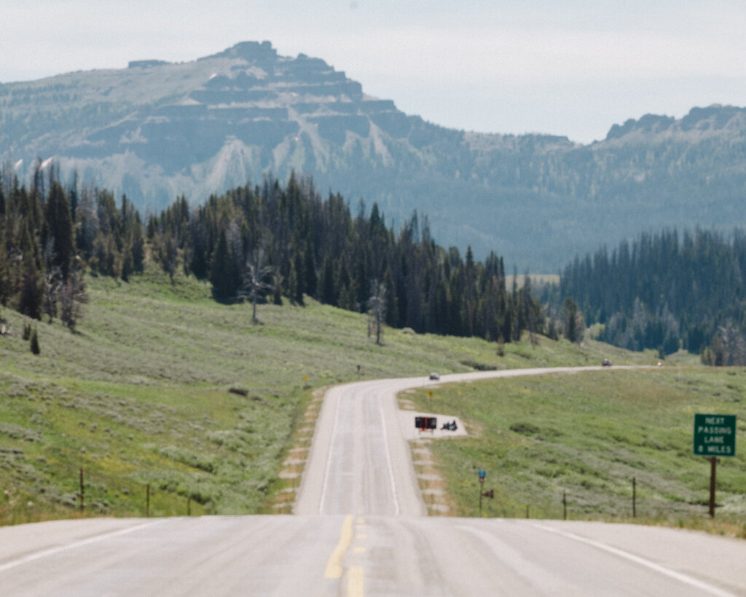



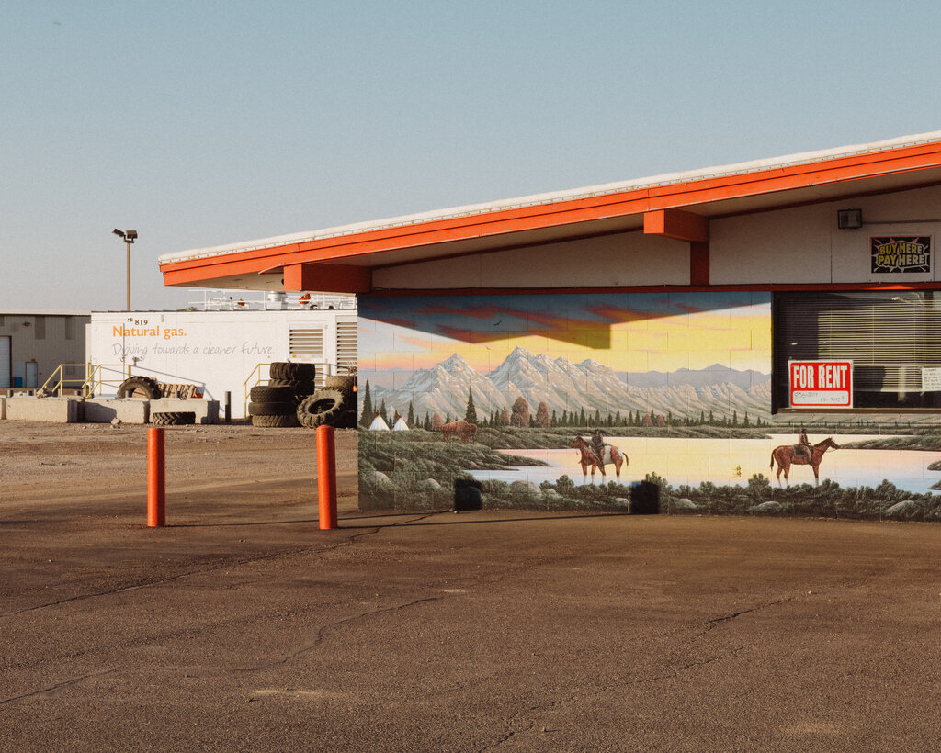

**1**

**2**

**3**

**4**

Alicia Cox, ​​executive director of Yellowstone-Teton Clean Cities, travels Wyoming offering free rides in an electric Chevy Bolt.

Continue scrolling

In conversations with activists, policymakers and corporate executives, it becomes clear that a save-the-planet argument doesn’t go very far. Most people won’t buy green technology unless it will clearly save them money and wows them with stunning designs or jaw-dropping performance.

Many, conservatives in particular, chafe at the prospect of the government forcing them to buy electric cars or ditch their natural gas appliances, polls show. That’s perhaps why those pitching the technology often avoid mentioning climate change. They emulate evangelists who don’t lead with Jesus when trying to win over nonbelievers.

**Many Americans Are Still Skeptical of E.V.s. Especially Republicans.**



How likely U.S. adults say they are to seriously consider purchasing an electric vehicle the next time they buy a car or truck:

**Not too/Not at all**

**Very/Somewhat**

38%

**U.S. adults**

50%

30%

56%

Democrat

**70%**

20%

Republican

Source: [Pew Research Center](https://www.pewresearch.org/science/2023/06/28/majorities-of-americans-prioritize-renewable-energy-back-steps-to-address-climate-change/)

Note: Percentages do not add up to 100. The rest of the survey respondents said they did not plan to purchase a vehicle.

By The New York Times

The Clean Energy Future Is a Battle for Hearts and Minds - The New York Times

A clean energy future will require painstaking and individually tailored persuasion campaigns. About half of Americans say they are not interested in buying electric cars, and a little more than half say they have not seriously considered solar panels, heat pumps or electric water heaters, [a recent Pew Research Center survey](https://www.pewresearch.org/science/2023/06/28/majorities-of-americans-prioritize-renewable-energy-back-steps-to-address-climate-change/) found.

“I never expect anyone to adopt an E.V. on the first go of it,” Ms. Cox said. “They need someone walking along beside them as they are making the decision.”



**“I never expect anyone to adopt an E.V. on the first go of it,” Ms. Cox said.**

**Selling Green Energy**

Jae Landreth operates a solar installation business in Baldwin City, Kan., a rural town southwest of Kansas City. Though he believes in climate change, he said, he “learned the hard way” not to mention it when marketing solar panels to his neighbors.

“That’s not how you sell it,” he said over coffee at his home. “Nobody’s ever going to make a decision unless it benefits them in a money sense.”

Mr. Landreth, an ebullient man who plays percussion in a Phil Collins tribute band, owns a Tesla, an electric off-road vehicle and an electric Ford F-150 Lightning pickup he uses for his business, Solar Planet.

His enthusiasm for electric vehicles is hardly the norm in this patch of corn-and-cattle country. It’s not unusual for drivers of Teslas and Toyota Prius hybrids to get “coal-rolled” by diesel trucks rigged to produce clouds of black exhaust on demand.

One of Mr. Landreth’s customers is Rob Leach, a dairy farmer. Mr. Leach hired Mr. Landreth to install solar panels on his barn when it was rebuilt after a 2019 tornado. The panels power the large fans that were keeping Mr. Leach’s cows cool on a July day when the temperature was in the high 90s.

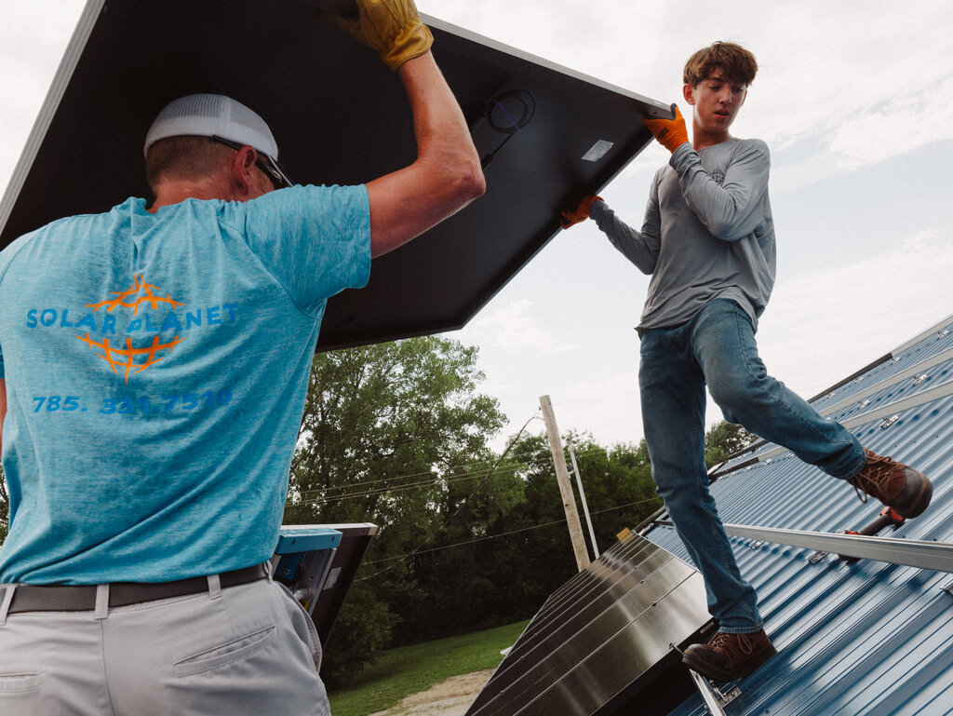

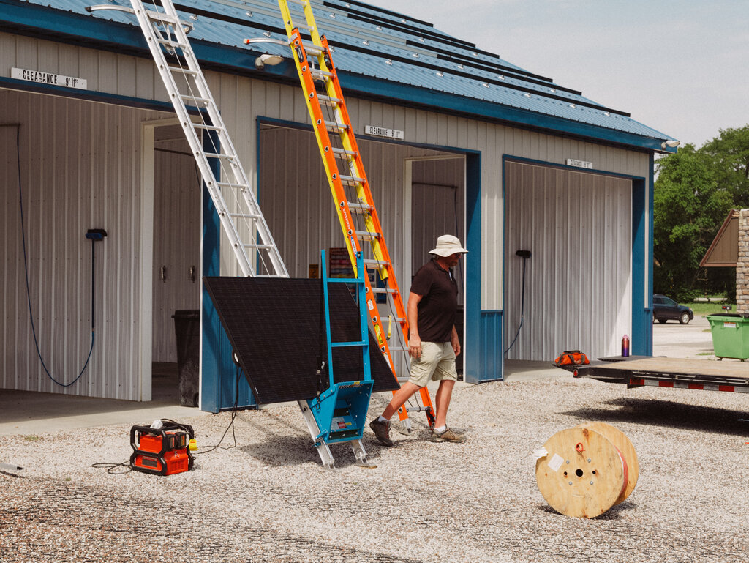



**1**

**2**

**3**

Jae Landreth’s solar installation business in Baldwin City, Kan., counts Rob Leach, a dairy farmer, among his customers.

Continue scrolling

Cost was crucial, according to Mr. Leach. “I said, ‘I just want to know at the end of the month, am I going to be paying less even with my investment in solar?’ And that has been the case.”

Mr. Leach has since encouraged other farmers to install solar panels. “I’ve had several friends of mine that were, you know, not necessarily trying to save the planet,” he said. “They just wanted to save money.”

The Inflation Reduction Act passed by Democrats last year allocated hundreds of billions of dollars in incentives for wind and solar manufacturing, electric vehicles and other clean energy.

**A Clean Energy Manufacturing Boom in the Making**

New manufacturing investments announced since the Inflation Reduction Act passed in August 2022

Source:[Jack Conness of Energy Innovation](https://www.jackconness.com/ira-chips-investments) and additional research by The New York Times

Note: This map only shows projects for which a detailed location has been announced.

By The New York Times

The Clean Energy Future Is a Battle for Hearts and Minds - The New York Times

Although no Republicans voted for the bill, much of the money has gone to G.O.P.-led states in the South where many automakers, battery manufacturers and solar companies are building factories in part to take advantage of the law’s tax breaks.

Getting credit for the new jobs is a political imperative for President Biden, who will be seeking re-election next year. That helps explains why his energy secretary, Jennifer Granholm, spent part of July traversing the Southeast in a caravan of electric vehicles.

**More Green Investments Are Flowing to Red Counties**

Location of new clean energy manufacturing investments by 2020 county election results



**$53.3 billion**

**Trump counties**

Biden counties

$19.1 billion

N/A

$4.0 billion

Source: [Jack Conness of Energy Innovation](https://www.jackconness.com/ira-chips-investments)

Note: The N/A category includes investments for which a detailed location has not yet been announced.

By The New York Times

Ms. Granholm stopped at universities and elementary schools, a hardware store and a Baptist church. She made the case that federal investment in clean energy is creating thousands of jobs, saving consumers money and even protecting the nation against President Vladimir V. Putin of Russia, who has used fossil fuel exports to exert pressure.

Not on Ms. Granholm’s list of reasons to go green: climate change.

Sipping black coffee at a Starbucks outside Memphis. Ms. Granholm said she liked to focus on how Biden administration policies were turning the region into a vibrant manufacturing hub. “It’s important to lean on the message that makes sense for people where they are.”



**Mr. Landreth said he had “learned the hard way” not to mention climate change when marketing solar panels to his neighbors.**

**Jobs and Savings**

In North and South Carolina, Georgia and Tennessee — states on Ms. Granholm’s itinerary — solid majorities accept that global warming is real, according to detailed polling by the [Yale Program on Climate Change Communication](https://climatecommunication.yale.edu/visualizations-data/ycom-us/). But there is widespread skepticism that humans are responsible.

“The climate has always been changing,” said Sue Burns, 59, at a gathering of Pontiac car enthusiasts in Murfreesboro, Tenn. “The left is out of control” in insisting that burning fossil fuels is causing a planetary crisis, Ms. Burns said.

Yet Ms. Burns drives a Prius — a far cry from a Pontiac muscle car — that runs on an internal combustion engine and an electric motor. She said she had bought the car to save money on gas.

Among residents benefiting from the economic boost, attitudes may be softening. Outside Dalton, Ga., Qcells, a maker of solar panels, is planning to expand a manufacturing plant. The factory is in the congressional district represented by Marjorie Taylor Greene, a Republican who has called fossil fuels “amazing” and climate change a “scam.”

William Turner, 49, one of Ms. Greene’s constituents, said he didn’t “really buy into that stuff” about global warming. But he added, “I don’t have anything against solar, especially if it’s creating jobs.”

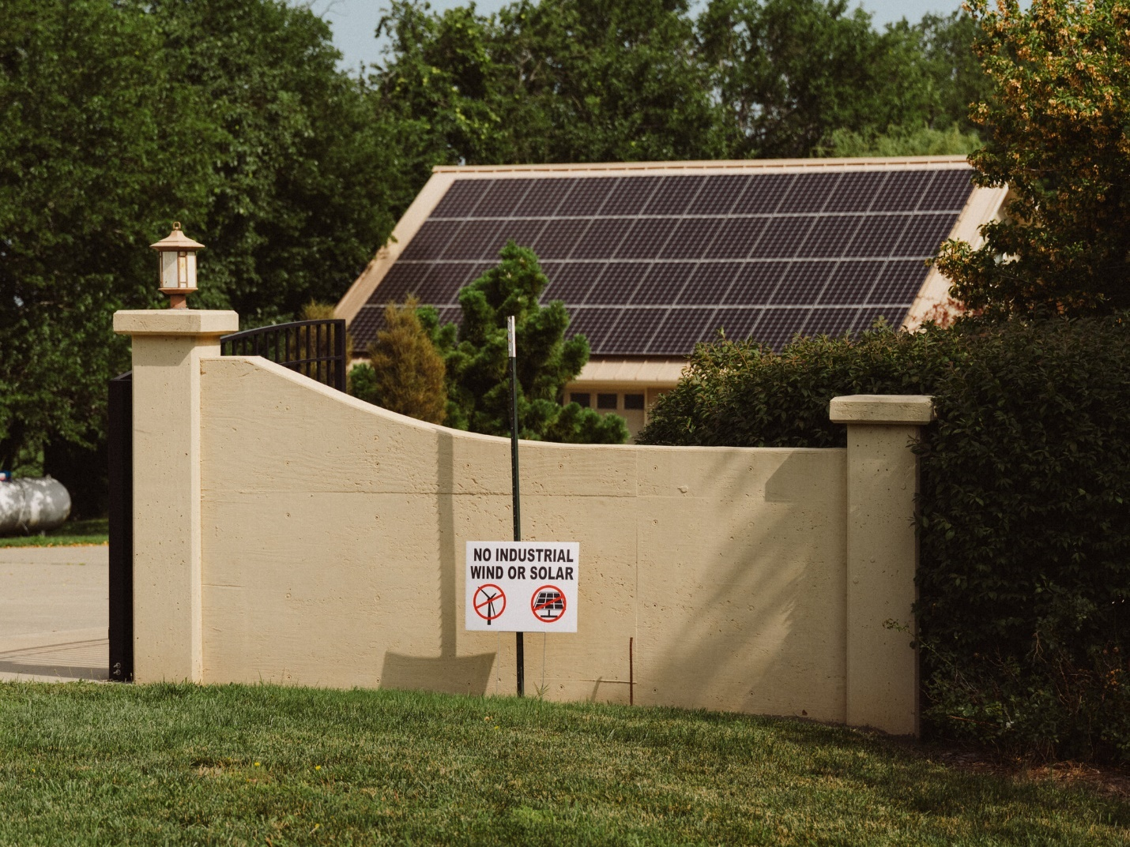

**Experts say most people won’t buy green technology unless it will clearly save them money or dazzle them.**

The true test of public opinion will come when the promised factories are up and running, said Jason Walsh, the executive director of the BlueGreen Alliance, a partnership of unions and environmental groups.

“Political messaging and press announcements" will not convince anyone, Mr. Walsh said. “But a paycheck might.”

In Democratic strongholds, Ms. Granholm’s clean energy message went down more smoothly. Yet even there, many people said they needed to think with their pocketbooks, not their principles.

“I care about climate change,” said Tia Williams, 29, eating lunch with a friend at the Georgia Institute of Technology before an appearance by Ms. Granholm. But she said she wasn’t planning to buy an electric car because they were too expensive.

“I know the corporations love them, but I don’t see much use for them myself,” Ms. Williams said of federal incentives designed to make electric vehicles more affordable.

Slightly less than half of Democrats say they support phasing out fossil fuels, according to Pew. And just 12 percent of Republicans support doing so. That’s perhaps why Mr. Biden tends to emphasize the economic upside of his policies.

[[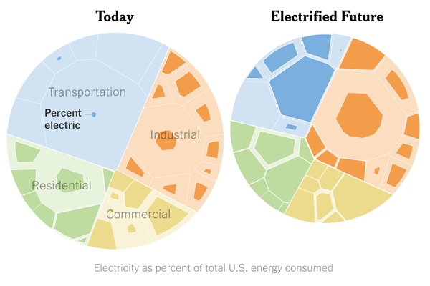](https://www.nytimes.com/interactive/2023/04/14/climate/electric-car-heater-everything.html)](https://www.nytimes.com/interactive/2023/04/14/climate/electric-car-heater-everything.html)

**[How Electrifying Everything Became a Key Climate Solution](https://www.nytimes.com/interactive/2023/04/14/climate/electric-car-heater-everything.html)**

[To tackle climate change, we’ll need to plug in millions of cars, trucks, home heaters, stoves and factories.](https://www.nytimes.com/interactive/2023/04/14/climate/electric-car-heater-everything.html)

In July, Mr. Biden went to South Carolina, where he taunted Republicans who had voted against climate change and infrastructure bills yet were reaping their benefits. Mr. Biden toured Flex, which makes fast chargers for electric cars and is in the district represented by Joe Wilson, a Republican who said the Inflation Reduction Act was “to the detriment of American families.”

“Didn’t get much help from the other team, but that didn’t stop us from getting it done,” Mr. Biden told the crowd, speaking of the legislation.

Gov. Roy Cooper of North Carolina, a Democrat, said in an interview that Republicans were trying to block or roll back efforts to promote electric trucks and buses, energy efficiency and offshore wind development. But Mr. Cooper predicted that economics would prevail.

“Even if some of them deny the science of climate change, they can’t deny good-paying jobs,” he said.

**Not ‘Mission: Impossible’**

In Wyoming, where coal, oil, natural gas and souped-up pickups are cherished, Patrick Lawson is fighting a lonely campaign.

A member of the Northern Arapaho Tribe, he tries to get local businesses to install charging stations. He takes out his Tesla Model Y and Ford F-150 Lightning as an Uber driver at night, less to make money than to drum up interest in electric vehicles.

Once a year he participates in the Rocky Mountain Rebels Car Show in Riverton, which adjoins his reservation. “I just want to change the perception that electric cars are not as good as big, noisy muscle cars,” Mr. Lawson said.

It’s a tough sell. During a Friday night “cruise parade” that opened the show, Mr. Lawson’s mother, Susan Lawson, drove a red Tesla Model X, its distinctive wing doors open. As she waited in a lumber store parking lot for the parade to start, a middle-age woman approached.

“Wow, it’s a Tesla, beautiful car,” said the woman, who identified herself only as Cheryl, “a patriot and small business owner.”

But then her tone shifted. “I don’t believe in electric cars,” she said. “The government could turn them off. The government controls our electricity.”

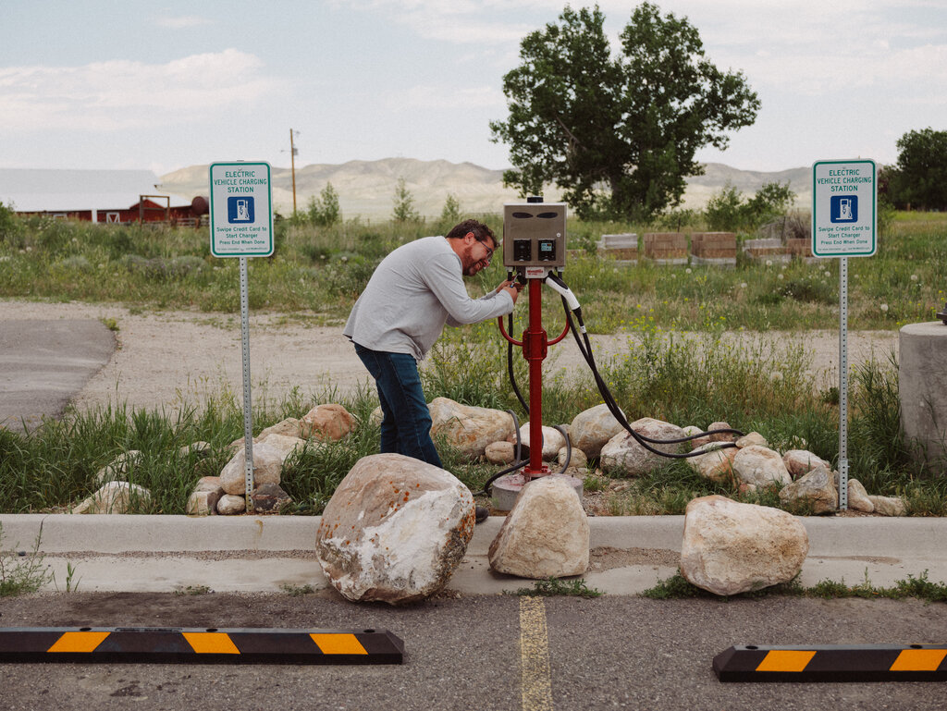







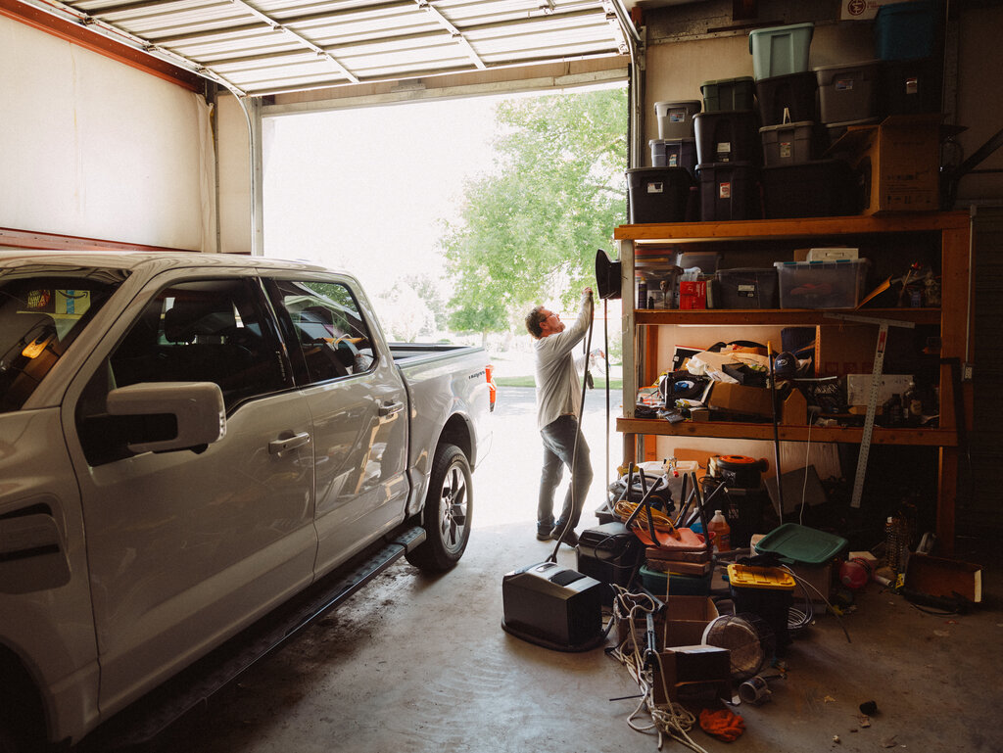

**1**

**2**

**3**

**4**

**5**

Patrick Lawson lobbies local businesses to install charging stations, talks to skeptics and demonstrates his Tesla at the car show’s obstacle course.

Continue scrolling

A few bystanders on the parade route commented favorably about the Tesla’s looks. But there were brickbats, too. “They’re on their way to Jackson,” someone said, referring to the liberal resort town. “Good luck getting over the pass in that thing,” shouted another.

After the Lawsons parked in front of the local Elks lodge, a man pretending to hold a machine gun fired a spray of imaginary bullets at the electric vehicles.

That kind of reaction doesn’t deter Mr. Lawson, 42, who manages the tribe’s internet company along with his small charging business, Wild West EV.

When Mr. Lawson arranged $174,000 to match a federal grant to install charging stations at the city hall and airport, the Riverton City Council declined the money. The one public charging station in town, outside a sandwich shop, is often blocked by trucks, sometimes deliberately parked horizontally to make charging impossible.

During an obstacle race that was part of the car show, another Tesla driver beat all 40 cars. Onlookers were impressed but still skeptical. “It doesn’t fit everybody’s needs,” said Kent Wheeler, a technician at an auto body and paint shop.

Mr. Lawson remains optimistic. “I’m in it for the long haul,” he said. “It’s not ‘Mission: Impossible.’”

Ford Motor, G.M. and dozens of other companies are investing hundreds of billions of dollars to refit factories and build new ones to produce electric vehicles. They don’t want to make cars that only Democrats buy.

One company confronting the marketing problem is Polaris, a Minnesota company that builds four-wheel off-road vehicles used by hunters and farmers.

In April, Polaris began selling a $25,000 electric vehicle called the Ranger XP Kinetic. Advertising barely mentions the environment, instead stressing its performance. The strategy seems to have worked. The initial production run sold out two hours after Polaris began taking orders.

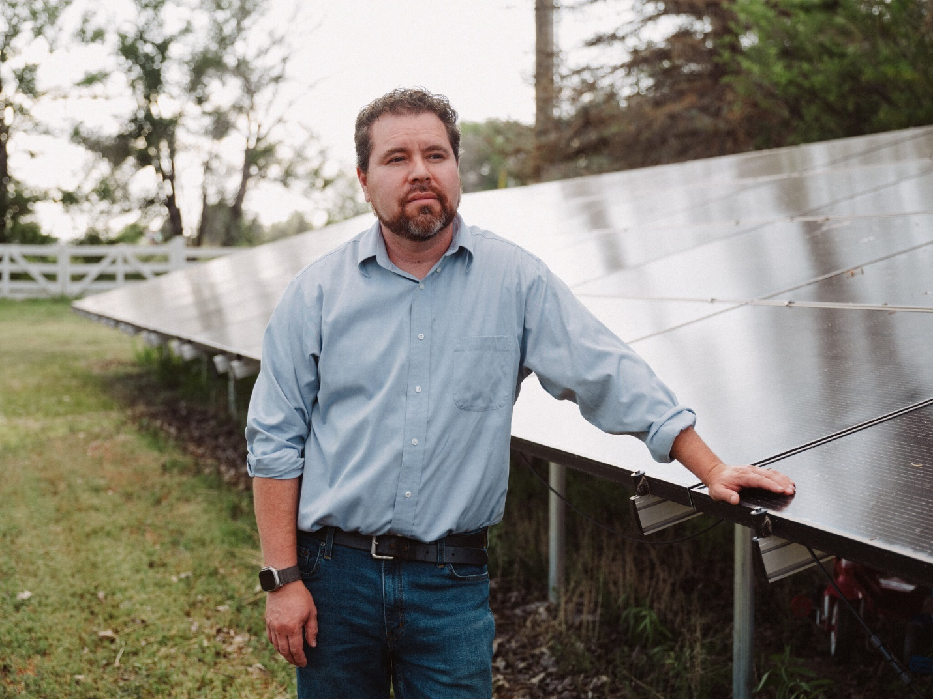

**Mr. Lawson, a member of the Northern Arapaho Tribe, said, “I just want to change the perception that electric cars are not as good as big, noisy muscle cars.”**

“We knew the target customer,” said Josh Hermes, vice president for electric off-road vehicles at Polaris. “We really focused in on the benefits of the product”

One of the first buyers was Paul Rosenzweig, a Georgia resident who is in the wholesale feed business and is skeptical that climate change is caused by mankind. Rather, Mr. Rosenzweig, who hunts deer, rabbit and squirrels in Louisiana, likes how quiet the Polaris is.

“You see more wildlife with electric than you do with the motor burning,” he said.

When G.M. begins selling a battery-powered version of its Chevy Silverado pickup this year, it will emphasize the truck’s 450-mile range and towing capacity.

The company’s chief executive, Mary T. Barra, said the cars were winning people over. Customers are “figuring out they’re really fun to drive, and it’s really nice to not have to go to the gas station,” she said in an interview.

There are tentative signs that conservative opposition is wavering.

The Republican-controlled Legislature in Alabama, where Mercedes-Benz makes electric cars and Polaris builds the Kinetic, has allocated $1 million a year for a campaign to encourage residents to buy electric vehicles.

“We want to make sure we embrace the jobs and economic opportunities that accompany this new generation of vehicles,” Kenneth Boswell, director of the Alabama Department of Economic and Community Affairs, said in a statement.

Republican lawmakers in Missouri have sought to block Quinton Lucas, Kansas City’s Democratic mayor, from raising the minimum wage, making buildings more energy-efficient and restricting gun ownership. But they have not tried to block Kansas City from buying electric cars and trucks, Mr. Lucas said.

Building inspectors and supervisors in the Fire Department drive electric cars. At the city-owned airport, electric tractors deliver baggage, and electric buses shuttle passengers. The technology saves the city thousands of dollars per vehicle in maintenance and fuel costs.

“They usually notice everything new that we do and often try to pre-empt it,” Mr. Lucas said of the Legislature. “And so what that tells me is, actually, I don’t see this being a flashpoint.”

<https://www.nytimes.com/interactive/2023/08/12/climate/electric-car-politics-chevy-general-motors.html>

#75

***Oil Companies Are Collapsing, but Wind and Solar Energy Keep Growing***

The renewable-energy business is expected to keep growing, though more slowly, in contrast to fossil fuel companies, which have been hammered by low oil and gas prices.

* Share full article

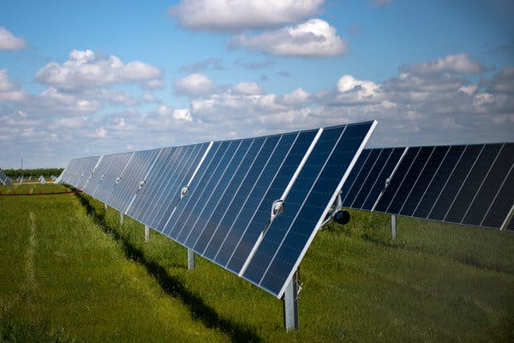

8minute Solar Energy temporarily stopped building a solar farm near Fresno, Calif., because of the coronavirus pandemic.Credit...Deanne Fitzmaurice for The New York Times

[](https://www.nytimes.com/by/ivan-penn)

**By**[**Ivan Penn**](https://www.nytimes.com/by/ivan-penn)

Published April 7, 2020Updated Sept. 8, 2021

**The DealBook Newsletter**Our columnist Andrew Ross Sorkin and his Times colleagues help you make sense of major business and policy headlines — and the power-brokers who shape them. Get it sent to your inbox.

A few years ago, the kind of double-digit drop in [oil and gas prices](https://www.nytimes.com/2020/04/27/podcasts/the-daily/oil-prices-coronavirus.html?action=click&module=Briefings&pgtype=Homepage) the world is experiencing now because of the coronavirus pandemic might have increased the use of fossil fuels and hurt renewable energy sources like [wind and solar](https://www.nytimes.com/interactive/2021/05/28/climate/climate-wind-solar-energy-map.html) farms.

That is not happening.

In fact, renewable energy sources are set to account for nearly 21 percent of the electricity the United States uses for the first time this year, up from about 18 percent last year and 10 percent in 2010, according to one forecast published last week. And while work on some [solar](https://www.nytimes.com/2021/09/08/business/biden-solar-energy-climate-change.html) and wind projects has been delayed by the outbreak, industry executives and analysts expect the renewable business to continue growing in 2020 and next year even as oil, gas and coal companies struggle financially or seek bankruptcy protection.

In many parts of the world, including California and Texas, wind turbines and solar panels now produce electricity more cheaply than natural gas and coal. That has made them attractive to electric utilities and investors alike. It also helps that while [oil prices](https://www.nytimes.com/2020/04/08/business/oil-markets.html) have been more than halved since the pandemic forced most state governments to order people to stay home, natural gas and coal prices have not dropped nearly as much.

Even the decline in electricity use in recent weeks as businesses halted operations could help renewables, according to analysts at Raymond James & Associates. That’s because utilities, as revenue suffers, will try to get more electricity from wind and solar farms, which cost little to operate, and less from power plants fueled by fossil fuels.

“Renewables are on a growth trajectory today that I think isn’t going to be set back long term,” said Dan Reicher, the founding executive director of the Steyer-Taylor Center for Energy Policy and Finance at Stanford University and an assistant energy secretary in the Clinton administration. “This will be a bump in the road.”

Of course, the economic slowdown caused by the fight against the coronavirus is taking a toll on parts of the renewable energy industry just as it is on the rest of the economy. Businesses that until recently were adding workers are laying people off and putting off investments. Among the hardest hit are smaller companies that sell solar panels for rooftops. Their orders have dropped steeply as customers put off installations to avoid possible contact with the virus.

Image

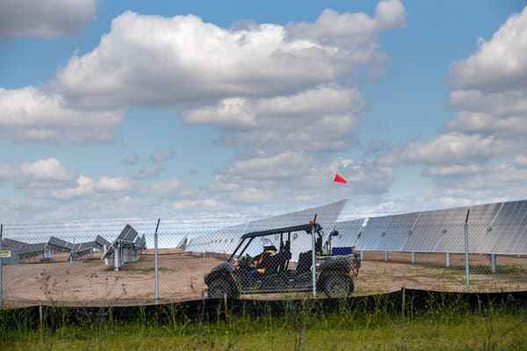

A sharp drop in the price of solar panels has helped the industry expand.Credit...Deanne Fitzmaurice for The New York Times

Luminalt, a solar and electricity storage company based in San Francisco that employs 42 people, recently told most of its installers to seek unemployment benefits as the company’s residential jobs — normally six a week — have all but evaporated. Jeanine Cotter, Luminalt’s chief executive, told workers that the company would cover their benefits but that there was no money coming in to pay all of them.

A half-dozen employees are installing solar at an affordable-housing project that has kept them working, and some who handle business operations are working from home. But Ms. Cotter worries about some installers who joined the company through San Francisco’s work force development program and depend on weekly paychecks to make ends meet.

“Revenue has stopped,” said Ms. Cotter, who helped found the business 15 years ago. “It’s very confusing right now.”

The Solar Energy Industries Association, a trade group, estimates that half of the 250,000 workers in the industry could lose their jobs at least temporarily because of the coronavirus outbreak. The association has downgraded projected growth by as much as one-third of the more than 19 gigawatts of new solar capacity that was expected this year.

But independent experts, including Wood Mackenzie, an energy research and consulting firm, say those projections could be overly pessimistic. “It’s still too early to call,” Ravi Manghani, head of solar at research at Wood Mackenzie. “The situation is changing on a daily basis.”

His firm estimates that solar and wind power will continue adding capacity this year and next. New wind installations might be down only about 3 percent from earlier projections, largely because wind turbines are typically erected outside urban areas, and many states have deemed construction an essential activity during the pandemic.

In a report last week, Raymond James analysts estimated that renewable energy sources would provide 20.7 percent of the nation’s electricity this year and at least 20 percent through 2022.

**Editors’ Picks**

[[](https://www.nytimes.com/2025/06/16/realestate/ireland-raffle-house-winner.html)](https://www.nytimes.com/2025/06/16/realestate/ireland-raffle-house-winner.html)

[‘By Chance, Did You Win a Cottage in Ireland?’](https://www.nytimes.com/2025/06/16/realestate/ireland-raffle-house-winner.html)

[[](https://www.nytimes.com/interactive/2025/06/12/travel/things-to-do-east-london.html)](https://www.nytimes.com/interactive/2025/06/12/travel/things-to-do-east-london.html)

[36 Hours in East London](https://www.nytimes.com/interactive/2025/06/12/travel/things-to-do-east-london.html)

[[](https://www.nytimes.com/2025/06/14/arts/national-history-day.html)](https://www.nytimes.com/2025/06/14/arts/national-history-day.html)

[At National History Day, Students Get Competitive About the Past](https://www.nytimes.com/2025/06/14/arts/national-history-day.html)

Although hydroelectric plants have long helped power homes and businesses, solar and wind power emerged as major energy sources only over the last 15 years or so. A sharp drop in the price of solar panels has helped the industry expand. Last year, solar capacity increased 23 percent from the year before. It added 13.3 gigawatts, exceeding new wind and natural-gas generation, according to industry data.

“We blew through all of the projections,” said Caton Fenz, chief executive of ConnectGen, a wind, solar and electricity-storage developer based in Houston. “We’re surfing a long-term wave,” he said. “We just can’t get specific things done because of the pandemic, but I don’t think that affects the broader trajectory.”

Image

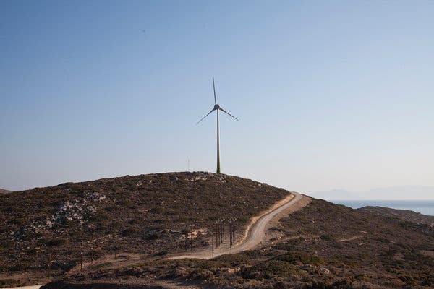

A wind turbine on the Aegean island of Tilos, Greece. The country is working to retire fossil fuel plants and replace them with renewables.Credit...Iliana Mier/Associated Press

His company, which is 22 months old, has 3,000 megawatts — the equivalent of three large power plants — under development in 11 states. About 40 percent is wind projects, 40 percent solar and the rest electricity storage.

Among the company’s backers is 547 Energy, an investment firm that specializes in renewable energy. Gabriel Alonso, who runs 547 Energy, said his firm received its funding from Quantum Energy Partners, which had long been an investor in oil and natural gas.

“As an investor in clean energy, renewable energy, the fundamentals that drove us to invest have not changed,” Mr. Alonso said.

Even as the pandemic spread, Mr. Alonso’s company [won a bid](https://www.globenewswire.com/news-release/2020/04/06/2012090/0/en/547-ENERGY-AND-ENORA-S-A-CONTINUE-MOMENTUM-IN-GREECE.html) last week for part of a new electricity project in Greece. His company will develop a wind farm in the northern regions of Imathia and Kozani. The auction, on Thursday, was part of a larger effort by Greece to retire fossil fuel plants and replace them with renewables.

Many renewable companies have projects around the world and have benefited from government efforts to address climate change. That has helped drive down costs of wind and solar equipment and made the industry more resilient to economic swings.

In addition, because developers can build wind and solar farms more quickly than natural-gas, coal and nuclear plants, Mr. Alonso said, the renewables have become more attractive financially. In difficult economic times like these, he said, private equity investors like Quantum are eager to seize on businesses that can quickly scale up and start earning money.

That said, solar businesses in particular are worried that the disruptions caused by the pandemic are serious enough that they are seeking help from Congress. Lobbyists for renewable energy are asking lawmakers to make it easier for their industry to take advantage of tax credits the government provides for wind and solar power.

Image

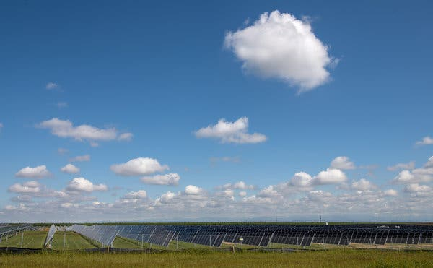

Last year, solar capacity increased 23 percent from the year before.Credit...Deanne Fitzmaurice for The New York Times

Developers usually enter into partnerships with banks and other financial institutions that can more efficiently make use of the tax credits than the contractors building renewable energy projects. The banks receive the tax credit and a share of the cash flow from the project typically for six to 10 years.

But because demand for loans has shot up as businesses across the economy struggle, banks have been less able to finance new projects, said Josh Goldstein, chief operating officer at 8minute Solar Energy, a developer of large solar farms. Solar and wind industry officials want Congress to streamline the process for obtaining tax credits and make the credits refundable so that their businesses could benefit directly.

“Their credit committees are in crisis mode,” Mr. Goldstein said about banks. “This disruption can have a particularly damaging effect.”

8minute Solar was recently forced to suspend work on the [Lotus Solar Project](https://www.businesswire.com/news/home/20190910005984/en/8minute-Solar-Energy-Allianz-Global-Investors-Announce), a 67-megawatt solar farm north of Fresno, Calif., that it is building for Allianz Global Investors. Officials said it was unclear whether the work, which employed about 50 people, was considered “essential.”

But the Department of Homeland Security included electricity production on its list of essential activities last month, affirming legal advice that 8minute had received, and the company sent workers back to finish construction.

The solar industry expected to add more panels in 2020 than in any other previous year, said Abigail Hopper, president of the Solar Energy Industries Association. That won’t happen now, but the industry is still poised to add capacity.

“We believe, over the long run, we are well positioned to outcompete incumbent generators,” Ms. Hopper said.

<https://www.nytimes.com/2020/04/07/business/energy-environment/coronavirus-oil-wind-solar-energy.html>

#76

***Vietnam Relied on Environmentalists to Secure Billions. Then It Jailed Them.***

The government is preparing to present its energy transition plan at the U.N. climate talks as it intensifies a crackdown on environmental advocates.

* Share full article
* 8

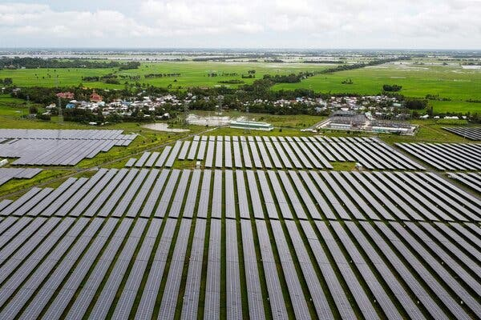

Solar panels at the Sao Mai power plant in An Giang Province, Vietnam, last year. The country has been awarded $15.5 billion in grants and loans in exchange for a commitment to renewable energy.Credit...Agence France-Presse — Getty Images

[](https://www.nytimes.com/by/sui-lee-wee)

**By**[**Sui-Lee Wee**](https://www.nytimes.com/by/sui-lee-wee)

Nov. 28, 2023

[Leer en español](https://www.nytimes.com/es/2023/11/29/espanol/vietnam-cop29-medioambiente.html)

When Vietnam was awarded a multibillion-dollar deal by a group of nine wealthy nations last year to work on reducing its use of coal, it agreed to regularly [consult with nongovernmental organizations](https://ec.europa.eu/commission/presscorner/detail/es/statement_22_7724).

Instead, the government has arrested several prominent environmentalists from those organizations who shaped policies that helped secure the funding, prompting concerns over sending money to countries that have violated human rights.

As the country prepares to announce how it will spend the money at the [United Nations climate talks](https://www.nytimes.com/article/cop28-climate-change-summit.html) that begin on Thursday, activists are saying that Vietnamese officials need to be held accountable for what they are calling a [harsh crackdown](https://www.nytimes.com/2022/06/17/world/asia/nguy-thi-khanh-environmental-activist-arrested.html) against those who speak out about the country’s environmental woes.

[Ngo Thi To Nhien](https://the88project.org/wp-content/uploads/2023/11/Understanding-the-arrest-of-energy-policy-researcher-Ngo-Thi-To-Nhien-Project88-compressed.pdf), the director of an energy think tank, was the sixth environmental campaigner to be detained in the past two years.

She had met with officials from the Ministry of Natural Resources and Environment in March to discuss a plan for the climate deal, the [Just Energy Transition Partnership](https://www.energytransitionpartnership.org/country/vietnam/), an effort among the United States, Japan and other developed countries to persuade developing economies to abandon coal. The nine nations had announced in December that Vietnam would receive $15.5 billion in grants and loans in exchange for a commitment to renewable energy.

Ms. Nhien, 48, never got the chance to see Vietnam present the plan. She was arrested in September and remains in a detention center on a charge of “appropriating documents of agencies and organizations.”

The other five who were detained were charged with tax evasion, which rights groups say are trumped-up accusations in response to their advocacy. Four were tried in closed hearings that lasted less than a day each, and given jail time, punishments more severe than the norm. While two activists have since been released, the United Nations high commissioner for human rights said in September that the “prosecutions and the arbitrary application of restrictive legislation are having a chilling effect” on environmentalists in Vietnam.

Activists and academics say that Vietnam appears to be emboldened by its growing importance to the West and has taken the opportunity to clamp down, knowing there will be few repercussions. The country has presented itself as an [increasingly important geopolitical player](https://www.nytimes.com/2023/09/08/world/asia/biden-vietnam-china.html), and one of the few Southeast Asian nations that has publicly pushed back against China. President Biden visited Vietnam in September, elevating [ties to a new strategic relationship](https://www.nytimes.com/2023/09/10/us/politics/biden-vietnam-hanoi.html) that he said would “be a force for prosperity and security in one of the most consequential regions in the world.”

**Editors’ Picks**

[[](https://www.nytimes.com/2025/06/16/realestate/ireland-raffle-house-winner.html)](https://www.nytimes.com/2025/06/16/realestate/ireland-raffle-house-winner.html)

[‘By Chance, Did You Win a Cottage in Ireland?’](https://www.nytimes.com/2025/06/16/realestate/ireland-raffle-house-winner.html)

[[](https://www.nytimes.com/interactive/2025/06/12/travel/things-to-do-east-london.html)](https://www.nytimes.com/interactive/2025/06/12/travel/things-to-do-east-london.html)

[36 Hours in East London](https://www.nytimes.com/interactive/2025/06/12/travel/things-to-do-east-london.html)

[[](https://www.nytimes.com/2025/06/14/arts/national-history-day.html)](https://www.nytimes.com/2025/06/14/arts/national-history-day.html)

[At National History Day, Students Get Competitive About the Past](https://www.nytimes.com/2025/06/14/arts/national-history-day.html)

Image



President Biden and Nguyen Phu Trong, the general secretary of the Communist Party of Vietnam, at a welcome ceremony in Hanoi in September.Credit...Kenny Holston/The New York Times

“We’re dealing with a juggernaut,” said Phil Robertson, the deputy director of Human Rights Watch’s Asia division. “They have run the table on the international community, and they’re continuing to do so.”

He pointed to Vietnam’s [invitation to the Group of 7 summit](https://apnews.com/article/japan-g7-kishida-guest-nations-7f3dcc03b04557740ab0b6a92f4ebc32) this year, its inclusion on the Human Rights Council and now the funding from the Just Energy Transition Partnership, despite the country’s troubling human rights record.

**Want to stay updated on what’s happening in Vietnam?** Sign up for Your Places: Global Update, and we’ll send our latest coverage to your inbox.

Since 2016, when Nguyen Phu Trong, the general secretary of the Communist Party of Vietnam, was re-elected, the space for civil society has shrunk immensely. The country has the second-highest number of political prisoners in Southeast Asia, with more than 160 people currently detained for exercising their basic rights, [according to Human Rights Watch](https://www.hrw.org/video-photos/interactive/2023/11/13/free-vietnams-political-prisoners).

The authorities in Vietnam have long persecuted people who are viewed as overt threats to one-party rule. But Mr. Trong’s administration has gone much further, targeting people who were previously given some room to operate.

Vietnam rejects any suggestions that the prosecutions are politically motivated. Pham Thu Hang, a spokeswoman for the Vietnamese foreign ministry, said last month that the environmentalists’ cases were “investigated, prosecuted and tried in accordance with the provisions of Vietnam law.”

Image

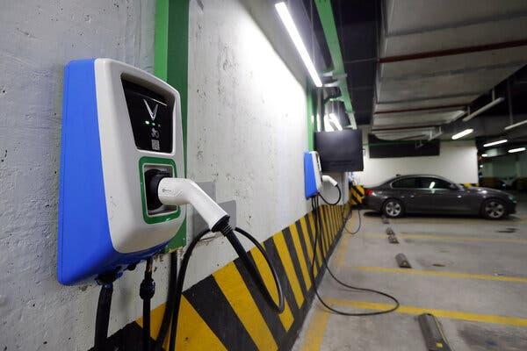

An electric vehicle charging station in a Hanoi parking garage. Nine wealthy nations announced in December that Vietnam would be the recipient of funding to facilitate its energy transition.Credit...Luong Thai Linh/EPA, via Shutterstock

All six ran organizations that were outspoken about the country’s environmental problems. That advocacy ultimately put them on a collision course with the Communist Party.

Their detentions are a signal that the government wants the energy transition to be carried out on its own terms and not on the advice of groups they have long deemed suspicious, said Nguyen Khac Giang, a visiting fellow at the ISEAS-Yusof Ishak Institute, a research organization in Singapore.

On the day Ms. Nhien was detained, Nhan Dan, the official newspaper of the Communist Party, criticized foreign donors who had funded policy research, saying they had directed groups to publish reports with “one-sided, negative content, tarnishing the situation of the country and the people of Vietnam.”

Vietnam, a manufacturing powerhouse that is home to nearly 99.5 million people, is the ninth-largest coal consumer globally. In 2021, Prime Minister Pham Minh Chinh vowed that the country would [phase out coal consumption](https://www.nytimes.com/2021/11/04/climate/cop26-coal-climate.html) by 2040.

Image

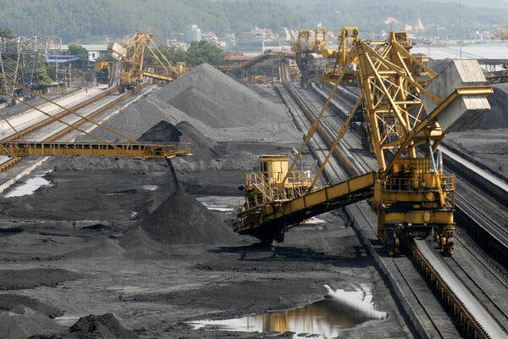

A coal company in Quang Ninh Province, in northeast Vietnam. The country is the ninth-largest coal consumer globally. Credit...Nguyen Huy Kham/Reuters

The Just Energy Transition Partnership was first awarded to South Africa in 2021 as part of an effort by wealthy countries to address longstanding inequities in tackling climate change. Activists now see Vietnam as a litmus test for future agreements. Should other repressive governments be given billions of dollars? Should there be specific requirements for countries that receive funding but have poor human rights records?

Several countries behind the climate deal have expressed concern about the detentions in Vietnam, but rights groups say those nations need to predicate their financial support on the release of the environmentalists or a pledge from the government that there will not be additional arrests. So far, the countries have been unwilling to do so, said Ben Swanton, a director at [The 88 Project](https://the88project.org/), a U.S.-based nonprofit that focuses on human rights issues in Vietnam.

Image



Dang Dinh Bach, 45, ran a law and policy research center before he was arrested in 2021.

In one of the harshest penalties in Vietnam for someone convicted of tax evasion, Dang Dinh Bach, 45, was given a five-year sentence in January 2022. He ran a law and sustainable development policy research center that provided legal aid to communities.

Mr. Bach refused to plead guilty. Tran Phuong Thao, his wife, said that she was not allowed to attend his trial and that he has been assaulted in prison by police officers.

“People like my husband have made great efforts to support the government and give suggestions on energy transition policies,” Ms. Thao said.

The arrest of Ms. Nhien, the think tank director, was particularly unusual because she was not a government critic. She led the Vietnam Initiative for Energy Transition Social Enterprise, the first group in the country to specialize in energy transition.

A former civil servant, Ms. Nhien had worked as a consultant at the World Bank and the Southeast Asia Energy Transition Partnership, a program managed by a U.N. infrastructure agency. She championed policymaking based on scientific evidence and was invited in May to speak to the Ministry of Science and Technology of Vietnam. In June 2020, she organized a workshop on integrating renewable energy sources into the country’s grid, presenting information from the state electricity utility.

That was enough to make her a target. On Sept. 15, four daysafter Mr. Biden left Vietnam, she was detained. The Ministry of Public Security pointed to the workshop as evidence of her “appropriating internal documents.”

Two weeks later, a court in Ho Chi Minh City sentenced Hoang Thi Minh Hong, 51, one of Vietnam’s best-known environmentalists, to three years in prison for tax evasion.

Image



Hoang Thi Minh Hong, one of Vietnam’s best-known environmentalists, was sentenced to three years in prison for tax evasion.Credit...Hoang Vinh Nam, via Agence France-Presse — Getty Images

Ms. Hong’s husband, Hoang Vinh Nam, called his wife’s trial a sham and said the tax department did not send anyone to testify against her. When her peers started being arrested two years ago, Ms. Hong called the tax bureau to ask whether she owed anything and was assured that she did not, he said.

In December, Ms. Hong decided to shut down her environmental nonprofit, citing government pressures. She was arrested in May.

<https://www.nytimes.com/2023/11/28/world/asia/vietnam-cop28-environment.html?searchResultPosition=1>